Kingdom of Saudi Arabia
Ministry of Higher Education
Imam Abdulrahman Bin Faisal University
College of Computer Sciences & Information Technology

Final Report

Title: Harnessing Deep Learning to Optimize Emergency Response

A project submitted
in partial fulfillment of the requirements for the degree of
Bachelor of Science in Artificial Intelligence
By:
# | Name | ID | Role
1 | Mohammed Kamal Hadi | 2220004360 | Leader
2 | Abdulrhman Mohammed Alshehri | 2220006250 | Member
3 | Saud Ali Rawdhan | 2220002478 | Member
4 | Ahmad Abdulqader Alakhdar | 2220002324 | Member
5 | Ali Ibrahim Asiri | 2220000306 | Member
Supervised by:
Dr. Mohammad Aftab Alam Khan & Dr. Atta-ur-Rahman
Committee Member Names:
Dr. Ito Wasito
Dr. Rabbab Alkhalifa
Date:
3/6/2026

ACKNOWLEDGEMENT
We want to sincerely thank our supervisor, Dr. Mohammed Aftab, for all the guidance and support he’s given us throughout this project proposal. His valuable insights and expert advice on the technical side really helped shape our research. We also deeply appreciate our co-supervisor, Dr. Atta-ur-Rahman, for his constant encouragement and patience along the way. Their feedback and suggestions have been incredibly helpful and will make a big difference in improving our work.

ABSTRACT
The project "Harnessing Deep Learning to Optimize Emergency Response" is designed to help emergency teams react more quickly and effectively to car accidents. Using advanced AI and computer vision, the system watches live videos from traffic and security cameras to spot accidents as they happen. It then sends detailed alerts to emergency responders, including the exact location of the crash.
By using powerful AI models like YOLO and convolutional neural networks, the system identifies collisions in real time, cutting down response times and improving outcomes. Beyond saving lives, it also helps ease traffic jams around accident sites, working toward the goal of safer, smarter cities. By automating accident detection and reducing the chance of human error, this project aims to make public safety and emergency coordination more reliable and efficient.
Table of Contents
Chapter 1: Introduction 18
1.1 Introduction 18
1.2 Problem Statement 18
1.3 Motivation 19
1.4 Justification 19
1.5 Aims & Objectives 19
1.6 Scope / Limitation of the Study 19
1.7 Social, Professional, Legal, and Ethical Implications 20
1.8 Project Organization 20
Chapter 2: Background and Literature Review 22
2.1 Introduction 22
2.2 Literature Review 22
Chapter 3: Software Project Management Plans (SPMP) 35
3.1 Project Overview 35
3.1.1 Purpose, Scope, and Objectives 35
3.1.2 Assumptions, Constraints and Risks 36
3.1.3 Project Deliverables 37
3.1.4 Schedule and Budget Summary 38
3.1.5 Evolution of the Plan 39
3.1.6 References 40
3.1.7 Definitions and Acronyms 41
3.1.8 Document Structure 41
3.2 Project Organization 42
3.2.1 External Interfaces 42
3.2.2 Internal Structure 42
3.2.3 Roles and Responsibilities 43
3.3 Managerial Process Plans 44
3.3.1 Startup Plan 44
3.3.2 Work Plan 45
3.3.3 Project Tracking Plan 49
3.3.4 Risk Management Plan 51
3.3.5 Project Closeout Plan 51
3.4 Technical Process Plans 52
3.4.1 Process Model 52
3.4.2 Methods, Tools, and Techniques 54
3.4.3 Infrastructure 54
3.4.4 Product Acceptance 55
3.5 Supporting Process Plans 55
3.6 Additional Plans 56
3.6.1 Data Privacy and Security 56
3.6.2 Documentation and User Operation 56
3.6.3 Maintenance and Updates 56
3.6.4 Deployment Considerations 56
3.6.5 Ethical and Legal Considerations 56
Chapter 4: Software Requirements Specification (SRS) 57
4.1 Introduction 57
4.1.1 Purpose 57
4.1.2 Scope 57
4.1.3 Definitions, Acronyms, and Abbreviations 57
4.1.4 References 57
4.2 Overall description 58
4.2.1 Product perspective 58
4.2.2 Product functions 58
4.3 Specific requirements 61
4.3.1 External interface requirements 61
Chapter 5: Software Design Specification (SDS) 70
5.1 Introduction 70
5.1.1 Purpose 70
5.1.2 Scope 70
5.1.3 Definitions, Acronyms, and Abbreviations 70
5.1.4 References 71
5.2 System overview 72
5.2.1 System Functionality 72
5.2.2 User Functionality 72
5.3 Design Considerations 74
5.3.1 Assumptions and Dependencies 74
5.3.2 General Constraints 75
5.4 User Interface Design 78
5.4.1 Overview of User Interface 78
5.4.2 Interface Design Rules 78
5.4.3 Screen Images 79
5.4.4 Screen Objects and Actions 84
5.4.5 Other Interfaces 86
5.5 System Architecture 88
5.5.1 Architectural Design Approach 88
5.5.2 Architectural Design 89
5.5.3 Subsystem Architecture 91
5.6 Data Design 94
5.6.1 Data Description 95
5.6.2 Data Dictionary 95
5.6.3 Database Description 99
5.7 Component Design 101
5.7.1 Detection Engine Component 101
5.7.2 Event Orchestrator Component 101
5.7.3 Assignment Engine Component 101
5.7.4 Notification Component 102
5.7.5 Repository Layer (Data Access Component) 102
5.8 Detailed System Design 103
5.8.1 Classification, Definition and Responsibilities 103
5.8.2 Composition 104
5.8.3 Uses/Interactions 104
5.8.4 Resources 105
5.8.5 Processing 106
5.8.6 Interface/Exports 109
5.8.7 Detailed Subsystem Design 110
5.9 Other Design Features 112
5.10 Requirements Traceability Matrix 113
Chapter 6: Implementation Process 117
6.1 Introduction 117
6.2 Changes from the Proposal Phase and Justifications 117
6.3 Dataset 117
6.3.1 Data Description 117
6.3.2 The Annotation System 118
6.3.3 Supplementary Datasets 118
6.3.4 Data Split 119
6.4 AI Models Changelog 120
6.4.1 Checkpoint File Index 121
6.4.2 Model Version History 122
6.5 AI Models Implementation 126
6.5.1 Architecture – VideoViT v4 126
6.5.2 Dual-Stream YOLO Detection Tokens 127
6.5.3 Alpha-Gated Cross-Attention 128
6.5.4 Training Configuration 128
6.5.5 Stage-3 Semantic Triage (Qwen2.5-VL-7B) 129
6.6 Website Implementation 131
6.6.1 Login Interface 132
6.6.2 Reset Password Interface 133
6.6.3 Administrator - Operational Dashboard 134
6.6.4 Administrator - Camera Management 135
6.6.5 Administrator - User Management 137
6.6.6 Administrator - System Audit Log 138
6.6.7 First Responder - Active Incidents Dashboard 139
6.6.8 First Responder - Accident Details 140
6.6.9 First Responder – Live Camera Feeds 142
6.6.10 First Responder - Incident Reports 143
6.6.11 AI Detection Test Lab 145
6.7 System Audit and Action Logs Specification 147
6.7.1 Core Auditing Objectives 147
6.7.2 Audit Log Data Schema 147
6.7.3 Log Ingestion & Generation Mechanics 148
6.7.4 Security, Integrity, and Performance Control 148
6.8 Conclusion 148
Chapter 7: Software Testing Plan 150
7.1 Introduction 150
7.2 Test Items 150
7.3 Features to be Tested 150
7.4 Approach 150
7.4.1 Data and Database Integrity Testing 151
7.4.2 Component Testing 152
7.4.2.1.1 Login 152
7.4.2.1.2 Reset Password 153
7.4.2.1.3 Administrator Dashboard Navigation 154
7.4.2.1.4 Camera Management 154
7.4.2.1.5 User Management 155
7.4.2.1.6 Audit Log 156
7.4.2.1.7 AI Test Lab 157
7.4.2.1.8 First Responder Dashboard Navigation 157
7.4.2.1.9 Incident Details 158
7.4.2.1.10 Live Camera Feeds 159
7.4.2.1.11 Stage 1: Spatial Detection (YOLO11n) 159
7.4.2.1.12 Stage 2: Temporal Classification (VideoViT v4) 160
7.4.2.1.13 Stage 3: Semantic Triage (Qwen2.5-VL) 160
7.4.3 Integration Testing 162
7.4.3.1.1 End-to-End AI Pipeline Integration 162
7.4.3.1.2 Administrator Interface Integration 163
7.4.3.1.3 First Responder Interface Integration 164
7.4.4 User Interface Testing 164
7.4.5 Interface Testing 165
7.4.6 Performance and Latency Benchmarks 165
7.4.7 Security Testing 166
7.4.8 Edge Case Testing 166
7.4.9 Verification and Validation Testing 167
7.4.10 Beta Testing 167
7.5 Results 167
7.5.1 Training Curve 167
7.5.2 Final Evaluation Results 167
7.5.3 Key Performance Indicators 168
7.5.4 Latency Analysis 168
7.6 Pass/Fail Criteria 168
7.7 Comparison of Design Choice (ABET - Accreditation Board for Engineering and Technology - Requirement) 169
7.7.1 Spatiotemporal Fusion vs. Pure Temporal Baseline 169
7.8 Testing Process 169
7.8.1 Test Deliverables 169
7.8.2 Testing Tasks 170
7.8.3 Responsibilities 170
7.8.4 Resources 170
7.8.5 Schedule 170
7.8.6 Environmental Requirements 171
Chapter 8: Conclusion 172
8.1 Introduction 172
8.2 Findings and Contributions 172
8.3 Impact 172
8.4 Issues Faced 173
8.5 Lessons Learned 174
8.6 Client Requirements 174
8.7 Recommendations for Future Work 175
References: 176
APPENDIX 178
Appendix A: 178
Appendix B: User Manual: AI Emergency Response Dashboard 179
1. Introduction 179
2. Role-Based Access and Capabilities 179
3. Getting Started (Common Functionalities) 180
4. Emergency Dispatch Operations (Responder Functionalities) 180
5. System Administration Operations (Admin Functionalities) 182
6. Troubleshooting and Support 183

Table of Tables
Table 1: List of Abbreviations. 18
Table 2: Literature Review Summary. 35
Table 3: Key projects risks 38
Table 4: Project Deliverables 39
Table 5: Schedule summary 40
Table 6: Human Resources and Phase Duration 46
Table 7: Required Skills for Project Roles 46
Table 8: Work Breakdown Structure 48
Table 9: Schedule Allocation (First Semester) 49
Table 10: Technical and Informational Resources 50
Table 11: Key Project Metrics 52
Table 12: Risk Management Plan 52
Table 13:The Waterfall Phases 54
Table 14: Used Tools 55
Table 15: The Essential Requirements 56
Table 16: Supporting Process Plans 57
Table 17: Login Interface 62
Table 18: Admin Dashboard Interface 63
Table 19: Camera Management Interface 64
Table 20: User Management Interface 64
Table 21: Responder Dashboard Interface 67
Table 22: Accident Alert Interface 67
Table 23: Accident Alert Interface 68
Table 24: User Interface Controls and Interactions. 87
Table 25: System Data Dictionary. 100
Table 26: Component Definitions and Responsibilities. 105
Table 27: Component Constraints and Conditions. 105
Table 28: Resource Allocation and Concurrency Management. 107
Table 29: Process Specification of Video Acquisition & Detection. 107
Table 30: Process Specification of Emergency Event Management. 108
Table 31: Process Specification of Emergency Units Management. 109
Table 32: Process Specification of Notification & Alerting. 109
Table 33: Process Specification of UI Dashboard. 110
Table 34: Process Specification of Data Management & Storage. 110
Table 35: System Interface Specifications. 111
Table 36: Requirements Traceability Matrix Linking SRS Functional Requirements to SDS System Component 117
Table 37: Key statistics and video metrics of the CADP dataset. 118
Table 38: Bounding box object classes annotated in the CADP dataset. 119
Table 39: Dataset composition by source. 120
Table 40: Project performance targets versus achieved results. 121
Table 41: Deep learning model checkpoints and file index. 122
Table 42: YOLO v1–v2 Model Version Entry (Deprecated). 123
Table 43: Historical performance metrics for YOLO detection models. 123
Table 44: Per-Class Average Precision (AP) Scores for Selected Object Categories. 123
Table 45: VideoMAE v4–v5 Model Version Entry (Deprecated). 124
Table 46: Evaluation metrics for VideoMAE baseline models (pure temporal classifiers, no YOLO tokens, distinct from VideoViT v4 in Table 47) 124
Table 47: EfficientNet-B0 Single-Frame Baseline Model Version Entry (Superseded). 124
Table 48: Comparison of VideoViT Training Runs by Trainable Parameters, Validation F1 Score, and False Positive Rate. 125
Table 49: TimeSformer + ByteTrack Physics Pipeline Model Version Entry (Superseded).TimeSformer + ByteTrack Physics Pipeline Model Version Entry (Superseded). 125
Table 50: Final Classification Metrics for the VideoViT v4 Model (Accuracy, Precision, Recall, and F1 Score). 126
Table 51: VideoViT v4 Production Model Version Entry (Active). 126
Table 52: VideoViT v4 Performance Metrics F1, Precision, Recall, Accuracy, and Latency. 127
Table 53: VideoViT v4 (NB2) Best Model Version Entry. 127
Table 54:VideoViT v4 architecture components. 128
Table 55: Training Configuration Parameter Values. 130
Table 56: Stage-3 Semantic Triage (Qwen2.5-VL-7B) Configuration Items and Values. 132
Table 57: Website Implementation Component Summary. 133
Table 58: Data and database integrity test cases. 153
Table 59: Test Cases of the Login Function. 154
Table 60: Test Cases of Reset Password. 155
Table 61: Test Cases of Administrator Dashboard Navigation. 155
Table 62: Test Cases of Camera Management. 156
Table 63: Test Cases of User Management. 157
Table 64: Test Cases of the Audit Log. 158
Table 65: Test Cases of the AI Test Lab. 158
Table 66: Test Cases of First Responder Dashboard Navigation. 159
Table 67: Component Test Cases, First Responder: Incident Details 160
Table 68: Test Cases of Live Camera Feeds. 160
Table 69: Test Cases of Stage 1 Spatial Detection. 161
Table 70: Test Cases of Stage 2 Temporal Classification. 161
Table 71: Test Cases of Stage 3 Semantic Triage. 162
Table 72: Integration Test Case End-to-End AI and Dashboard Pipeline. 164
Table 73: Integration Test Cases Administrator Interface. 165
Table 74: Integration Test Cases First Responder Interface. 165
Table 75: Edge Case Test Cases. 167
Table 76: Training metrics per epoch. Best checkpoint is at epoch 15. 168
Table 77: Per-class classification report on 587 validation clips. 169
Table 78: Key Performance Indicators and benchmarks. 169
Table 79: Testing Tasks. 171
Table 80: Software Testing Resources. 171
Table 81: Testing Task Schedule. 172

Table of Figures
Figure 1: Internal structure 45
Figure 2: Gantt Chart: Project Schedule 52
Figure 3: The Waterfall Model 54
Figure 4: Admin Use Case 62
Figure 5: First Responders Use Case 62
Figure 6: Admin workflow system 66
Figure 7: The Responders Login Flow 67
Figure 8: AI Alert System Flow 70
Figure 9: Secure emergency response login screen with system branding and role-based sign-in. 81
Figure 10: Reset Password Interface. 82
Figure 11: System Administrator Operational Dashboard. 82
Figure 12: Camera Management Interface. 83
Figure 13: User Management Interface. 83
Figure 14: System Audit Log Interface. 84
Figure 15: First Responder Active Incidents Dashboard. 84
Figure 16: First Responder Incident Reports Interface. 85
Figure 17: Accident Details Interface. 85
Figure 18: Physical Entity Relationship Diagram. 102
Figure 19: ERD Mapping Relational Schema. 102
Figure 20: Sequence of Interactions Across Subsystems. 107
Figure 21: Sample frames from the CADP training split. Top: accident. Bottom: no_accident 122
Figure 22: Login Interface. 134
Figure 23: Login Interface (Phone). 135
Figure 24: Reset Password Interface. 135
Figure 25: Reset Password Interface (Phone). 136
Figure 26:Operational Dashboard Interface. 136
Figure 27: Operational Dashboard Interface (Phone). 137
Figure 28: Camera Management Interface. 137
Figure 29: Camera Management Interface (Phone). 138
Figure 30: Add Camera Modal Interface. 138
Figure 31: User Management Interface. 139
Figure 32: User Management Interface (Phone). 139
Figure 33: Create New Emergency Unit Modal Interface. 140
Figure 34: Create New Emergency Unit Modal Interface. 140
Figure 35: System Audit Log Interface (Phone). 141
Figure 36: Active Incidents Dashboard Interface. 141
Figure 37: Active Incidents Dashboard Interface (Phone). 142
Figure 38: Accident Details Interface. 143
Figure 39: Accident Details Interface (Phone). 143
Figure 40: Assign Responder Modal Interface. 144
Figure 41: Live Camera Feeds Interface. 144
Figure 42: Live Camera Feeds Interface (Phone). 145
Figure 43: Incident Reports Interface. 145
Figure 44: Incident Reports Interface (Phone). 146
Figure 45: Create New Incident Report Modal Interface. 147
Figure 46: AI Detection Test Lab Interface. 148
Figure 47: AI Detection Test Lab Interface (Phone). 148
Figure 48: Audit Log Data Schema. 150
Figure 49: VLM triage output – MEDIUM alert, Severity 3/5, multi-vehicle intersection collision. 163
Figure 50: VLM triage batch evaluation 12 frames (8 accident, 4 normal), 100% valid JSON. 164

List of abbreviations
AI | Artificial Intelligence
YOLO | You Only Look Once (Object Detection Model)
CNN | Convolutional Neural Network
GAN | Generative Adversarial Network
UAV | Unmanned Aerial Vehicle
LSTM | Long Short-Term Memory (Neural Network type)
GPS | Global Positioning System
STP | Software Testing Plan
SPMP | Software Project Management Plan
SRS | Software Requirement Specification
SDS | Software Design Specification
MTT | Motion Temporal Templates (used in motion tracking)
CNN Encoder | Convolutional Neural Network Encoder
ViT | Vision Transformer
BPM | Business Process Management (related to drone incident response)
LLM | Large Language Model
TAD | Traffic Accidents Dataset
TAA | Traffic Accident Anticipation
DeepSORT | Deep Learning-based Sorting Algorithm for tracking multiple objects
AI | Artificial Intelligence
ML | Machine Learning
CNN | Convolutional Neural Network
CNN Encoder | Convolutional Neural Network Encoder
CNNs | Convolutional Neural Networks
DNNs | Deep Neural Networks
GAN | Generative Adversarial Network
GCN | Graph Convolutional Network
LSTM | Long Short-Term Memory (network)
ViT | Vision Transformer
VLM | Vision-Language Model
LLM | Large Language Model
SVMs | Support Vector Machines
YOLO | You Only Look Once (object-detection architecture)
VideoMAE | Video Masked Autoencoder
SORT | Simple Online and Realtime Tracking
DeepSORT | SORT extended with a deep association metric (Simple Online and Realtime Tracking)
NMS | Non-Maximum Suppression
GELAN | Generalized Efficient Layer Aggregation Network (YOLOv9)
I3D-ConvLSTM2D | Inflated 3D ConvNet (I3D) with a ConvLSTM2D module
MTT | Motion Temporal Templates
DAPT | Domain-Adaptive Pre-Training
FT | Fine-Tuning
FFT | Fast Fourier Transform (in a cited architecture)
TAA | Traffic Accident Anticipation
TAD | Traffic Accidents Dataset
mAP | Mean Average Precision
mAP50 | Mean Average Precision at IoU 0.50
AUC | Area Under the Curve
FPR | False Positive Rate
FPS | Frames Per Second
KPI | Key Performance Indicator
FP16 | 16-bit Floating Point (half precision)
NF4 | 4-bit NormalFloat (quantization)
AMP | Automatic Mixed Precision
RGB | Red, Green, Blue (color model)
HSV | Hue, Saturation, Value (color model)
CCD | Charge-Coupled Device (image sensor)
VOC | Visual Object Classes (PASCAL VOC format)
CPU | Central Processing Unit
GPU | Graphics Processing Unit
VRAM | Video Random-Access Memory
AGX | NVIDIA Jetson AGX (Orin) embedded module
AWS | Amazon Web Services
EC2 | (Amazon) Elastic Compute Cloud
ONNX | Open Neural Network Exchange
TensorRT | NVIDIA inference optimization library
GB | Gigabyte
MB | Megabyte
API | Application Programming Interface
REST / RESTful | Representational State Transfer
HTTP | HyperText Transfer Protocol
HTTPS | HyperText Transfer Protocol Secure
RTSP | Real-Time Streaming Protocol
HLS | HTTP Live Streaming
SSE | Server-Sent Events
WS | WebSocket
WSS | WebSocket Secure
URL | Uniform Resource Locator
IP | Internet Protocol
NAT | Network Address Translation
SMTP | Simple Mail Transfer Protocol
SMS | Short Message Service
SPA | Single-Page Application
UI | User Interface
UX | User Experience
UI/UX | User Interface / User Experience
GUI | Graphical User Interface
FastAPI | Python web framework (product name)
GET | HTTP method — retrieve a resource
POST | HTTP method — create / submit data
PUT | HTTP method — replace a resource
PATCH | HTTP method — partially update a resource
DELETE | HTTP method — remove a resource (also a SQL statement)
DB | Database
SQL | Structured Query Language
MySQL | Relational database (product name)
PostgreSQL | Relational database (product name)
PostGIS | PostgreSQL spatial/GIS extension
PostgREST | Auto-generated REST API over PostgreSQL (product)
SQLite | Embedded relational database (product)
MongoDB | Document database (product name)
ORM | Object-Relational Mapping
DAO | Data Access Object
CRUD | Create, Read, Update, Delete
ACID | Atomicity, Consistency, Isolation, Durability
OLAP | Online Analytical Processing
CAS | Compare-And-Swap (atomic operation)
TTL | Time To Live
ER | Entity-Relationship
ERD | Entity-Relationship Diagram
SELECT / INSERT / UPDATE / WHERE / NOTIFY | SQL statements / clauses
VARCHAR | Variable-length Character string (SQL data type)
TEXT | Variable-length text (SQL data type)
TIMESTAMP | Date-and-time value (SQL data type)
DECIMAL | Fixed-point numeric (SQL data type)
BOOLEAN | True/false value (SQL data type)
JSON | JavaScript Object Notation
JSONB | Binary JSON (PostgreSQL data type)
UUID | Universally Unique Identifier
RBAC | Role-Based Access Control
JWT | JSON Web Token
HMAC | Hash-based Message Authentication Code
PII | Personally Identifiable Information
TLS | Transport Layer Security
AES-256 | Advanced Encryption Standard (256-bit key)
STRIDE | Spoofing, Tampering, Repudiation, Information disclosure, Denial of service, Elevation of privilege (threat model)
SRS | Software Requirements Specification
SDS | Software Design Specification
SDD | Software Design Document
SPMP | Software Project Management Plan
STP | Software Test Plan
STS | Software Test Specification
PDL | Program Design Language (procedural pseudocode)
DFD | Data Flow Diagram
UML | Unified Modeling Language
WBS | Work Breakdown Structure
QA | Quality Assurance
PDF | Portable Document Format
CSV | Comma-Separated Values
MP4 | MPEG-4 Part 14 (video container)
JPG | Joint Photographic Experts Group (image format)
HTML | HyperText Markup Language
HTML5 | HyperText Markup Language, version 5
CSS | Cascading Style Sheets
SVG | Scalable Vector Graphics
README | Project “read me” documentation file
CCTV | Closed-Circuit Television
UAV | Unmanned Aerial Vehicle
GPS | Global Positioning System
GIS | Geographic Information System
BPM | Business Process Management
IT | Information Technology
ICT | Information and Communication Technology
KSA | Kingdom of Saudi Arabia
DOT | Department of Transportation (e.g. Iowa DOT)
JIT | Just-In-Time (compilation)
OpenCV | Open Source Computer Vision Library
CVAT | Computer Vision Annotation Tool
VATIC | Video Annotation Tool from Irvine, California
CADP | Car Accident Detection and Prediction (defined in the report)
CRASH | Crash Recognition and Anticipation System (cited system)
DoTA | Detection of Traffic Anomaly
DAD | Commonly “Dashcam Accident Dataset” (not expanded in the report)
DADA-2000 | Driver Attention in Driving Accident scenarios (dataset)
LOTVS-DADA | LOTVS DADA dataset repository
BDD100k | Berkeley DeepDrive 100k
KITTI | Karlsruhe Inst. of Technology & Toyota Technological Institute (dataset)
UCF-Crime | University of Central Florida Crime dataset
SUTD-TrafficQA | SUTD Traffic Question-Answering dataset
TADBench | Traffic Accident Detection Benchmark
GTACrash | Grand Theft Auto (synthetic) crash dataset
NDS | Naturalistic Driving Study
SHRP2 | Strategic Highway Research Program 2 (source of the NDS data)
COCO | Common Objects in Context (dataset)
TU-DAT | German traffic dataset (name as used in the report; not expanded)
VIENA2 | Cited dataset (name as used in the report; not expanded)
V-TIDB | Cited dataset/benchmark (name as used in the report; not expanded)
CIRS | Cited multi-agent ML framework (name as used; not expanded)
ACCIDENT-picekl | Dataset clip set referenced in the report
IEEE | Institute of Electrical and Electronics Engineers
ACM | Association for Computing Machinery
ICML | International Conference on Machine Learning
NeurIPS | Neural Information Processing Systems (conference)
ECCV | European Conference on Computer Vision
ITSC | IEEE Intelligent Transportation Systems Conference
ICETES-2026 | Conference venue, 2026 (full name not expanded in the report)
ABET | Accreditation Board for Engineering and Technology
ARTI | Artificial Intelligence — academic course prefix
SUTDCV | Singapore Univ. of Technology & Design – Computer Vision (research group)
YOLOv4 / v5 / v8 / v9 / v11 | Version variants of the YOLO detector
YOLO11 / YOLO11n | YOLO v11 (n = nano variant)
Qwen2.5-VL | Qwen 2.5 Vision-Language model
Qwen2.5-VL-7B / -Instruct | Qwen2.5 Vision-Language, 7-billion-parameter (instruction-tuned) variant
LLaVA-1.5-7B | Large Language and Vision Assistant (v1.5, 7B)
VideoLLaMA3 | Video LLaMA 3 (vision-language model)
ACTIVE / DETECTED / NEW / OLD | Runtime state / enum string values
DEPRECATED / SUPERSEDED / BASELINE / PRODUCTION / BEST | Model-version lifecycle labels in experiment tables
MEDIUM / TEST / THRESHOLD / PASSED | Severity / test / threshold status values
NB1 / NB2 | Notebook 1 / Notebook 2 (experiment notebooks)
ARTI-511 | Course/section code (ARTI = AI course)
CAM-001-KSA / CAM-001-RUH / CAM-042 | Example camera identifiers (KSA = Saudi Arabia, RUH = Riyadh)
ER-20240521-0011 | Example incident/Emergency Report ID (date 2024-05-21, sequence 0011)
Table 1: List of Abbreviations.

Chapter 1: Introduction
This chapter kicks off with a brief introduction to the project, highlighting key details and exploring the scope and limitations of the problem at hand. It also outlines the main causes and reasons behind the issue, along with the goals this project aims to achieve. The chapter wraps up by explaining how the project is structured to guide the reader through what’s coming next.

1.1 Introduction
Our project, Optimizing Emergency Response, is all about helping emergency teams react to car accidents faster and more effectively. The project use advanced computer vision and AI to monitor live video feeds from traffic and security cameras. Whenever our system detects that an accident has happened, it instantly sends an alert to emergency services, no waiting for someone to call it in. These alerts include key details like the location and severity of the accident, giving police, paramedics, and firefighters the head start they need.
At the core of our solution are AI models trained to spot crash patterns and unusual road behavior. Using technologies such as YOLO and convolutional neural networks, our system analyzes footage in real time, recognizing collisions within seconds. Once detected, surrounding authorities are notified immediately so they can act quickly and prepare the right resources.
The benefits go beyond saving lives. Rapid detection helps traffic authorities reroute vehicles to ease congestion around accident scenes, which reduces the risk of secondary crashes and keeps the roads moving. It’s a step toward building safer, smarter cities where technology actively works to protect people.
By removing human errors from accident reporting and delivering precise, timely information, the system empowers first responders to make better decisions under pressure. The result is faster rescues, less chaos, and a more coordinated emergency response.
Optimizing Emergency Response isn’t just a technological upgrade, it’s a vision for how AI can strengthen public safety and make our cities more resilient. We’re showing what’s possible when innovation directly serves the well-being of communities.

1.2 Problem Statement
Every second matters when it comes to responding to car accidents, but emergency teams often lose time because reports come in too slowly or with incomplete details. In many cases, crashes go unreported for several minutes, time that can make a life-or-death difference. Even once help is on the way, traffic congestion and unsafe driving around emergency vehicles can slow responders down further, putting both victims and rescuers at greater risk.
Right now, emergency responses still depend heavily on human calls and eyewitness accounts. That system leaves too much room for delays and errors. Our project tackles this challenge by using AI and computer vision to detect accidents the moment they happen. By analyzing live video feeds in real time, the system can instantly alert emergency teams with accurate information on location and severity, helping them mobilize immediately.

1.3 Motivation
- Help emergency teams spot accidents faster so they can save lives.
- Stop delays by automatically detecting accidents instead of waiting for calls.
- Give clearer, more accurate info to first responders.
- Reduce traffic jams caused by accidents for smoother roads.
- Support Saudi Arabia's Vision 2030 goal of safer roads and smarter cities.
- Use modern AI technology to improve public safety.
- Make emergency response quicker, smarter, and more reliable.

1.4 Justification
This project matters because fast and accurate accident detection can make the difference between life and death. Today, emergency teams usually rely on people calling in accidents, which often leads to delays or missing details. By detecting accidents automatically and sending out alerts right away, responders can act faster and more effectively. The initiative also aligns with Saudi Arabia’s Vision 2030, supporting the country’s goal of building safer, smarter cities through advanced technology. It closes a critical gap in how emergencies are reported and managed, offering a practical solution that benefits both first responders and the public they serve.

1.5 Aims & Objectives
The goal of this project is to create a smart system that can spot car accidents as they happen by using advanced computer vision technology. By detecting accidents in real time, the system will help emergency services respond faster, save lives, and improve overall road safety. It will also deliver precise details about the accident’s location, giving first responders the information they need to prepare effectively before reaching the scene.
To make this possible, the project will build a system that continuously watches live videos from surveillance cameras, analyzes it using powerful deep learning models, and identifies accidents within seconds. Once an accident is detected, alerts will be sent immediately to emergency crews along with key information, while traffic authorities can reroute vehicles to prevent congestion. In doing so, the project aims to boost the efficiency of emergency response and contribute to Saudi Arabia’s Vision 2030 by promoting safer roads and smarter cities.

1.6 Scope / Limitation of the Study
This project aims to develop a smart system that can detect car accidents in real time using video feeds from surveillance cameras. Its focus includes identifying accidents as they happen, sending instant alerts to emergency services, and helping manage traffic flow around the affected area.
There are, however, a few limitations to consider. The system’s performance depends heavily on the availability and clarity of camera footage, which can be influenced by factors like weather, lighting conditions, and camera angles. Privacy and data security regulations may also restrict access to certain video sources. In addition, the detection models might occasionally generate false alarms or miss complex accident situations, and hardware issues could impact reliability.
Lastly, this project is designed mainly for urban traffic settings, so results may differ in rural or less monitored regions.

1.7 Social, Professional, Legal, and Ethical Implications
This project aims to save lives by speeding up emergency response and improving road safety. It quickly detects accidents, protecting drivers, passengers, and pedestrians while giving emergency teams accurate, real-time information to act faster. It also supports smarter city planning through valuable traffic data.
Legally and ethically, the project must protect privacy and secure all video data. It should follow regulations, use technology responsibly, minimize errors, and ensure transparency and accountability to maintain public trust.

1.8 Project Organization
The organization of this project is structured into eight main chapters, each focusing on important aspects of the development and implementation process:

- Chapter 1: Introduction
This chapter provides a clear overview of the project, outlining the problem, its scope, limitations, motivations, and objectives. It also explains why this project is important and how it fits within broader goals like Saudi Arabia’s Vision 2030.
- Chapter 2: Background and Review of Literature
Here, the project examine existing research and technologies related to accident detection, AI, and computer vision, giving context to our approach and highlighting advancements and gaps.
- Chapter 3: Software Project Management Plans (SPMP)
This section details the project’s scope, timeline, deliverables, risks, assumptions, and resource planning to ensure smooth execution.
- Chapter 4: Methodology/Software Requirement Specification (SRS)
This chapter explains the technical approach, including AI models, data requirements, and system functionalities that are necessary to achieve the project’s goals.
- Chapter 5: Software Design Specification (SDS)
Here, the architecture of the system is described in detail, outlining how components like video processing, accident detection algorithms, alert mechanisms, and user interfaces interact.
- Chapter 6: Implementation
This chapter covers the practical development of the system, including training AI models, integrating with hardware, testing for accuracy and reliability, and refining based on results.
- Chapter 7: Software Testing Plan (STP)
This chapter outlines how the system will be tested to ensure it works correctly and reliably. It covers the testing methods for all key components, verifying accuracy, performance, and user experience.
- Chapter 8: Conclusion
The final chapter summarizes the project’s outcomes, key achievements, limitations, and lessons learned. It also suggests areas for future improvements and research.

Chapter 2: Background and Literature Review
This chapter gives an overview of past research on using artificial intelligence and computer vision for real-time accident detection and emergency response. It summarizes the methods used, the datasets and video sources tested, and how each system’s performance was evaluated. The review also points out the main results and limitations found in previous studies. By doing so, it helps identify what has already been achieved, where the gaps remain, and how these insights shape the design of our own accident detection system.

2.1 Introduction
This literature review examines key studies on using artificial intelligence for real-time traffic accident detection and emergency response. The research review explores different techniques, including deep learning, computer vision, and multimodal methods, applied to surveillance footage, sensor data, and emergency management platforms.
These studies also highlight common challenges, such as limited datasets, the difficulty of predicting accidents, maintaining model accuracy, and integrating solutions into smart city systems. By identifying current trends, proven methods, and existing gaps, this review provides valuable guidance for designing an effective accident detection system that supports the goals of Saudi Arabia’s Vision 2030.

2.2 Literature Review
Adewopo et al. tackled one of the biggest challenges in AI-based accident detection, the lack of large, diverse datasets. [16] They compiled around 5,700 accident samples from multiple sources, combining aerial TrafficCam footage with ground-level DashCam videos to capture different accident scenarios. Their dataset enabled advanced models like I3D-CONVLSTM2D to achieve higher accuracy in detecting accidents as they occur. [16]
Bakheet and Al-Hamadi developed a fast, efficient detection system that uses motion temporal templates (MTTs) and fuzzy time-slicing to record and interpret motion changes. [17] By turning motion tracking into a classification task, their adaptive deep neural network reached a 98.5% accuracy rate in real-time conditions, demonstrating strong potential for practical deployment in vehicles. [17]
Liao et al. introduced CRASH, a framework designed for autonomous vehicles that recognizes and anticipates collisions. [18] It uses spatial-temporal attention modules to focus on high-risk objects and a frequency-domain context-aware module to detect subtle visual cues like lane markings. Tested on real-world data, CRASH performed well even with missing information, showing its promise for proactive accident prevention. [18]
Behboudi et al. reviewed 191 studies on accident risk prediction, severity assessment, and duration modeling. [19] Their findings highlight deep neural networks as the most effective for managing complex data sources, including weather conditions and social media inputs. They emphasize the importance of integrating predictive systems into traffic management while noting ongoing challenges like unbalanced datasets and the need for more adaptive models. [19]
Zhang et al. developed SeeUnsafe, a next-generation framework that uses multimodal large language models to create an interactive accident analysis system. [20] It organizes and prioritizes video events by severity, uses visual prompts for precise localization, and allows engineers to interact through conversational queries. With a success rate above 51%, SeeUnsafe represents a major step toward explaining and managing accidents through natural language-based systems. [20]
Karim et al. created a fast traffic incident detection system by combining YOLOv8 with Deep-SORT for multi-object tracking. [1] Tested on urban video datasets, the system achieved strong precision and recall, proving effective in controlled environments. However, the study was limited by a small sample size, no cross-dataset validation, and insufficient testing of how emergency services could use it in real time. [1]
Chen et al. addressed the shortage of labeled accident data by developing a generative adversarial network (GAN) that produces realistic synthetic traffic features such as speed and acceleration patterns. [2] This helps train classifiers and improves accident prediction accuracy, but the focus on trajectory data instead of raw video limits scene reconstruction and generalization. [2]
Arefin et al. built a quick accident detection pipeline using updated YOLO models applied to a large, annotated image dataset. [3] Their system offers fast, consistent detection for vision-based monitoring, though it relies on still images instead of continuous video, has limited testing in harsh conditions, and lacks validation on lightweight hardware. [3]
Ahmed et al. proposed a hybrid real-time vision system that combines YOLO detection with DeepSORT tracking and adds modules for classifying accident severity and detecting fires after collisions. [4] It performed well on CCTV datasets in varied scenarios but has not been tested on uninterrupted video streams or benchmarked for resource efficiency on lightweight devices. [4]
Ayesha et al. introduced CIRS, a multi-agent machine learning framework using YOLOv11 for frame-level accident detection, VideoLLaMA3 for semantic captioning, and an agent-based layer to coordinate alerts. [5] The system worked well on CCTV datasets but faced constraints such as low training sampling rates, domain bias from mixed data sources, and no resilience testing for continuous video or deployment on edge devices. [5]
Fang et al. differentiate between Traffic Accident Detection (TAD), which focuses on identifying accidents as they occur, and Traffic Accident Anticipation (TAA), which aims to predict them before they happen. [21] They highlight how rare and complex traffic accidents are, stressing challenges like timing, uncertainty, and fair evaluation. By reviewing 31 public datasets, they propose a structured framework that helps researchers compare models more consistently, encouraging better reporting on accuracy, detection timing, and responsiveness.
Akter, Shihab, and Sharma explore how foundational models such as large language models and vision-language models can be applied to crash analysis. Their review examines techniques that combine visual and textual information for tasks like captioning, question answering, and causal reasoning. [21]
Zhou et al. introduce an enhanced YOLOv9 model integrated with a Generalized Efficient Layer Aggregation Network (GELAN) to detect traffic accidents in real time. [10] Trained on a varied dataset of accident images, the model reached 94.2% precision after 100 epochs, outperforming previous YOLO versions in both recall and average precision. This improvement shows strong potential for faster and more accurate emergency response systems. [10]
Omari Alaoui et al. present a wide-ranging review of vision systems used in emergency vehicles, charting the shift from handcrafted features and Support Vector Machines (SVMs) to deep learning approaches like Convolutional Neural Networks (CNNs), Vision Transformers (ViT), Siamese networks, and GAN-based data augmentation. [24] They highlight how combining robust detectors with context encoders improves recognition and prioritization in dense urban areas. The study also identifies ongoing challenges related to system scalability, latency, and the need for standardized multimodal testing frameworks. [24]
Nishanth et al. design a simple, low-cost accident detection solution using classical computer vision tools available in OpenCV. [22] Centered on motion cues and object tracking, their system runs efficiently in real time and is ideal for small-scale or resource-limited environments. While it struggles with occlusion, lighting changes, and limited temporal understanding, it provides a solid baseline for comparing the progress and advantages of newer deep learning or multimodal methods. [22]
Elhag et al. suggest a new approach for handling accident reports by bringing drones into Saudi Arabia’s emergency response system. [6] Their tests show that drones can speed up incident response by about 40%, especially during busy travel times, by quickly capturing and sharing accident information. This demonstrates how adding drones can directly improve data collection and response times, supporting the country’s smart city goals and Vision 2030 plans for better emergency management. [6]
Xi et al. created a powerful accident detection system by combining advanced AI tools, Generative Adversarial Networks, Convolutional Neural Networks, and Vision Transformers. [7] They use synthetic accident data and smart classification to achieve a 95% accuracy rate in identifying crashes from video. This work shows the potential in blending computer-generated data with deep learning for fast, dependable accident detection in modern smart cities. [7]
Ragab et al. focus on hospital emergency rooms, using machine learning with Graph Convolutional Networks to help manage patient flow. [8] Their system classifies cases by severity and predicts how long patients will stay, reaching around 92% accuracy with real hospital data. This kind of technology is especially useful during busy periods, helping hospitals allocate resources better and make quicker decisions when it matters most. [8]
Ghahremannezhad et al. developed a system using YOLOv4 for real-time accident detection that tracks road users, maps their movements, and analyzes those patterns to spot possible accidents. [9] The system achieves over 93% detection accuracy, showing strong reliability for traffic monitoring. By combining object tracking with motion analysis, it detects and flags accidents efficiently. [9]
Wu et al. (2024) provides a massive benchmark dataset for AI-powered accident detection tailored to the demands of smart cities. [25] By testing advanced deep learning models like YOLO on this data, they achieve improved detection accuracy and stronger, more dependable traffic monitoring systems. This work paves the way for robust accident detection tools in large-scale urban environments. [25]
Mane et al. (2025) developed a real-time system for detecting accidents using YOLOv8 for object detection alongside OpenCV for analyzing traffic videos. [11] Their model, trained on a large Crash Car Detection Dataset, stands out with impressive performance, 93.8% precision, 98% recall, and 96.1% mean average precision, outperforming previous YOLO and CNN models. Rigorous testing across different road environments shows that this system adapts well and is a solid option for advanced traffic safety monitoring. [11]
Zhang and Sung designed a hybrid detection approach that combines YOLOv5 with background subtraction, a CNN encoder for spatial details, and a transformer decoder to track motion over time. [12] By filtering out static elements from scenes, the system can focus on analyzing moving objects, and the transformer provides sophisticated tracking across video frames. Trained on data from vehicle crashes, it achieves 96% accuracy for spotting severe accidents, showing how noise reduction and combining spatial and temporal features lead to effective, real-time detection, even in complicated traffic conditions. [12]
Florence and Kirubasri created a deep learning solution that uses YOLOv5 on CCTV footage to spot accidents in real time. [13] They tested it on both the GIS-CADP dataset and a variety of YouTube videos, ensuring it could handle different vehicles and weather or lighting situations. Their platform aims to reduce mistakes and speed up emergency responses. They also propose adding 3D-CNNs for grading accident severity and a web alert system to notify hospitals, demonstrating that YOLOv5 delivers the best balance between speed and accuracy for fully automated traffic surveillance. [13]
Pawar and Attar reframe accident detection as spotting anomalies, something out of the ordinary, by using a mix of LSTM autoencoders. [14] These models learn what normal traffic flow looks like, then flag any sudden changes, like abrupt stops or crashes, as potential accidents. This method doesn’t need tons of labeled data and adapts well to different traffic conditions. It performs strongly in real-world video tests with few false alarms, though it can struggle in poor visibility or with minor incidents. [14]
Xu et al. created the Traffic Accidents Dataset (TAD), a comprehensive resource with over 800 accidents and 24,000 labeled video frames covering a range of roads, lighting, and weather. [15] TAD gives researchers a robust way to test how well different models work in tough, real-life scenarios. While YOLOv5, ResNet, and 3D-CNNs do well in clear-cut cases, they still have trouble with rare, rapid collisions or when the view is blocked. The study suggests that bigger datasets and using semi-supervised learning could further strengthen accident detection in the real world. [15]

No. | Author/s | Year | Title | Dataset Sources | Technique/s | Results | Limitations | Gap Analysis
1 | Karim et al. | 2024 | YOLOv8 + DeepSORT CCTV-based detection. | Accident frame annotations Image set (roboflow) (~1,000 / 500 ) of annotated accident frames. Dataset Link | YOLOv8 + DeepSORT | High detection/tracking metrics in controlled environments; lacks dataset size, cross-validation, latency data. | Image level training (not long CCTV streams); reasonably small / web-sourced set; no extensive adverse-condition testing; no end to end latency to camera to alert. | This is required to perform Needs CCTV stream evaluation, temporal/track aggregation, cross-dataset validation and edge/device latency tests.
2 | Z. Chen et al. | 2021 | Traffic Accident Data Generation Based on Improved GANs. | Simulated trajectory /feature vectors (speed, accel, etc.) of highway / vehicle data; GAN-generated samples. | GAN with DenseNet | Synthetic data improves classifier training.  limited scope and no cross-dataset validation. | Produces feature vectors (non-raw video); only vehicle/highway cases; does not have any temporal/sequence validation and cross-dataset tests. | Solid feature-level augmentation technique - however, it is not a replacement of the training data in forms of videos, there is still a need to bridge to visual/temporal data.
3 | M. S. Arefin et al. | 2025 | Real-time rapid accident detection for Bangladesh | Huge annotated image corpus (approximately 9,000 of them reported: train/val/test split) generated through Roboflow; training by image. | YOLO variants on large image dataset | Stable and fast detection; limited live video and edge device testing. | Focus on still-images (not long CCTV streams); potential web / viewpoint bias; minimal adverse condition, end-to-end deployment testing. | Test on continuous CCTV streams, temporal aggregation/tracking, bad conditions lighting/occlusion and real end-to-end latency.
4 | M. M. Ahmed et al. | 2023 | Deep learning traffic accident detection and alerting | The inclusion of custom CCTV + couple web/semi-synthetic frames; modules: YOLOv5+DeepSORT (detection/tracking), severity classifier, ResNet152 (fire). Dataset Link | YOLO, DeepSORT, classification modules | Robust detection/classification; partial synthetic data. limited long-sequence benchmarking | Frame level analysis (not a running stream); partial use of non pure CCTV data; limited edge / operational deployment tests. | Test on continuous CCTV streams, test on edge hardware, test in the real-world and test robustness.
5 | S. Ayesha et al. | 2025 | CIRS multi-agent machine learning for real-time detection | Self-recorded video/CCTV data (paper reports of 10k frames: 5,200 accident, 4,800 non-accident; proprietary CCTV videos). | YOLOv11, VideoLLaMA3, multi-agent coordination | Sensitive detection and captioning; low sampling rate; domain bias; frame based eval | Mixed training data (public/proprietary), low training time, frame- of- training measures and no continuous stream metrics, Vlm risk of hallucination. | Valuable multi-agent, semantic augmentation approach, gaps are temporal robustness, domain generalization on cities, field level dispatch / latency test.
6 | S. M. Elhag et al. | 2023 | Accident response enhancement using drones | No public dataset was used; data came from real-world cases, Najm’s records, and drone simulation reports. | Drone integration with BPM | 40% reduced emergency turnaround; supports Vision 2030 goals | The system is untested in real-world conditions, with uncertain travel time, battery, and weather performance, and manual reporting causing delays and inaccuracies. | The system needs real-world validation and full AI automation to improve accuracy and response efficiency.
7 | Z. Xi et al. | 2025 | GAN + CNN + ViT for enhanced accident detection | Dataset built from YouTube video frames, split into accident and non-accident sets, with GAN-based synthetic data used for augmentation.  Accident Detection from CCTV Footage on Kaggle | GAN, CNN, Vision Transformer | 95% accuracy on video streams; robust synthetic and classification integration | Synthetic data may not capture real-world complexity, models need high-quality labels, and testing has been limited to pre-collected datasets, with potential difficulties in complex urban scenarios. | Key challenges include closing the gap between synthetic and real data performance and real-time validation across diverse urban conditions.
8 | M. Ragab et al. | 2023 | GCN for emergency department patient flow management | Uses the Cleveland and Statlog healthcare datasets for emergency department monitoring and classification.  Cleveland Heart Disease Dataset  Statlog Heart Disease Dataset | Graph Convolutional Networks | 92% accuracy; improved resource allocation and crowd control | Focused on healthcare data classification, relying on feature selection and tuning, but lacks validation on large-scale, real-time datasets and doesn’t address real-time incident detection | Applying these techniques to real-time accident monitoring and multi-source data integration would enhance practical emergency response.
9 | H. Ghahremannezhad et al. | 2022 | Real-time accident detection in traffic surveillance | Collected 26 YouTube videos of day and night intersection accidents, manually annotated, and used MS COCO for YOLOv4 pretraining.  GitHub dataset link with accident videos | YOLOv4, trajectory and conflict analysis | 93.1% detection rate; effective in real traffic surveillance | Dependent on YOLOv4 and Kalman tracking, which struggle in crowds; heuristic analysis may miss subtle accidents; dataset is small. | Stronger tracking, multi-modal analysis, and larger datasets are needed to improve real-world reliability.
10 | Y. Zhang and Y. Sung | 2023 | Accident detection using trajectory tracking and influence maps | Uses the Car Accident Detection and Prediction (CADP) dataset with 1,416 annotated CCTV video segments of traffic accidents, covering various times of day, weather conditions, and traffic densities.  CADP dataset link | YOLOv5, CNN, trajectory analysis | 95% accuracy in spatial-temporal accident detection | Deep SORT may mistrack under occlusion, the influence map needs refinement, and the CNN detects only binary accidents. | Future work should enhance tracking robustness, add severity prediction, and use transfer learning for better generalization.
11 | D. T. Mane et al. | 2023 | Real-time vehicle accident recognition using YOLOv8 and OpenCV | Used Crash Vehicle Detection Dataset which includes 2,525 annotated images from surveillance and social media sources showing crashes, congestion, and normal traffic.  Crash Car Dataset | YOLOv8, OpenCV | 96.1% mAP; 93.8% precision; adaptable to various environments | Struggles in low light, false positives | Incorporate temporal or motion-based analysis to enhance detection reliability and reduce false positives.
12 | Y. Zhang and Y. Sung | 2023 | YOLOv5 + background subtraction + transformer decoding | Uses Car Crash Dataset, a dashcam dataset with 1,500 accident and 3,000 normal videos, annotated for weather, time of day, ego-vehicle involvement, and bounding boxes for participants.  Car Crash Dataset | YOLOv5, CNN encoder, transformer decoder | 96% accuracy; enhanced temporal modeling | Sensitive to lighting and background | Develop lightweight, robust models adaptable to real-world surveillance.
13 | J. A. Ruby Florence and G. Kirubasri | 2022 | Accident detection system using deep learning | A custom dataset of 100 CCTV videos collected from YouTube and CADP, showing different vehicles and weather conditions. | YOLOv5 | Real-time vehicle detection across conditions | Very small dataset, limited coverage | Expand dataset and add severity classification.
14 | K. Pawar and V. Attar | 2022 | Deep learning-based accident detection as anomaly recognition | The study used IITH (127,138 normal frames, 863 accidents), Iowa DOT (100 train, 150 test freeway videos), and DoTA (4,677 dashcam accident videos with annotations) datasets.  IITH Dataset  Iowa DOT Dataset  DoTA Dataset | Spatiotemporal autoencoder + LSTM | Can detect anomalies without labeled accident data; shows potential for adaptability | Trained only on normal data, lacks active learning | Needs training on diverse anomaly types and adaptive learning for new patterns.
15 | Y. Xu et al. | 2024 | Traffic Accidents Dataset (TAD) benchmark | TAD dataset includes 344 CCTV videos from highways, city, and village roads with four accident types and detailed annotations.  TAD Dataset | YOLOv5, ResNet, 3D CNN | Large-scale dataset; challenges with rare and occluded accidents | Benchmark only, no new detection method | Use TAD for advanced multi-class, real-time detection models.
16 | V. Adewopo et al. | 2024 | Big data and deep learning for AI-driven traffic accident detection | 5.7K annotated, multi-perspective accident data (TrafficCam/DashCam) gathered from open-source repositories to cover 8 accident types.  Dataset Link | Multi-source datasets (TrafficCam, DashCam) | 5,700 samples; enhances detection with RGB + optical flow | Imbalanced class distribution, US geographic bias | Needs more coverage of rare accident types, rural incidents, and global contexts
17 | S. Bakheet and A. Al-Hamadi | 2022 | Motion temporal templates and fuzzy time-slicing | Evaluation on motion temporal templates derived from public traffic video datasets, using sequences that capture various accident and normal traffic scenarios.  DataSet Link | Motion history images, fuzzy-slicing, deep net | 98.5% hit rate at 28 FPS; efficient motion feature extraction | Dark/cluttered scenes degrade performance | Expand to nighttime/low-light detection, improve occlusion handling
18 | H. Liao et al. | 2024 | CRASH: Crash recognition and anticipation system | Tested on several real-world accident video datasets including challenging scenarios (occlusion, multi-agent); utilizes annotated video frames and context labels.  Dataset Link 1  Dataset Link 2 | Object Focus Attention, Context-Aware FFT module | Effective prediction and handling of accident scenarios | Sensor-dependent, needs further edge optimization | Real-time operation on edge, generalization across vehicle types
19 | N. Behboudi et al. | 2024 | Review of advances in traffic accident analysis and prediction | Meta-review of over 191 studies using data from government road accident records, on-board vehicle sensors, GPS, weather data, and social media feeds.  Dataset Link | ML methods, DNNs | Highlights multi-source data use; addresses imbalance and integration challenges | The field is constrained by heterogeneous datasets, feature differences, persistent data imbalance and under-reporting, and a lack of standardized accident severity labels | Standardize open, multi-source data; create frameworks to fix data imbalance; and implement real-time data in traffic systems.
20 | R. Zhang et al. | 2025 | Multimodal LLMs for video-based traffic accident analysis | Performance was validated on extensive traffic video datasets (clips, prompts, and labels), employing segmentation masks for precise event localization.  Dataset Link | Multimodal large language models | Enhances accident understanding using language and vision integration | Lacks high-frequency accident scenes; moderate accuracy | Contextual reasoning for rare events, scale to urban surveillance needed
21 | J. Fang et al. | 2023 | Vision-based traffic accident detection and anticipation | Surveys 31+ datasets with links to major public accident sets like DoTA, DAD, CADP, DADA-2000, VIENA2, and others.  DoTA  CCD  DADA-2000  SUTD-TrafficQA  GTACrash | Survey of detection and anticipation methods | Comprehensive review of TAD and TAA techniques | Traffic accident detection is hindered by data imbalance, rare events, tough conditions like low light and occlusion, and limited datasets. Models often mistake anomalies for accidents and depend on unreliable detection and tracking, reducing real-world accuracy. | The field lacks large, balanced datasets and robust models capable of handling occlusion, ambiguity, and data imbalance in real-world accident detection.
22 | N. M. L. et al. | 2025 | Automated system for accident detection using OpenCV | No public datasets used; authors collected proprietary data from TrafCam and dashcams without releasing benchmarks. | OpenCV classical vision techniques | Practical implementation for real-time detection | Handcrafted methods are rigid, prone to false positives, and lack data diversity and reasoning for varied accidents. | Classical vision methods rely on heuristics and small proprietary data, highlighting the need for deep learning on large realistic datasets for better adaptability and accuracy.
23 | S. Akter et al. | 2025 | Large language models for crash detection: methods and challenges | Reviews benchmark datasets like DAD, CADP, BDD100k, UCF-Crime, SHRP 2 NDS, and synthetic CrashEvent.  DAD  CADP  BDD100k  UCF-Crime  SHRP 2 NDS | Survey of LLMs in crash detection | Analysis of datasets, fusion techniques, and current challenges | The field faces limited and inconsistent datasets, difficulty with detailed annotations, and scalability issues from long videos. Models also struggle with occlusion, domain shifts, and high complexity, while current metrics fail to capture crash semantics well. | Despite LLM advances, the lack of diverse annotated datasets and standard evaluation frameworks limits model generalization and adoption in crash detection.
24 | A. Omari Alaoui et al. | 2025 | Emergency vehicle systems with deep learning | No accident-specific dataset used; the study cites general vision datasets like ImageNet, KITTI, Cityscapes, Pascal VOC, and COCO while focusing on technique reviews. | CNNs, ViT, GAN augmentation | Advances in vehicle recognition and routing; needs integration of multimodal reasoning | Models struggle in bad weather and occlusion, lack diverse annotated data, require heavy computation, and rarely use multimodal sensors, reducing reliability in crowded urban settings. | Despite deep learning advances, large annotated emergency vehicle datasets are scarce, and multimodal integration and real-time optimization remain limited in complex urban settings.
25 | X. Wu et al. | 2024 | Comprehensive dataset for AI traffic accident detection | A public dataset of 5,700+ labeled traffic and accident videos from multiple sources, annotated with Labelbox for AI-based detection research.  Dataset Link | Large-scale urban dataset, YOLO models | Improved detection accuracy and system robustness for smart cities | The dataset faces class imbalance, annotation inconsistency, and quality variation, requiring high computation and limiting real-world generalization. | Despite its size and variety, the dataset faces class imbalance, inconsistent annotations, and few rare accidents, highlighting the need for better curation and augmentation to boost robustness and fairness.
Table 2: Literature Review Summary.

Chapter 3: Software Project Management Plans (SPMP)

3.1 Project Overview
The aim of the project, the scope and the objectives of which are defined in this Software Project Management Plan, is to support the development of the Harnessing Deep Learning to Optimize Emergency Response project. Furthermore, this section contains an explanation of the project assumptions and constraints, the enumeration of project deliverables, as well as a brief description of project schedule and budget.

3.1.1 Purpose, Scope, and Objectives
- Purpose
To put it concisely, the project aims at the creation of an emergency response optimization system driven by AI that will make use of deep learning and computer vision for the purpose of real-time detection of car accidents through the analysis of the footage from surveillance cameras. The system is designed to cut down the time taken for emergency response by auto notifying the relevant authorities (police, ambulance, fire services) right away after accident detection thus making the roads safer and even saving lives in some cases.
- Scope
This project includes the preparation, creation, testing, and launching of a real time accident detection system based on YOLO and Convolutional Neural Network (CNN) models. The solution will be able to handle the feeds from the traffic cameras in real time, detect accidents, and send alerts to first responders automatically. Furthermore, the project will aim for the 24/7 live deployment of the system and covering the entire process from detection to alert generation.
- Objective
The primary goals of this project include:
  - Achieving at least 85% accuracy (precision, recall, and F1-score) of the model on the test dataset of accident detection.
  - Aiming for less than 2 seconds detection time, video streams will be processed in real-time with negligible latency.
  - An automated alert generation functional prototype system will be made that is capable of detection of accidents and thus is able to generate alerts.
  - Creating complete documentation that consists of SRS, SDS, STP, and User Manual according to IEEE standards.
  - Aligning the project phases in the timeline of the 2025 2026 academic year.
Showing the system efficiency by going through testing and validation stages.
- Project Relationship
This project is to be done along with the course requirements at Imam Abdulrahman Bin Faisal University, College of Computer Science & Information Technology, during Term 1 2025/2026. It is the next step of research already carried out around computer vision and emergency response systems by applying top-class deep learning methods to the problems and needs of emergency management.
- Requirements Reference
The project requirements are officially documented in the Software Requirements Specification (SRS) document, which will be made according to the IEEE Standard 830-1998 and submitted on October 30, 2025.

3.1.2 Assumptions, Constraints and Risks
- Assumptions
The project is based on the following assumptions:
  - Adequate public datasets containing traffic accident videos are available for training and validating the model
  - Team members are skilled or can become skilled in Python, TensorFlow/PyTorch, and computer vision
  - University computing resources and labs are accessible during the whole project period
  - If the local hardware is not adequate, then GPU resources from the cloud (Google Colab Pro, AWS) will be available for use
  - The project supervisor will give prompt critique and direction when the project reaches important points
  - Internet access and collaborative tools (GitHub, Microsoft Teams) will be available all the time
- Constraints
The project is being carried out with the strength of the following imposed constraints:
  - Schedule Constraints:
    - The project has a time limit that corresponds to the academic year 2025/2026.
    - The deadlines for submission of the reports are bi-weekly and mid-semester reports by October 16, 2025, and the final report by December 11, 2025, which are unchangeable.
    - The final presentation is going to take place on December 17-18, 2025.
  - Budget Constraints:
    - Budget allocation is minimal or not at all (mainly open-source tools and existing resources will be used).
    - A limited budget may be possible for cloud GPU services if required for intensive model training.
    - No funding is allocated for commercial software licenses or proprietary datasets.
  - Resource Constraints:
    - The composition of the team is limited to five undergraduate students.
    - Development will rely on personal computers and university lab facilities.
    - Public datasets are the only source of data to be used (no access to proprietary traffic camera feeds).
    - Access to high-performance computing resources is very limited.
- Risks
The key project risks and the corresponding strategies for their mitigation:
Risk ID | Risk Description | Probability | Impact | Mitigation Strategy
R1 | Insufficient number of accidents or their poor video quality for training | Moderate | Quality, Schedule | Combine data from several public sources; apply data augmentation methods
R2 | Low model performance not reaching the target accuracy | Moderate | Quality | Testing with different architectures; deep hyperparameter tuning
R3 | Not enough computing power to train the model efficiently | High | Budget, Schedule | Cloud GPU access setup with primary/backup solution
R4 | Manual annotation takes longer than expected and affects the schedule | Moderate | Schedule | Implementing the use of efficient tools (CVAT); splitting the workload among team members
Table 3: Key projects risks

3.1.3 Project Deliverables
To fulfill the goals set for the ARTI-511 class and the project charter, the items listed below will be delivered:
Deliverable | Description | Delivery Date | Format
Bi-weekly Report #1 | Initial planning and role assignment | September 18, 2025 | MS Word document
Bi-weekly Report #2 | Literature review findings | October 2, 2025 | MS Word document
Mid-Semester Report | Project progress, SPMP development | October 16, 2025 | MS Word document
Software Project Management Plan (SPMP) | Complete project management documentation | October 16, 2025 | MS Word document (IEEE 1058-1998)
Bi-weekly Report #3 | Software Requirements Specification | October 30, 2025 | MS Word document
Software Requirements Specification (SRS) | Detailed functional and non-functional requirements | October 30, 2025 | MS Word document (IEEE 830-1998)
Bi-weekly Report #4 | Software Design Specification | November 13, 2025 | MS Word document
Software Design Specification (SDS) | System architecture and design details | November 13, 2025 | MS Word document (IEEE 1016-1998)
Bi-weekly Report #5 | Design finalization progress | November 27, 2025 | MS Word document
First Semester Final Report | Comprehensive project documentation | December 11, 2025 | MS Word document
Final Presentation | Oral presentation of project outcomes | December 17-18, 2025 | PowerPoint presentation
Trained AI Models | YOLOv8 and CNN model weights | Phase completion | Python/PyTorch format
Source Code Repository | Complete system implementation | Project completion | GitHub repository
User Manual | System operation and maintenance guide | Project completion | MS Word document (IEEE format)
Table 4: Project Deliverables
Delivery Location: The university's learning management system will be used to submit all documents and/or Dr. Mohammad Aftab Alam Khan, the project supervisor, will receive them directly. On GitHub, source code and models will be recorded/archived.

Packaging and Handling: Digital submission will be carried out as per the university's submission guidelines. Source code will be managed via version control using Git, accompanied with complete documentation and README files.

3.1.4 Schedule and Budget Summary
- Schedule summary
The project has a timeline from August 31, 2025, to February 20, 2026, which is divided into seven major phases:
Phase | Duration | Timeline | Accountable Actions
1. Project Initiation & Proposal | 2.5 weeks | Aug 31 - Sep 18, 2025 | Proposal approval, team planning, and role assignment
2. Literature Review | 2 weeks | Sep 21 - Oct 2, 2025 | Thorough examination of past research and present technologies
3. Project Plan & Mid-Semester Report | 2 weeks | Oct 5 - Oct 16, 2025 | SPMP creation, work plan development, mid-semester report
4. System Requirements (SRS) | 2 weeks | Oct 19 - Oct 30, 2025 | Gathering and analyzing requirements
5. System Design (SDS) | 2 weeks | Nov 2 - Nov 13, 2025 | Architecture designing, data flow specification
6. Final Design & Report Writing | 4 weeks | Nov 16 - Dec 11, 2025 | Design finalizing and writing of the first semester final report
7. Final Presentation | 1 week | Dec 14 - Dec 18, 2025 | Presentation preparation and delivery
Table 5: Schedule summary
The timeline of the first semester covers planning, requirements, and design, while the second semester (January-February 2026) is allocated for implementation, testing, and deployment.
- Budget summary
The financial aspect of the project is quite meager since it mostly supports itself with institutional resources and open-source software:
  - Primary Resources (No Cost):
    - Open-source development tools: Python, TensorFlow, PyTorch, OpenCV
    - University computer labs and personal PCs equipped with NVIDIA GPUs
    - Free collaboration tools: GitHub, Microsoft Teams
    - Publicly available datasets for training and testing
  - Possible Costs:
    - Approximate $50-150 for cloud GPU services (Google Colab Pro, AWS EC2) when their local capacity is exceeded due to intensive training
    - The total budget is estimated at $0-150 for the entire project duration
Note: The actual budget for computational resources will be based on actual needs during the implementation phase.

3.1.5 Evolution of the Plan
- Compliance to Standards
The layout of the Software Project Management Plan adheres to the IEEE standard 1058-1998 (IEEE Standard for Software Project Management Plans). In addition, it is intended that all the related documents such as SRS, SDS, STP, and User Manual will also adopt the relevant IEEE standards to ensure consistency and high-quality professional work.
- Plan Updates
  - Scheduled Updates:
    - At the end of each major project phase, the SPMP will be subjected to a review and update procedure.
    - The mid-semester review (October 2025) and the start of the second semester (January 2026) will mark the times for announcing formal updates.
    - Each change will be tracked by version control along with a transparent revision history.
  - Unscheduled Updates:
    - In case of significant changes in the scope of the project, probably lack of resources or any risk event that has a huge impact on the project plan, emergency updates will be developed.
    - Any unscheduled updates will have to be approved by the project supervisor and will need to be accompanied by a justification.
  - Dissemination of Updates
    - Microsoft Teams will be the channel through which all plan updates will be sent to team members, and they will also be stored in the shared Google Drive.
    - Updates will be formally communicated to Dr. Mohammad Aftab Alam Khan, project supervisor.
    - The newest versions along with the respective version tags will be uploaded to the GitHub repository.
  - Configuration Management
    - Until the team leads by the supervisor, the first edition of this SPMP, will be subjected to configuration management right after being approved by the supervisor.
    - Change management for the SPMP will be conducted through a formal change control process which will require the consensus of the team and the supervisor’s approval, and this process will be applied to all changes thereafter.
- Change Control
After the initial issue of this plan, all changes will be controlled through the following process:
  - Change request presented by team member along with the reason
  - Impact evaluation performed by project leader
  - Team consideration and debate in the weekly meeting
  - Manager's approval for major alterations that affect the project’s scope, schedule, or resources
  - Incorporation of sanctioned changes into the revision history
  - Circulation of the new version to all stakeholders.

3.1.6 References
The present Software Project Management Plan includes the following documents and sources of information:
- IEEE Std 1058-1998, IEEE Standard for Software Project Management Plans, Institute of Electrical and Electronics Engineers, 1998
- IEEE Std 830-1998, IEEE Recommended Practice for Software Requirements Specifications, Institute of Electrical and Electronics Engineers, 1998
- IEEE Std 1016-1998, IEEE Recommended Practice for Software Design Descriptions, Institute of Electrical and Electronics Engineers, 1998
- ARTI 511 Course Syllabus, Term 1 (2024/2025), Imam Abdulrahman Bin Faisal University, College of Computer Science & Information Technology
- Ultralytics YOLOv8 Documentation, Available at: https://docs.ultralytics.com/, Accessed: October 2025
- TensorFlow Documentation, TensorFlow Core v2.x, Available at: https://www.tensorflow.org/
- PyTorch Documentation, PyTorch v2.x, Available at: https://pytorch.org/docs/
- OpenCV Documentation, OpenCV 4.x, Available at: https://docs.opencv.org/
Note: Additional references for specific technical implementations, research papers, and methodologies will be documented in the Literature Review section and will also be included in subsequent deliverables.

3.1.7 Definitions and Acronyms
- Definitions
  - Accident Detection: via live monitoring video clips, the whole process of detections of accidents using machine vision and deep learning methods is done.
  - Alert Generation: the notifications are created and sent to the emergency response services instantly right after the accident is detected.
  - Deep Learning: the aspect of machine learning that utilizes sophisticated multi-layered neural networks to extract intricate patterns from very large datasets.
  - Real-time Processing: the ability to process video streams and detect accidents within a time frame of 2 seconds (the target is to achieve a latency of under 2 seconds).
  - Model Training: the training procedure of a neural network for identification of accident detection patterns by a dataset containing labeled training examples.

3.1.8 Document Structure
The Software Project Management Plan that follows the recommendations of IEEE Std 1058-1998 is divided into six main sections:
- Section 1: Project Overview - This section gives an extensive description of the project attributes such as purpose, scope, objectives, assumptions, constraints, risks, deliverables, schedule and budget summary, plan evolution, references, and definitions.
- Section 2: Project Organization - The section introduces the organizational context, the interface with external stakeholders, the internal team structure and the detailed roles and responsibilities of the individual team members.
- Section 3: Managerial Process Plans - The plan discusses the startup plan (estimates, staffing, training), work plan (WBS, schedule, resources, budget), project tracking plan (requirements management, schedule control, quality control, reporting, metrics), risk management plan, and project closeout plan in detail.
- Section 4: Technical Process Plans - The section delineates the software development process model (Waterfall), methods, tools, and techniques to be used, infrastructure requirements, and product acceptance criteria.
- Section 5: Supporting Process Plans - The section describes documenting standards, formats, preparation responsibilities, and reviewing procedures for all project deliverables.
- Section 6: Additional Plans - The section goes over issues like data privacy and security, documentation and user operation, maintenance and updates, and deployment ethical and legal compliance; all which are included in supplementary considerations.
Every section consists of well-defined subsections which impart extensive assistance for all project management facets, thus allowing systematic progress and quality control to flow through the project lifecycle.

3.2 Project Organization
This section provides an overview of the organizational context of the project, its internal structure, and the key roles and responsibilities that are needed to deliver the Optimizing Emergency Response system. It outlines the interaction of the project with external parties, the structure of the team, and the kind of activity various positions are supposed to undertake.

3.2.1 External Interfaces
The project is carried out under the university's supervision and will be reviewed by the faculty evaluation committee. Key external interfaces include:
- Parent organization / sponsor: Imam Abdulrahman Bin Faisal University, in particular the College of Computer Science and Information Technology, offers academic supervision, institutional resources and formal assessment in the form of the project supervisor and the assigned committee.
- Primary users / customers: emergency-response agencies (police, ambulance, fire and rescue) and traffic/transport authorities who will be notified and provided with outputs of the operations.
- Data owners: CCTV network operators and traffic control centers of cities that can provide the video streams or the sample footage to develop and test it.

3.2.2 Internal Structure
The project follows a structured approach to roles and functional units to ensure consistent coordination and efficient workflow. The basic units are:
- Project management: planning, monitoring of progress, reporting and liaising with the supervisor and committee.
- Development: implementation of the video ingest pipeline, object detection model, tracking, and alert logic.
- Design & user interface: operator displays, dashboard design and usability checks.
- Quality assurance & documentation: checking, verification and making of reports and submission materials.

Figure 1: Internal structure

3.2.3 Roles and Responsibilities
The project manager shares responsibilities fairly among all the team members and he controls the performance of their duties assigned. In this model, every team member has a role to play in the entire life of development. Table 5 provides details on the assigned duties and responsibilities of each individual in the team.
Role | Responsibilities
Project Leader-Mohammed Hadi | General planning and coordination; schedule and milestone control; major liaison with supervisor; makes deliverables of the first quality.
Abdulrhman Mohammed Alshehri, Saud Ali Rawdhan— Developers | Build and integrate the detection and tracking modules, implement the streaming pipeline, and support testing and optimization.
Ahmad Abdulqader Alakhdar — Designer / Tester | UI/UX design of hub displays; prepares test plans, executes test plans, documentation of test results and bug reports.
Ali Ibrahim Asiri — Documentation & Quality Lead | Develop and implement test plans (unit/frame level and sample stream tests), defects logging and fixes verification.
Supervisor: Dr. Mohammad Aftab Alam Khan | Technical oversight, decision approval on important design issues, milestone evaluations.
Table 6: Roles and Responsibilities

3.3 Managerial Process Plans
The section outlines the entire management plan of our project "Harnessing Deep Learning to Optimize Emergency Response”. It elaborates on the intended procedures of project launching, implementation, performance tracking, risk avoidance and the formal closure.

3.3.1 Startup Plan
The startup plan will explain the components that will be the basis in the successful start up of the project. It involves preliminary estimates, project staffing, and the necessary competencies to run the project.

3.3.1.1 Estimates
The cost, resource and time requirements of the project have been carefully planned to make the plan realistic and achievable.
- Cost Estimate: The project is designed to be very cost-effective since it uses mostly open-source systems ( Python, OpenCV, TensorFlow, and PyTorch ) and already owned university hardware. The only expected expense is the possible use of cloud-based services of GPGUs (e.g., Google Colab Pro, AWS) to train models that are computationally intensive. Therefore, temporary budget will be allocated to these services in the event it is required.
- Resource Estimate: Resources of the project are further broken down into:
  - Human Resources: A team of five students.
  - Technical Resources: The high-performance personal computers with GPUs, the access to the university labs, and a huge collection of traffic-accident videos to train the model.
- Estimated Time: The project will be estimated to be completed during the 2025-2026 academic year. The Work Plan section has a detailed Gantt chart indicating a definite plan on each phase, thus, ensuring that all the deadlines are adhered to.

3.3.1.2 Staffing
The project team will include five motivated students of the College of Computer Science and Information Technology. The sharing of roles and responsibilities is based on personal expertise in order to streamline the working process, and provide high-quality results.
Project Phase | Allocated Human Resources | Estimated Duration
Phase 1: Planning & Requirement Analysis | All Team Members | 4 Weeks
Phase 2: Data Collection & Preprocessing |  | 4 Weeks
Phase 3: Model Design, Training & Validation |  | 10 Weeks
Phase 4: System Implementation & Integration |  | 8 Weeks
Phase 5: System Testing & Quality Assurance |  | 3 Weeks
Phase 6: Final Documentation & Project Closeout |  | 4 Weeks
Table 6: Human Resources and Phase Duration

3.3.1.3 Project Staff Training
In order to meet the technical needs of the project, the team will implement and develop specific competencies associated with artificial intelligence and computer vision.
Role | Key Skills & Competencies
Project Leader | - Leadership,  - Project Scheduling,  - Risk Management,  - Team Coordination,  - Communication
AI/ML Developer | - Python,  - TensorFlow/PyTorch,  - OpenCV,  - Computer Vision Models (YOLO, CNNs),  - Data Annotation,  - Model Training & Evaluation
Backend Developer | - API Development (Flask/Django),  - System Integration,  - Real-time Data Handling
Data Specialist | - Data Sourcing & Cleaning,  - Video Preprocessing,  - Data Annotation Tools (CVAT),  - Data Augmentation
QA & Testing Engineer | - Test Plan Development & Execution,  - Performance Analysis,  - Bug Tracking,  - System Validation
Table 7: Required Skills for Project Roles

3.3.2 Work Plan
The work plan provides a systematic way of implementing the project, listing the task breakdown, a graphical schedule and allocation of the necessary resources.

3.3.2.1 Work Breakdown Structure
The project is outlined into a distinct order of activities and sub-activities. The table below further breaks down the activities of the work, the resources that will be needed, timelines and the key deliverables of the work involved in each component of the project.
Task ID | Activity | Resources | Timeframe | Deliverable
1.0 | Project Initiation & Planning | MS Office Suite | 4 Weeks | SPMP & SRS Documents
1.1 | Define Project Scope & Objectives | MS Word | 1 Week | Approved Scope
1.2 | Conduct In-depth Literature Review | Academic Databases | 2 Weeks | Tech Stack Decision
1.3 | Develop SPMP & SRS Documents | MS Word | 1 Week | SPMP & SRS
2.0 | System Design | Diagramming Tools, MS Word | 2 Weeks | SDS Document
2.1 | Design System Architecture | Draw.io | 1 Week | Architecture Diagram
2.2 | Design Alert Mechanism & Data Flow | MS Word | 1 Week | Design Specifications
3.0 | Data Management | Python, CVAT/LabelImg | 4 Weeks | Prepared Dataset
3.1 | Acquire Video Datasets | Web Browser | 2 Weeks | Raw Video Data
3.2 | Annotate & Preprocess Data | Python, CVAT | 2 Weeks | Annotated Labels
4.0 | Implementation & Development | Python, AI Libraries | 18 Weeks | Trained Model & System
4.1 | Develop & Train Detection Model | Google Colab, Jupyter | 10 Weeks | Trained Model Weights
4.2 | Implement Video Processing Module | Python, OpenCV | 4 Weeks | Video Capture Script
4.3 | Develop Backend Alert System | Flask/Django | 4 Weeks | Alerting API
5.0 | Testing & Validation | Python, Test Plans | 3 Weeks | STP/STS & Test Report
5.1 | Evaluate Model Performance Metrics | Jupyter | 1 Week | Performance Metrics Report
5.2 | Conduct Integration & System Testing | Local Server | 2 Weeks | Integration Test Log
6.0 | Final Documentation & Delivery | MS Office, GitHub | 4 Weeks | Final Report & Code
6.1 | Write Final Project Report | MS Word | 3 Weeks | Final Report
6.2 | Prepare Final Presentation & Archive | PowerPoint, GitHub | 1 Week | Presentation & Archive
Table 8: Work Breakdown Structure

3.3.2.2 Schedule Allocation
The table below outlines the project schedule, and every task is scheduled in accordance with the official due dates that are outlined in the course outline of first semester.
No. | Work Activity | Start Date | Duration | End Date
1 | Project Initiation & Proposal | Aug 31, 2025 | 2.5 Weeks | Sep 18, 2025
1.1 | Proposal Discussion & Approval | Aug 31, 2025 | 5 days | Sep 4, 2025
1.2 | Initial Team Planning & Role Assignment | Sep 7, 2025 | 11 days | Sep 18, 2025
1.3 | Submit Bi-weekly Report #1 | - | - | Sep 18, 2025
2 | Literature Review | Sep 21, 2025 | 2 Weeks | Oct 2, 2025
2.1 | Conduct In-depth Literature Study | Sep 21, 2025 | 11 days | Oct 2, 2025
2.2 | Submit Bi-weekly Report #2 | - | - | Oct 2, 2025
3 | Project Plan (SPMP) & Mid-Semester Report | Oct 5, 2025 | 2 Weeks | Oct 16, 2025
3.1 | Develop Work Plan, Risks, & Resources | Oct 5, 2025 | 11 days | Oct 16, 2025
3.2 | Consolidate Mid-Semester Report | Oct 5, 2025 | 11 days | Oct 16, 2025
3.3 | Submit Midterm Report | - | - | Oct 16, 2025
4 | System Requirements (SRS) | Oct 19, 2025 | 2 Weeks | Oct 30, 2025
4.1 | Gather & Analyze Requirements | Oct 19, 2025 | 11 days | Oct 30, 2025
4.2 | Submit Bi-weekly Report #3 (SRS) | - | - | Oct 30, 2025
5 | System Design (SDS) | Nov 2, 2025 | 2 Weeks | Nov 13, 2025
5.1 | Design System Architecture & Data Flow | Nov 2, 2025 | 11 days | Nov 13, 2025
5.2 | Submit Bi-weekly Report #4 (SDS) | - | - | Nov 13, 2025
6 | Final Design & Report Writing | Nov 16, 2025 | 4 Weeks | Dec 11, 2025
6.1 | Finalize Project Design | Nov 16, 2025 | 11 days | Nov 27, 2025
6.2 | Submit Bi-weekly Report #5 | - | - | Nov 27, 2025
6.3 | Write First Semester Final Report | Nov 16, 2025 | 25 days | Dec 11, 2025
6.4 | Submit Final Report | - | - | Dec 11, 2025
7 | Final Presentation | Dec 14, 2025 | 1 Week | Dec 18, 2025
7.1 | Prepare Oral Presentation | Dec 11, 2025 | 5 days | Dec 16, 2025
7.2 | Deliver Final Presentation | - | - | Dec 17-18, 2025
Table 9: Schedule Allocation (First Semester)

3.3.2.3 Resource Allocation
The project will also take advantage of a collection of modern hardware, software, and informational sources to enable the growth.
Category | Allocated Resources
Hardware | - High-performance PCs with NVIDIA GPUs,  - University Computer Labs,  - Cloud-based GPU Instances (as needed).
Software | - Development: Python, VS Code, Jupyter Notebook  - AI/ML Libraries: TensorFlow, PyTorch, OpenCV, Scikit-learn  - Collaboration: Git, GitHub, Microsoft Teams  - Documentation: Microsoft Office Suite
Informational | - Research Papers (IEEE Xplore, arXiv),  - Official Software Documentation,  - Online AI/ML Community Forums.
Table 10: Technical and Informational Resources

3.3.2.4 Budget Allocation
Budgetary allocations are not yet decided but the project is expected to have low expenditure on the project but no expenses to be made on software licensing. One of the possible cost can be the cloud computing services in case an intensive model training is necessary.

3.3.3 Project Tracking Plan
This plan outlines steps to follow to monitor progress, changes, and also to make sure that the project deliverables are of the highest quality.

3.3.3.1 Requirements Management
In order to ensure that the project is a success, it is important that the project requirements are given priority and clearly defined. This kind of clarity makes it easy to monitor the status of the project. The requirements will be addressed as required to make any amendments or updates. In cases where change is justified, one needs to consider the impact that the project is likely to be affected by change. In case it is necessary and crucial, the revision of requirements will go through only with the unanimous agreement of the whole team and consultants, and the process of revision will require significant effort. On the other hand, when the change is not very critical and it does not affect the project flow, implementation will depend on the timing.

3.3.3.2 Schedule Control
The monitoring of the project advancement will be done proactively and in relation to the detailed schedule. The Gantt chart as the main visual tracking tool will be used to show task dependencies, durations and milestones. This allows the delays to be noticed at once and corrective measures to be planned.
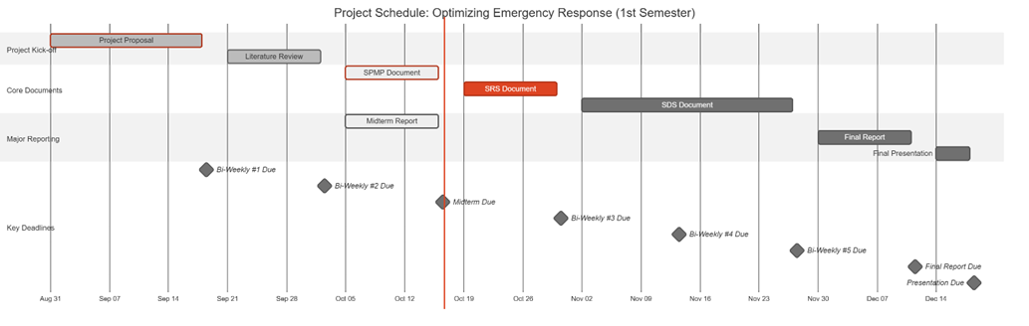
Figure 2: Gantt Chart: Project Schedule

3.3.3.3 Quality Control
The quality assurance will be ensured by the strict testing and following the standards defined. The main quality requirements are:
- Model Performance: The AI model should obtain a high accuracy, precision and recall on a special test set.
- System Performance: The video streams should be processed by the system with low latency to achieve real-time processing.
- Code Quality: The code will be version-controlled, documented, and peer-reviewed.

3.3.3.4 Reporting
The team and the supervisor will maintain constant communication and transparency on the status of the projects through a well-organized reporting system.
- Team Meetings: Meeting will take place on a weekly basis with internal members to report progress and address any arising issues and to discuss future functions. There will be recording of minutes, which will be distributed among the members.
- Bi-Weekly Reports: As required by the course syllabus, formal progress reports will be presented to the supervisor after every two weeks where information on the work done, status and further plans of the next cycle will be given.
- Milestone Reports: This will include major deliverables that will be prepared and presented formally to be reviewed by the supervisor and the evaluation committee, including the Mid-Semester and Final reports. Such reports will give a detailed review of the project progress and success at the critical points.

3.3.3.5 Project Metrics
Quantifiable metrics will be used to track the performance of the project.
Metric | Description | Frequency
Schedule Variance | Measures the deviation from the planned schedule to identify delays early. | Weekly
Model Accuracy | Quantifies the model's detection performance (mAP, F1-Score). | Per Training Cycle
System Stability | Tracks the number of critical bugs identified and resolved during testing. | During Testing Phases
Table 11: Key Project Metrics

3.3.4 Risk Management Plan
There are possible risks in the project that are identified in this plan and proactive measures to capture the effect of these risks.
Risk ID | Risk Description | Probability | Mitigation Strategy | Impact
R1 | Data Scarcity/Poor Quality: Lack of sufficient or diverse accident footage for robust model training. | Moderate | Proactively aggregate data from multiple public sources; employ data augmentation techniques. | Quality, Schedule
R2 | Low Model Performance: The trained model fails to achieve the desired accuracy for reliable, real-world detection. | Moderate | Experiment with various state-of-the-art model architectures and conduct extensive hyperparameter tuning. | Quality
R3 | Insufficient Computing Power: Local hardware is inadequate for training the deep learning model efficiently. | High | Establish and test access to cloud GPU platforms (e.g., Google Colab Pro) as a primary or backup solution. | Budget, Schedule
R4 | Time-Consuming Annotation: Manual labeling of video frames takes longer than allocated in the schedule. | Moderate | Utilize efficient annotation tools (e.g., CVAT) and distribute the workload evenly among team members. | Schedule
Table 12: Risk Management Plan

3.3.5 Project Closeout Plan
The project closeout phase will be used to ensure that the project is professional and in an orderly manner ended.
- Final Verification: Making sure that all systems functions and requirements have been covered.
- Project Archiving: The project materials such as source code, trained models and documentation will be arranged and archived on GitHub.
- Final Reporting: It will produce a final report and user manual that has undergone a review and is submitted.
- Knowledge Transfer: The group will provide a final presentation and hold a session of lessons learned to document lessons learned that will be used in future projects.

3.4 Technical Process Plans
This section includes process models, methods, tools, and techniques. Moreover, it includes infrastructure and product acceptance.

3.4.1 Process Model
The Waterfall model was selected as the primary software development approach for this project, Optimizing Emergency Response, because of its structured, sequential, and documentation-oriented nature. Each phase produces a set of deliverables that serve as verified inputs to the next phase. Given that this project follows academic supervision, institutional milestones, and fixed submission deadlines, the Waterfall model ensures systematic progress and traceable quality control across all development stages.

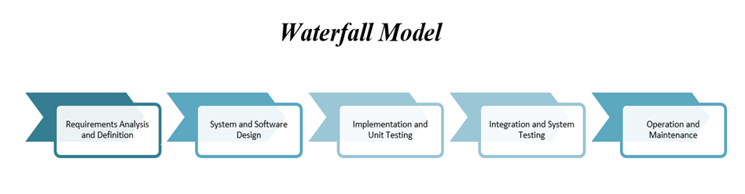
Figure 3: The Waterfall Model
Table 13 shows the waterfall phases, along with their Phase, Duration, Description, Main Activities, Deliverables and Outcomes.
Phase | Duration | Description | Main Activities | Deliverables / Outcomes
1. Requirements Analysis | Nov 1 – Nov 20 2025 | Identify, analyze, and document all functional and non-functional requirements for the system. | • Gather requirements from literature and emergency response protocols.• Define system functions (accident detection, alert generation, and reporting).• Specify hardware & software constraints, datasets, and ethical considerations. | • Software Requirements Specification (SRS).• Use-case and context diagrams.• Dataset description document.
2. System and Software Design | Nov 21 – Dec 10 2025 | Translate the requirements into detailed architecture and technical design. | • Design overall system architecture (camera feed → YOLOv8 model → alert module).• Define data flow and database structure.• Select frameworks and AI tools (TensorFlow 2.x, PyTorch, OpenCV). | • Software Design Specification (SDS).• Architecture and dataflow diagrams.• Database schema and interface design.
3. Implementation (Coding) | Dec 11 – Jan 10 2026 | Convert the design into executable modules and integrate the core AI model. | • Develop and train YOLOv8 and CNN models on labeled datasets.• Implement real-time accident detection and alert system in Python.• Develop API and dashboard interface for emergency notifications.• Use GitHub for version control and continuous testing. | • Trained AI models.• Source code repository.• Integrated prototype with detection and alert modules.
4. Testing and Verification | Jan 11 – Jan 25 2026 | Validate that the system meets specified requirements and performance targets. | • Conduct unit testing for each module.• Perform integration and system testing.• Evaluate accuracy (Precision, Recall, F1-Score).• Simulate accident scenarios for response time testing. | • Software Testing Plan (STP).• Test reports and performance metrics.• Validated system ready for deployment.
5. Deployment and Integration | Jan 26 – Feb 5 2026 | Deploy the validated system for demonstration and evaluation. | • Deploy system on cloud platform (Google Colab or AWS EC2).• Integrate real-time video feed for testing.• Prepare user manual and presentation materials. | • Operational prototype demonstration.• Deployment report.• User manual and demo video.
6. Maintenance and Enhancement | Feb 6 – Feb 20 2026 | Conduct system review, bug fixes, and enhancements based on feedback. | • Resolve issues from testing and presentation reviews.• Optimize model parameters and update dataset.• Document lessons learned and future improvements. | • Updated system version.• Maintenance log.• Final project closure report.
Table 13:The Waterfall Phases

3.4.2 Methods, Tools, and Techniques
This section describes the software development methods, tools, and techniques utilized throughout the project Optimizing Emergency Response. The project integrates Artificial Intelligence, computer vision, and web technologies to detect car accidents in real time using live surveillance footage. The adopted methods focus on ensuring high detection accuracy, efficient model performance, and seamless communication with emergency services. The tools and frameworks were selected based on their reliability, open-source support, and suitability for AI-based computer vision applications.

Category | Tool / Framework | Purpose / Description
Development Environment | Python 3.10 | Primary programming language for system development, AI modeling, and automation.
AI & Deep Learning Frameworks | YOLOv8 (Ultralytics) | Used for real-time object and accident detection in traffic footage. Offers state-of-the-art accuracy and fast inference speed.
 | TensorFlow 2.x / PyTorch | For training and fine-tuning Convolutional Neural Network (CNN) models and integrating YOLOv8 models.
Computer Vision Library | OpenCV | Used for video stream handling, frame extraction, and pre-processing of camera footage.
Data Labeling and Preparation | LabelImg / Roboflow | Tools for annotating accident datasets and managing dataset versions for model training.
Database Management | MySQL / SQLite | Used to store incident records, alert logs, and user information.
Backend Framework | Flask (Python) | Lightweight web framework used to handle the system’s API for alert generation and response communication.
Frontend Development | HTML, CSS, JavaScript (React optional) | Used to design the monitoring dashboard for displaying live detection and alerts.
Version Control | Git & GitHub | For collaborative source code management, version control, and tracking development progress.
Testing Tools | PyTest / Unittest | Used for unit and integration testing of modules to ensure system stability and correctness.
Deployment Platform | Google Colab / AWS EC2 | Used for model training, testing, and hosting the prototype in a cloud environment.
Project Management & Documentation | Microsoft Word / Excel / Trello | Used for documentation, scheduling tasks, and progress tracking throughout the development cycle.
Table 14: Used Tools

3.4.3 Infrastructure
This section outlines the hardware and software infrastructure used in each development phase of the Optimizing Emergency Response project. The infrastructure was selected to support deep learning model training, real-time video processing, and deployment of the system prototype. Each phase of the Waterfall model relies on specific tools and environments to ensure efficiency, accuracy, and scalability.

Project Phase | Tools / Infrastructure Used
Requirements Analysis | Microsoft Word, Excel, Trello, Google Drive
System and Software Design | Draw.io, Lucidchart, Visual Paradigm, MySQL Workbench
Implementation (Coding) | Python 3.10, TensorFlow 2.x, PyTorch, YOLOv8, OpenCV, Flask
Testing and Verification | PyTest, Unittest, Jupyter Notebook, Confusion Matrix Metrics
Deployment and Integration | Google Colab, AWS EC2, GitHub, Flask Server
Maintenance and Enhancement | GitHub Issues Tracker, Google Colab, MySQL, Documentation Tools
Table 15: The Essential Requirements

3.4.4 Product Acceptance
This section defines the criteria and procedures that will be followed to ensure the Optimizing Emergency Response system meets its intended objectives and quality standards before final submission and deployment. Product acceptance is based on verifying that all functional and non-functional requirements are satisfied, that the system performs reliably in real-time environments, and that it operates according to its design specifications.

3.5 Supporting Process Plans
This section outlines the documentation standards, responsibilities, and review procedures followed throughout the Optimizing Emergency Response project. All project documents are prepared in accordance with the relevant IEEE standards and university-provided templates to ensure consistency, accuracy, and traceability across all development phases. Each document is collaboratively prepared by the project team and reviewed under the supervision of Dr. Aftab, ensuring that all deliverables meet academic and professional quality standards before submission.

Document Type | Format Standard | Prepare Document | Review Document
Introduction and Literature Review | Provided by the supervisor | All team members | Project Supervisor: Dr. Aftab
Mid-Semester Report | Provided by the supervisor | All team members | Project Supervisor: Dr. Aftab
Software Project Management Plan (SPMP) | IEEE Standard 1058-1998 | All team members | Project Supervisor: Dr. Aftab
Software Requirements Specification (SRS) | IEEE Standard 1058-1998 | All team members | Project Supervisor: Dr. Aftab
Methodology | Provided by the supervisor | All team members | Project Supervisor: Dr. Aftab
Software Design Specification (SDS) | IEEE Standard 1058-1998 | All team members | Project Supervisor: Dr. Aftab
First Semester Final Report | Provided by the supervisor | All team members | Project Supervisor: Dr. Aftab
Software Test Plan | IEEE Standard 1058-1998 | All team members | Project Supervisor: Dr. Aftab
User Manual | IEEE Standard 1058-1998 | All team members | Project Supervisor: Dr. Aftab
Senior Project Source Code and Report | Provided by the supervisor | All team members | Project Supervisor: Dr. Aftab
Table 16: Supporting Process Plans

3.6 Additional Plans
This section describes the supporting considerations for data handling, documentation, system operation, and compliance with ethical and legal standards. These plans help ensure the project is properly organized, secure, and adaptable to different use contexts.

3.6.1 Data Privacy and Security
All datasets used in this project are publicly available and pre-annotated. No personal information is collected or stored. Data processing is performed locally to maintain security and control. Appropriate care will be taken to ensure data is used responsibly and handled according to standard academic and institutional guidelines.

3.6.2 Documentation and User Operation
A structured set of instructions will accompany the system, detailing the environment setup, model execution steps, and how to view and interpret results. This documentation ensures that the system can be operated consistently and understood clearly by authorized users.

3.6.3 Maintenance and Updates
The project resources, including the source code and model files, are organized to support proper tracking and structured management. This organization facilitates adjustments or technical refinements when necessary, without requiring major system changes.

3.6.4 Deployment Considerations
The system is developed to operate on standard computing environments. Its structure allows it to be integrated with external components or operational setups as needed. The design emphasizes modularity, making it easier to adapt the system to different configurations or extend its functionality when required.

3.6.5 Ethical and Legal Considerations
The system complies with ethical standards by avoiding the use of any personal data and ensuring responsible handling of input sources. In all cases, data usage and system operation are expected to align with relevant legal and regulatory frameworks concerning surveillance and information security.

Chapter 4: Software Requirements Specification (SRS)

4.1 Introduction
This Software Requirements Specification (SRS) document describes the requirements for the project Harnessing Deep Learning to Optimize Emergency Response. It defines the overall purpose, features, and behavior of the system, along with its expected performance and interaction with users. The document serves as a guide for the project team, supervisor, and evaluators, ensuring that all members share a clear understanding of what the system will do and how it will operate.

4.1.1 Purpose
The purpose of this Software Requirements Specification (SRS) is to clearly define and document the functional and non-functional requirements of the proposed system. It provides a foundation for design, development, and testing, ensuring that the system aligns with its intended goals of accuracy, reliability, and usability. This document also facilitates communication by establishing a shared understanding of the system’s objectives, scope, and constraints.

4.1.2 Scope
This project has in its goal the designer, tester, and implementation of a real-time emergency response optimization system which utilizes deep learning for the detection of accidents. It takes in real-time video streams from traffic cameras and uses YOLO and CNN algorithms to recognize car crashes. Then, it initiates the alert procedure for the emergency responders (police, ambulance, fire services) automatically. By covering the whole process from detection to alert creation, the system supports live deployment all day, every day aiming at cutting down emergency response time and enhancing road safety.

4.1.3 Definitions, Acronyms, and Abbreviations
- Definitions
  - Accident Detection: the entire procedure of letting machines see and learn to detect accidents through the application of state-of-the-art technology in vision processing and deep learning is carried out using video clips in real time monitoring.
  - Alert Generation: immediately after the accident is detected, the alerts are generated and sent to the emergency response services.
  - Deep Learning: the area of machine learning that relies on extremely complex and layered neural networks to identify very subtle patterns among the colossal amount of data.
  - Real-time Processing: it is a video processing performance that recognizes accidents at a maximum duration of 2 seconds (the target is to make the delay shorter than 2 seconds).
  - Model Training: the process of teaching a neural network to recognize accident detection patterns through a dataset that has labeled training examples.

4.1.4 References
- IEEE Std 1058-1998, IEEE Standard for Software Project Management Plans, Institute of Electrical and Electronics Engineers, 1998
- IEEE Std 830-1998, IEEE Recommended Practice for Software Requirements Specifications, Institute of Electrical and Electronics Engineers, 1998
- IEEE Std 1016-1998, IEEE Recommended Practice for Software Design Descriptions, Institute of Electrical and Electronics Engineers, 1998
- ARTI 511 Course Syllabus, Term 1 2025-2026, Imam Abdulrahman Bin Faisal University, College of Computer Science & IT
- Ultralytics YOLOv8 Documentation, Available at https://docs.ultralytics.com, accessed October 2025
- TensorFlow Documentation, TensorFlow Core v2.20, Available at https://www.tensorflow.org
- PyTorch Documentation, PyTorch v2.90, Available at https://pytorch.org/docs
- OpenCV Documentation, OpenCV 4.12.0, Available at https://docs.opencv.org

4.2 Overall description
The product is a smart software system, which uses artificial intelligence and computer vision to track live video feeds and identify road incidents automatically. It runs live camera feeds through trained models to detect and categorize accidents, retains temporary footage to verify them, and directly transmits the relevant emergency response agencies including police, ambulance, and fire departments. It is an autonomous system as well as it does not require any direct interaction with the user and is instead used as a background monitoring system to assist emergency teams by providing proper, reliable and timely alerts. It may be used as a standalone solution, or work with the current city or agency infrastructure, guaranteeing that it will operate continuously under the different environmental and network parameters. The main aspects will be privacy, data processing, and reliability of the work, ensuring that the entire visual information is processed safely and the system does not drop even when the quality of input or connection is impaired.

4.2.1 Product perspective
The software is mainly a stand-alone program which may also have an integration as a part of a larger emergency management or smart city program. It independently observes live video streams, identifies an incident on the road, and is automatically able to dispatch structured messages to the emergency authorities, including police, ambulance, and fire services. The software can be integrated with the available dispatch or analytics platforms to share incident data and metadata of the camera to facilitate coordinated and prompt reactions. When used independently, it does the same monitoring and alerting functions on its own and has its own local database and communication interfaces.
Major Inputs and Outputs:
Inputs: Continuous live video streams from surveillance or traffic cameras, along with optional metadata such as camera identifiers and geographic coordinates.
Outputs: Automatically generated messages with event information, time and place of events, severity measurements, and graphical evidence, which are safely sent to assigned emergency response units or systems.

4.2.2 Product functions
The proposed system, Harnessing Deep Learning to Optimize Emergency Response, is designed to automatically detect and report car accidents using real-time video analysis powered by deep learning and computer vision. Its main functions work together to minimize human error and reduce emergency response time.

1. Real-Time Video Monitoring
- The system continuously receives live video streams from surveillance and traffic cameras placed across urban roads and intersections.
- Video feeds are processed in real time to ensure that the system can immediately analyze ongoing traffic events.
- A video buffering mechanism maintains short-term footage storage for immediate review or evidence collection.
2. Accident Detection Using Deep Learning
- The system uses AI models such as YOLO and Convolutional Neural Networks (CNNs) to detect accidents within video frames.
- Upon detection, the system validates the event to minimize false alarms, ensuring high accuracy and reliability.
3. Accident Classification and Severity Assessment
- After identifying an incident, the system classifies it by severity level (e.g., minor, moderate, or major crash) based on visual cues such as collision intensity, number of vehicles, and fire or debris presence.
- Severity classification helps emergency control centers allocate the right resources (ambulance, police, or fire services).
4. Automated Alert and Notification System
Once an accident is confirmed, the system automatically generates an alert that includes:
- Accident location (via GPS or mapped camera coordinates)
- Time and estimated severity
- Reference camera ID and a visual of the incident
The alert is then sent to relevant emergency units through mobile notification, or integration with emergency service platforms.
5. System Management and Monitoring Dashboard
Authorized users, such as emergency control staff, can access a centralized Emergency Response Dashboard.
The dashboard enables users to:
- View live camera feeds and add or remove connected Surveillance Nodes.
- Monitor real-time accident alerts and update linked Emergency Units (hospitals, fire departments, police stations).
- Review past incidents and generate analytics reports for performance and response tracking.
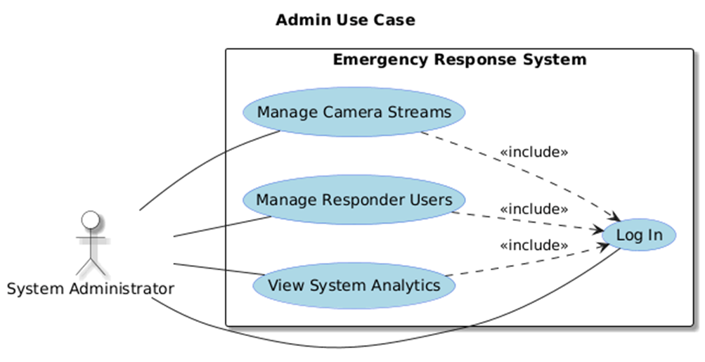
Figure 4: Admin Use Case

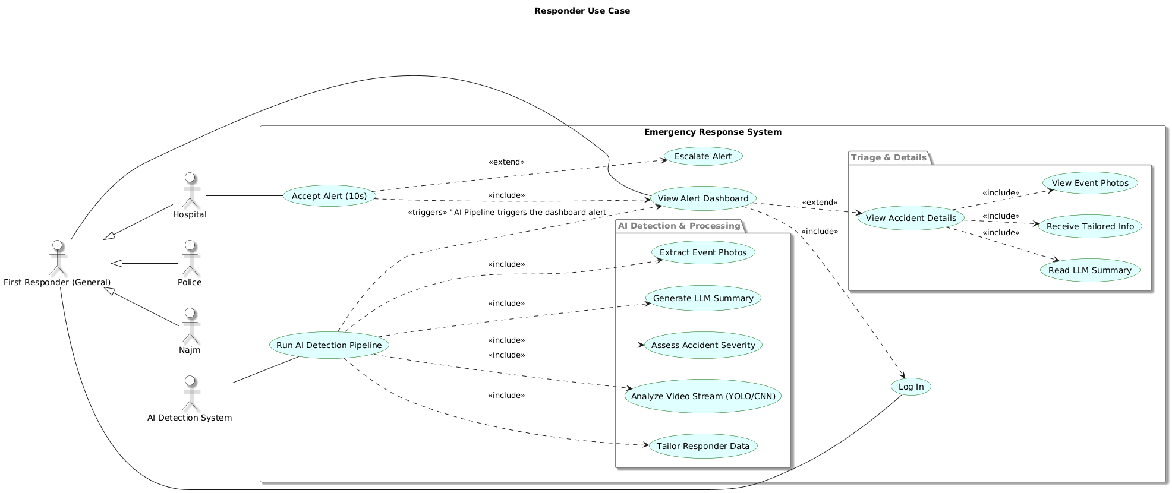
Figure 5: First Responders Use Case

4.3 Specific requirements
This section outlines the detailed functional and non-functional requirements of the Emergency Response Optimization System. It defines how the system will operate, including data input from surveillance cameras, real-time accident detection using deep learning models, alert generation, and communication with emergency units. The requirements specify user interactions, system performance, reliability, and security standards to ensure accurate detection, fast response, and seamless integration with existing smart city infrastructure.

4.3.1 External interface requirements
This section details the interfaces connecting the system to its users and other external components.

4.3.1.1 User interfaces
The system will provide a web-based graphical user interface (GUI) built using the React framework to ensure a responsive, modern, and high-performance user experience. The interface will be simple and intuitive, tailored to two primary user roles: System Administrator and First Responder User.

4.3.1.1.1 Common Interfaces

4.3.1.1.1.1 Login Interface
This is the secure entry point for all users.
Field | Format | Level | Input/Output | Comment
Username / Email | Text (Email format) | Required | Input | User's registered email address.
Password | Text (Masked) | Required | Input | User's secure password.
Login Button | Button | Required | Input | Submits credentials for authentication.
Forgot Password | Link | Optional | Input | Initiates password reset flow.
Error Message | Text (Red) | N/A | Output | Displays if authentication fails (e.g., "Invalid username or password").
Table 17: Login Interface

4.3.1.1.2 System Administrator Interfaces
Accessible after a user with "Admin" role logs in.

4.3.1.1.2.1 Admin Dashboard (Homepage)
Main navigation hub for the administrator.
Field | Format | Level | Input/Output | Comment
Header | Text | Required | Output | Displays "Administrator Dashboard" and logged-in user's name.
Navigation Menu | Links | Required | Input | Links to "Camera Management" and "User Management".
System Status | Text / Graphics | Required | Output | A summary view showing system health (e.g., "All systems operational").
Active Streams | Number | Required | Output | A count of currently active and processing video streams.
Logout Button | Button | Required | Input | Logs the administrator out of the system.
Table 18: Admin Dashboard Interface

4.3.1.1.2.2 Camera Management Interface
Allows the admin to add, view, and manage the city's camera streams ("Surveillance Nodes").
Field | Format | Level | Input/Output | Comment
Camera List | Table | Required | Output | Displays all registered cameras with their ID, Name, Stream URL, and Status (e.g., "Active", "Offline").
Add Camera Button | Button | Required | Input | Opens the "Add Camera" modal/form.
View Stream | Button | Optional | Input | Allows admin to view the live feed from the camera.
Edit/Delete | Buttons | Optional | Input | Allows editing or removing an existing camera from the list.
Camera ID (Form) | Text | Required | Input | A unique identifier for the camera (e.g., "CAM-001-KSA").
Camera Name (Form) | Text | Required | Input | A human-readable name (e.g., "King Fahd Rd @ Olaya St").
Stream URL (Form) | Text (URL) | Required | Input | The RTSP or HLS link for the live video feed.
Save Camera Button | Button | Required | Input | Saves the new camera to the system.
Table 19: Camera Management Interface

4.3.1.1.2.3 User Management Interface
Allows the admin to create, manage, and update "Emergency Units" (responder accounts).
Field | Format | Level | Input/Output | Comment
Agency List | Table | Required | Output | Displays all registered agencies (Hospital, Police, Najm) with their name, user email, and type.
Add Agency Button | Button | Required | Input | Opens the "Add Agency User" modal/form.
Agency Name (Form) | Text | Required | Input | e.g., "King Faisal Hospital ER" or "Najm - Riyadh".
User Email (Form) | Text (Email) | Required | Input | The login email for the new user account.
Agency Type (Form) | Dropdown | Required | Input | Options: "Hospital", "Police", "Civil Defense", "Najm".
Contact Number (Form) | Text (Phone) | Required | Input | Emergency contact number for alerts.
Save User Button | Button | Required | Input | Creates the new responder user account.
Edit/Delete | Buttons | Optional | Input | Allows editing or removing an existing agency account.
Table 20: User Management Interface
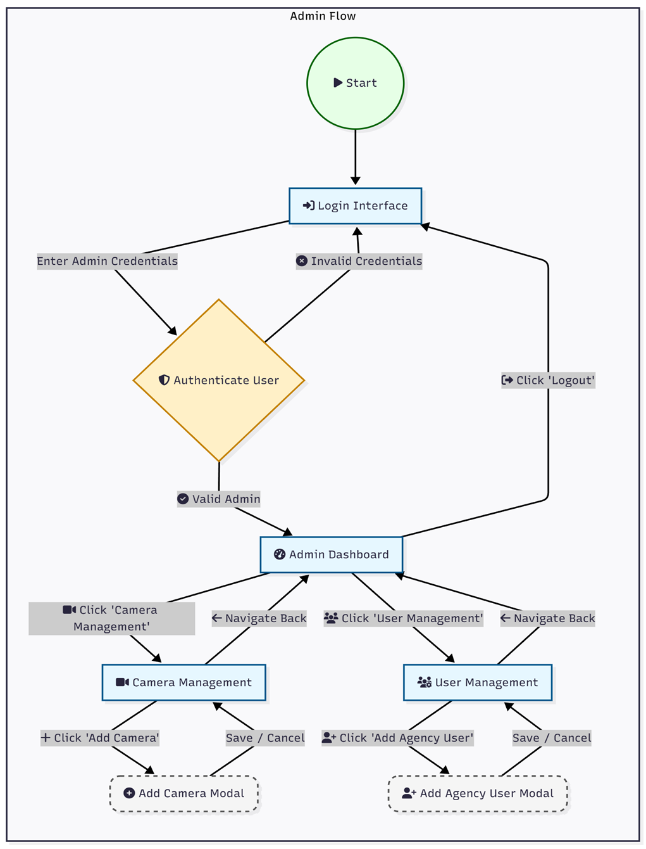
Figure 6: Admin workflow system

4.3.1.1.3 First Responder User Interfaces
Accessible after a user with a "Responder" role (e.g., Hospital, Police, Najm) logs in.
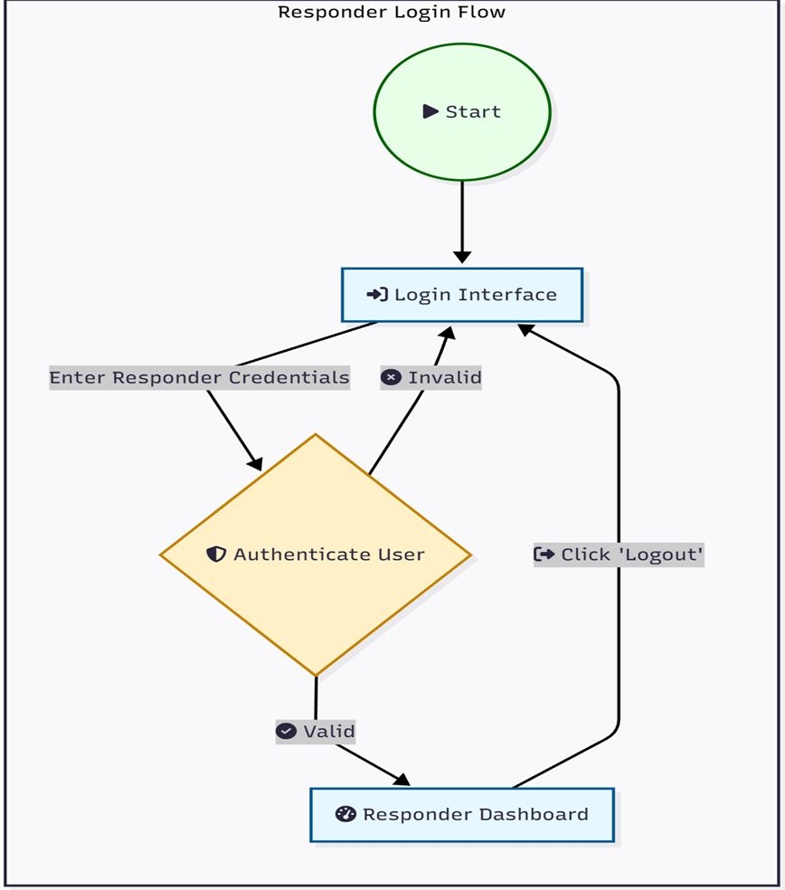
Figure 7: The Responders Login Flow

4.3.1.1.3.1 Responder Dashboard (Homepage)
Main dashboard for viewing and managing active accident alerts.
Field | Format | Level | Input/Output | Comment
Header | Text | Required | Output | Displays agency name (e.g., "King Faisal Hospital ER") and logged-in user.
Alerts List | List / Table | Required | Output | A list of active alerts, sorted by time (newest first). Each item shows location, time, and status (e.g., "New", "Accepted").
Alerts Map | Interactive Map | Required | Output | A map (e.g., OpenStreetMap) showing pins for all active accident locations.
Logout Button | Button | Required | Input | Logs the responder out.
Table 21: Responder Dashboard Interface

4.3.1.1.3.2 Accident Alert Interface (Modal)
This is the immediate notification that appears on the Responder Dashboard.
Field | Format | Level | Input/Output | Comment
Alert Title | Text | Required | Output | "!! NEW ACCIDENT DETECTED !!"
Location | Text | Required | Output | Address or GPS coordinates of the accident.
Time | Timestamp | Required | Output | Time of detection.
Accept Button | Button | Required (for Hospitals) | Input | Responder clicks to accept the case. after 10 seconds if not clicked/responeded, it will send to the second nearest hospital.
View Details | Button | Required | Input | Navigates to the full Accident Details Interface.
Timer | Countdown | Required (for Hospitals) | Output | A visual 10-second countdown timer.
Table 22: Accident Alert Interface

4.3.1.1.3.3 Accident Details Interface
This page provides the full, LLM-generated summary of the accident event.
Field | Format | Level | Input/Output | Comment
Case ID | Text | Required | Output | Unique identifier for the accident.
Location | Text & Map | Required | Output | Static map and text address.
Time of Incident | Timestamp | Required | Output | The time the accident was detected.
Accident Photos | Image Gallery | Required | Output | Key-frame snapshots captured by the AI.
Event Summary (LLM) | Text Block | Required | Output | A natural language summary of what happened (e.g., "A blue sedan collided with a white truck...").
Agency-Specific Info (LLM) | Text Block | Required | Output | This section is tailored.  - Hospital: "Estimated Injuries: 3"  - Najm: "Fault Assessment: 70% Blue Sedan, 30% White Truck."  - Police: "Vehicles: 2. Traffic Impact: High."
Action Log | Text | Required | Output | A log of actions (e.g., "Alert sent to KFH 14:32:01", "Alert accepted by KFH 14:32:08").
Table 23: Accident Alert Interface
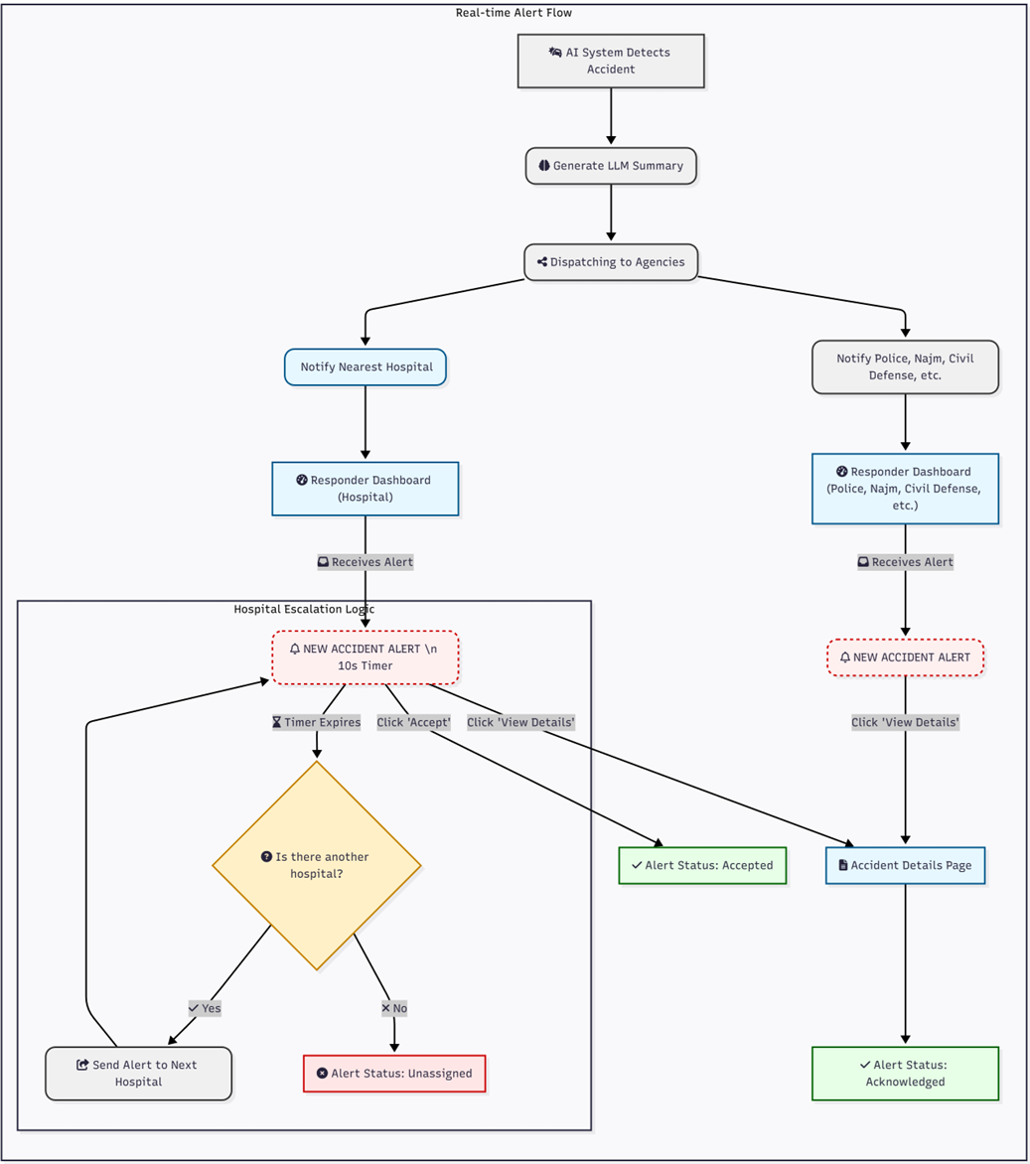
Figure 8: AI Alert System Flow

4.3.1.2 Hardware interfaces
- CCTV Cameras: The system will connect to IP-based surveillance cameras, to which it will purchase discoverable video streams (e.g. by RTSP or HLS).
- Application Server: The back end of the system is the system of AIs and a web server that will run on a high-performance server, which usually has between one and more GPUs to able deep learning inference.
- User Devices: The web-based user interface is going to be available on the normal desktop computers (e.g. dispatch centers) and also on the handheld devices (i.e. field responders) using modern web browsers.

4.3.1.3 Software interfaces
- AI Backend: The AI models (TensorFlow or PyTorch) will be serving out of a Python-based backend, based on frameworks like Flask or FastAPI, to the business logic of the system.
- Web Frontend: The client-side part will be a one-page application programmed in JavaScript, namely, in the React framework.
- Database: Data on users, camera metadata and logs of incident events will be stored in a relational database (or postgreSQL) or a non-relational database (or mongoDB).
- LLM API: The system will be calling upon external application programming interfaces to a big language model, like the Gemini API of Google, to produce brief summaries of accidents.
- Mapping API: The system will connect to a cartographic web service ( e.g., OpenStreetMap or the Google Maps API) to map spatially incident locations.
- Notification API: The system will be connected to a third-party telephony or short messaging service, like Twilio, in order to send emergency call alerts to responding agencies.

4.3.1.4 Communication interfaces
- HTTPS: The entire traffic between the users and the webserver will be encrypted using the HTTPS protocol.
- RTSP/HLS: The system will use the Real Time Streaming Protocol (RTSP) or the HTTP Live Streaming (HLS) to feed on the video feeds of cameras.
- WebSockets: To ensure the delivery of real-time alerts to the Responder Dashboard, the server will use a persistent WebSocket connection to dispatch the informatio.
- REST API: The Python backend will be connected to the React-based frontend through a secure RESTful API to exchange all the ancillary data transactions (e.g., authentication, the retrieval of inventories of the cameras).

Chapter 5: Software Design Specification (SDS)

5.1 Introduction
This Software Design Specification (SDS) details the architecture and organization of the "Harnessing Deep Learning to Optimize Emergency Response" system. It defines the architectural decisions, subsystems, interfaces, and data structures necessary to implement real-time video processing, deep learning accident detection, and automated emergency alert generation, serving as the essential blueprint for developers.

5.1.1 Purpose
The purpose of this SDS is to describe the complete design blueprint of the Real-Time Accident Detection and Emergency Alert System, outlining the system architecture, major components, data design, interfaces, and operational workflows. This document translates the functional and non-functional requirements defined in the SRS into detailed design elements that guide development, integration, and testing. It provides a shared technical reference for developers, testers and supervisors to ensure consistent understanding of how the system processes CCTV video streams, detects accidents using deep learning models, and dispatches alerts with minimal latency. This SDS forms the foundation for implementation and future system verification activities.

5.1.2 Scope
The scope of this SDS covers the full design of the accident detection and emergency alerting system, including the video processing pipeline, deep learning inference modules, alert dispatch mechanisms, data structures, and interface definitions. It describes the system’s architecture, constraints, operational behavior, and component responsibilities required to support continuous real-time monitoring. While the SDS focuses solely on the design of the software, related details such as testing procedures, deployment plans, and management activities are addressed in separate project documents.

5.1.3 Definitions, Acronyms, and Abbreviations

- Definitions
  - Accident Detection: the entire procedure of letting machines see and learn to detect accidents through the application of state-of-the-art technology in vision processing and deep learning is carried out using video clips in real time monitoring.
  - Alert Generation: immediately after the accident is detected, the alerts are generated and sent to the emergency response services.
  - Real-time Processing: it is a video processing performance that recognizes accidents at a maximum duration of 2 seconds (the target is to make the delay shorter than 2 seconds).
  - Incident Log: A persistent, timestamped record of every detected and confirmed accident, stored in the database for historical review and system auditing.
  - User Authentication: The process of verifying a user's identity (Admin or Responder) before granting access to the system's dashboards and data.
  - Latency: The time delay measured from when an event occurs in the video stream to when the system reports the final alert.

5.1.4 References
- IEEE Std 1058-1998, IEEE Standard for Software Project Management Plans, Institute of Electrical and Electronics Engineers, 1998
- IEEE Std 830-1998, IEEE Recommended Practice for Software Requirements Specifications, Institute of Electrical and Electronics Engineers, 1998
- IEEE Std 1016-1998, IEEE Recommended Practice for Software Design Descriptions, Institute of Electrical and Electronics Engineers, 1998
- ARTI 511 Course Syllabus, Term 1 2025-2026, Imam Abdulrahman Bin Faisal University, College of Computer Science & IT
- Ultralytics YOLOv8 Documentation, Available at https://docs.ultralytics.com, accessed October 2025
- TensorFlow Documentation, TensorFlow Core v2.20, Available at https://www.tensorflow.org
- PyTorch Documentation, PyTorch v2.90, Available at https://pytorch.org/docs
- OpenCV Documentation, OpenCV 4.12.0, Available at https://docs.opencv.org

5.2 System overview
The Harnessing Deep Learning to Optimize Emergency Response system is an autonomous, real-time traffic monitoring solution designed to reduce accident response times in urban areas. The system functions as a continuous intelligence pipeline that monitors live video feeds from cameras, detects car crashes using deep learning models, assesses incident severity, and automatically generates tailored alerts for first responders. It operates primarily as a background service with a dedicated web interface for authorized personnel (Police, Hospital, Fire Services) to view and manage alerts in real time. The core design is built for high availability and low latency, aiming to confirm and dispatch an alert in the least possible time after an accident occurring on the video stream.

5.2.1 System Functionality
The system is designed to fulfill three primary roles:
- AI Detection System: The core intelligence, responsible for video ingestion, frame-by-frame analysis using the AI models (YOLOv8/CNN) and generating a structured incident report upon confirmation.
- Alerting and Communication Engine: The module responsible for taking the structured incident report, generating a natural language summary using a Large Language Model (LLM), determining the nearest relevant responder, and initiating the alert escalation.
- Presentation and Management Layer: serves as the user-facing component of the system, implemented as a responsive web application. It is the centralized hub for system configuration and real-time incident response, ensuring that all user interactions are secure and role specific.

5.2.2 User Functionality
The system operates with two primary user roles: Admin and Responder. The following section outlines the specific functionalities granted to each.

5.2.2.1 Common Functionalities
Both Admin and Responder users can log into the system to access their functionalities.
- Enable Secure Authentication (Sign In/Sign Out).
- Allow Password Reset/Retrieval.
- Allow users to Update Profile (change contact info, password).
- Receive system Notifications and alerts.

5.2.2.2 Admin Functionalities
The Admin has full control over system configuration, user access, and resource management.
- Manage user accounts (Add, edit, and delete users).
- Manage agency permissions and roles for external units (e.g., Police, Civil Defense, and Hospitals).
- Add and remove hospitals and other response agencies from the system contact list.
- Manage surveillance infrastructure (Add, remove, and monitor cameras).
- Review and Export the System Audit Log.

5.2.2.3 First Responders Functionalities
The Responder manages real-time emergency incidents and coordinates response units.
- View Real-Time Alerts and Incidents (list and map view).
- Accept incoming alerts and initiate the response process.
- View detailed Accident Details (location, time, severity).
- Log all actions taken during incident response.
- View and Create New Incident Reports.
- Generate PDF reports for individual cases

5.3 Design Considerations
This section outlines the key issues, constraints, assumptions, and external factors that influence the system architecture and design decisions. Understanding these considerations ensures that the proposed design is realistic, maintainable, and compatible with the operational environment.

5.3.1 Assumptions and Dependencies
The design of the system is based on several assumptions and external dependencies that may affect its functionality or performance. These must be acknowledged to ensure consistency in implementation and deployment.

5.3.1.1 Related Software or Hardware
The system depends on the presence and performance of the following hardware and software components:
- The system requires working traffic or surveillance cameras providing stable, continuous video streams with adequate resolution and coverage for accurate accident detection.
- Processing hardware, either on a server or local machine, equipped with GPUs for deep learning tasks. Cloud-based GPU platforms can be used for training and inference if local resources are inadequate.
- Software Dependencies:
  - Python
  - Deep learning frameworks (TensorFlow / PyTorch)
  - OpenCV for video handling
  - Flask / Django for backend APIs
  - YOLOv8 model and necessary libraries
  - CVAT/LabelImg for dataset annotation

5.3.1.2 Network, Connectivity, and Streaming
- The system assumes stable network connectivity to continuously receive CCTV video streams without interruptions.
- Adequate bandwidth is required to handle real-time feeds from all connected cameras.
- Video streams should maintain a consistent frame rate (15–30 FPS) and resolution (720p or higher) for accurate detection.
- Low network latency is required to ensure real-time accident detection and timely alert generation.

5.3.1.3 Dataset Availability and Quality
- The system assumes access to publicly available accident and non-accident video datasets suitable for training and evaluating the deep learning models.
- It depends on accurate and consistent manual annotations (bounding boxes, accident labels) to ensure proper model learning.
- Training data is assumed to include sufficient variability in lighting, weather, camera angles, and traffic conditions to generalize well to real CCTV environments.
- The quality and resolution of dataset videos are assumed to be adequate for object detection models such as YOLOv8 (e.g., 720p or higher).
- Model performance is limited by the diversity and realism of the datasets, rare accident types may be underrepresented.

5.3.1.4 End-User Characteristics
The system will serve two main user groups assuming that they are familiar with basic computer systems and emergency response workflows:
1. Emergency Responders
- Require real-time, accurate alerts with minimal interface complexity.
- Typically non-technical users who rely on clear visuals and actionable information.
- Expect alerts containing time, location, severity, and detection confidence.
2. System Administrators
- Responsible for managing camera inputs, system updates, logs, and performance monitoring.
- More technically proficient (IT staff or trained operators).
- Require dashboard access to models, logs, camera settings, and alert statistics.

5.3.1.5 Possible And/Or Probable Changes in Functionalities
- Integration with Real CCTV Networks:
Currently, training uses public datasets. In the future, integration with live municipal camera networks may require changes to ingestion modules.
- Scalability Requirements:
The design may need to accommodate:
  - More cameras
  - Higher traffic density
  - Multiple processing nodes
- Deployment Changes:
Early versions may run locally, final versions may require:
  - Edge devices for real-time inference
  - Cloud-based distributed processing
- Model Updating:
Improvements in AI models may trigger migration to more efficient architectures.

5.3.2 General Constraints
The following inherent limitations have a great influence on software design and the consequent impact on the architectural and implementation options.

5.3.2.1 Hardware / Environment
- Constraint: Deployment involves the use of common computing nodes that have real-time video processing (edge devices or small servers).
- Impact: Model and pipeline optimization (frame sampling, model compression/quantization) in such a way that the system can meet low inference latency and fixed throughput on a limited hardware.

5.3.2.2 Software Stack & Libraries
- Constraint: System depends on Python 3.x and key libraries (OpenCV, PyTorch or TensorFlow for training, TensorRT for edge inference).
- Impact: Fix compatible library versions and provide reproducible environments to prevent conflicts during development and deployment.

5.3.2.3 Network & Camera Protocols
- Constraint: Live video is fed by CCTV/traffic video cameras using RTSP, nets may be limited by bandwidth or behind a NAT.
- Impact: Implement adaptive streaming, local buffering, and connection-resilient logic to maintain service despite variable network conditions.

5.3.2.4 Video Sources & Robustness
- Constraint: Video sources are heterogeneous (different codes, resolutions, frame rates) and connections may be intermittent.
- Impact: Use adaptive frame sampling, resolution fallback, and reconnect strategies so detection quality degrades gracefully rather than failing outright.

5.3.2.5 Performance & Latency
- Constraint / Design goal: The system should be capable of real-time or near real-time detection of accidents with low end to end delay.
- Impact: This involves the employment of efficient model architectures, regulation of the per-camera processing load, the employment of asynchronous pipelines, and minimization of the needless UI updates to make the system responsive to different workloads.

5.3.2.6 Storage & Capacity
- Constraint: Limited local storage; video and logs grow rapidly.
- Impact: Enforce rolling logs, TTL-based object retention, and configurable upload/archival to central storage.

5.3.2.7 Interoperability & Interfaces
- Constraint: It needs to be an always-on integrated system with external systems (including traffic control APIs and SMS gateways, webhooks).
- Impact: specification of stable JSON schemas, authentication (api keys/ HMAC) and failing on delays / backoff behavior when making external calls.

5.3.2.8 Security & Privacy
- Constraint: Protected data and privacy regulations apply; system must secure PII and video material.
- Impact: Encrypt data at rest and in transit, implement RBAC, audit logging, and optional face‑masking/anonymization features.

5.3.2.9 Standards & Documentation
- Constraint: Deliverables should also be based on institutional and IEEE-style of documentation and traceability practices.
- Impact: Have versioned documents, requirements traceability matrix and SDD/TEST change control.

5.3.2.10 Verification & Validation
- Constraint: Acceptance must be proven to display accuracy, latency and combination tests with representative streams.
- Impact: Test evidence and metrics Staged testing (unit) to simulated streams to live pilot.

5.4 User Interface Design
This section outlines the user interfaces and their design principles, including example screens and a description of the main screen elements and their actions.

5.4.1 Overview of User Interface
The user interface of the system is a secure role-based web platform and is equipped to work in real time. Depending on the role assigned to the user, the user is allowed access to certain functionality which is verified at the login point. There are two primary perspectives:
- System Administrator: The perspective of the administrator is centered on the health and set up of the system. Their primary dashboard will display the high-level view of the key performance indicators (KPI) such as the state of the system, active cameras, and the quantity of active incidents. At this main hub, they will be able to go out to modules and make use of the core parts of the system. This contains a Camera Management area to view, add or delete surveillance feeds, and User Management area where accounts to various responder agencies can be controlled. A detailed Audit Log also allows the administrators to overview all the major activities performed in the system in terms of its security and responsibility.
- First Responder: The view of the responder is functional and incident oriented. They are designed based on their experience. The main dashboard is an Active Incidents map which shows the actual geographical placement of all the emergencies in real-time and supplemented by a list of the most recent ones. This perspective is updated by default when the AI identifies new events. On the Incident Report page, rescuers are able to view a history of all incidents, which can be filtered and viewed chronologically. The selection of a particular incident will lead to an Accident Details screen, where all important information, such as a map and computer-generated summaries, will track the response between the detection until the resolution.

5.4.2 Interface Design Rules
The interface design is driven by the fact that it is necessary to be clear and fast in high pressure conditions.
- Clarity and Readability: The interface is developed on dark-mode theme with high contrast to reduce eye strain, which is normal in 24/7 command center layout. The display of the information is done in a clear typeface and understandable icons.
- Role-Based Simplicity: Role-based access is strictly adhered to in the system. There is only a navigation sidebar that contains links that are specific to the role of the logged-in user. This eliminates distractions of administrative environments to responders and secures sensitive settings to the operating personnel.
- Visual Status Feedback: The system provides a visual representation of the status of some of the critical components. Cameras are also specifically marked as Online or Offline, and the incidents marked with their status (e.g. New, Acknowledged, Scene Cleared) so that one can get an immediate overview.
- Layout Consistency: Each of the screens has a similar layout: on the left there is the main navigation sidebar, on the header is the title of the page, and there is a main content area. This uniform design enables the user to learn their way around the various modules easily and in a predictable fashion.

5.4.3 Screen Images
This section provides graphical representations of the most important user interfaces (UI) of the system, its structure, components and behavior. Each visual is described with a short explanation of what the interface is and how the user interacts with the interface.

5.4.3.1 Login Interface
This is the secure entry point for all users. The interface is divided into two parts where the system branding and other important functionalities (Real-Time Detection, Multi-Agency Coordination) appears on the left, and the login form is situated on the right. To access it, users fill their email and password. Password retrieval and fast access links are provided depending on the user roles.
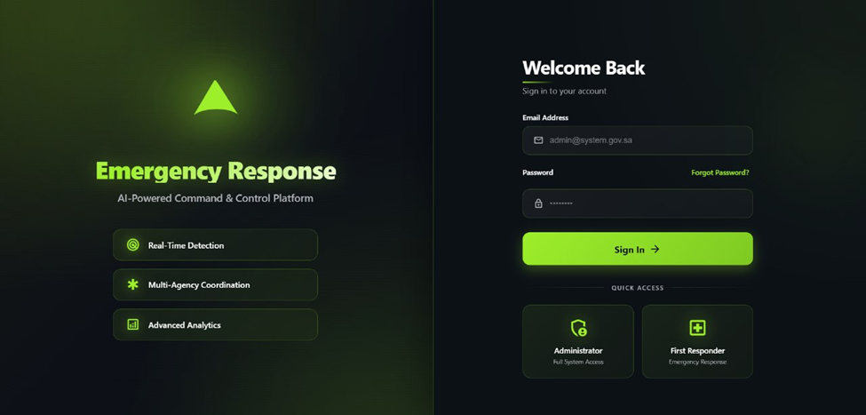
Figure 9: Secure emergency response login screen with system branding and role-based sign-in.

5.4.3.2 Reset Password Interface
It is a screen on which one can access a forgotten password. The user is requested to enter her registered email. It will then send by email, a reset link or verification code, to their email, to enable them to securely establish a new password.
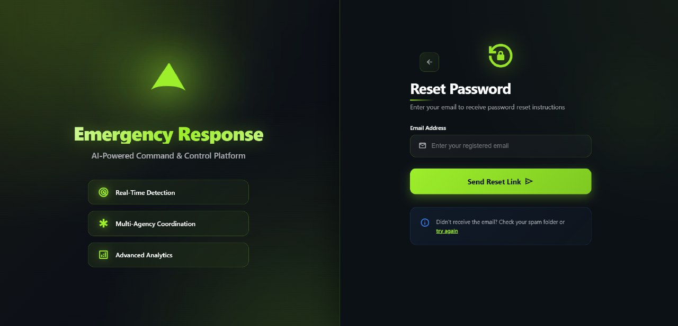
Figure 10: Reset Password Interface.

5.4.3.3 Administrator - Operational Dashboard
This is a landing page intended to be used by System Administrators and gives them a general report of the overall system health. It contains the main metric cards, which are the number of ongoing incidents, the number of active cameras, and the average response time.
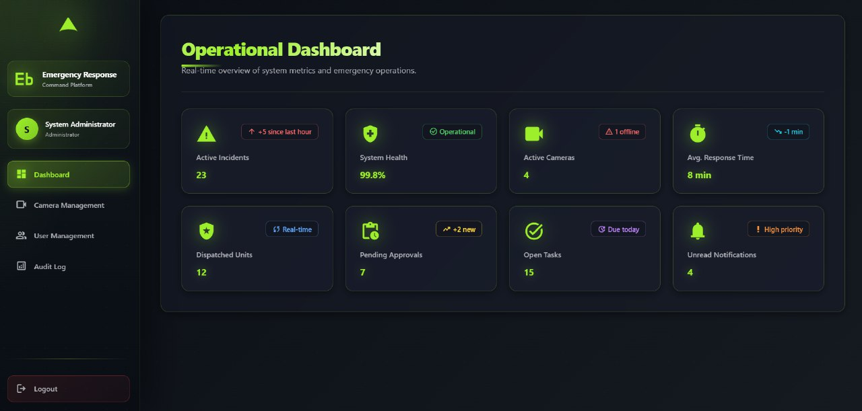
Figure 11: System Administrator Operational Dashboard.

5.4.3.4 Administrator - Camera Management
Through this screen, administrators can keep track of all the surveillance cameras attached and make all the necessary arrangements. It presents an outline of online, offline, and the total cameras. The main screen displays a grid of all registered cameras, each with their name, location and an obvious Online or Offline status badge. Via this page, administrators can add new cameras or update/delete those that are already in existence.
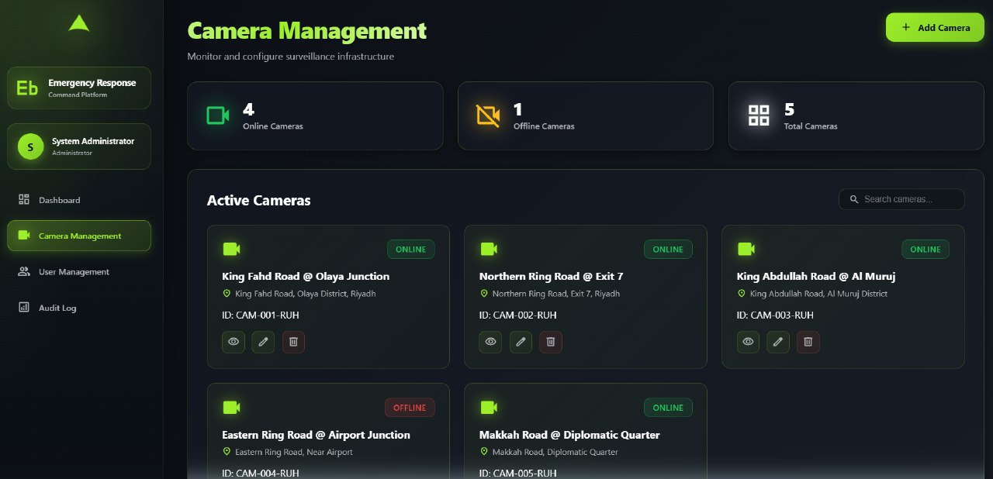
Figure 12: Camera Management Interface.

5.4.3.5 Administrator - User Management
The administrators use this interface to maintain the user accounts of all the external agencies. It gives a list of registered agencies (e.g. hospitals, police departments, civil defense) in a card format. The administrators have the capability to add new users to the agency or update and remove accounts to manage the system access.
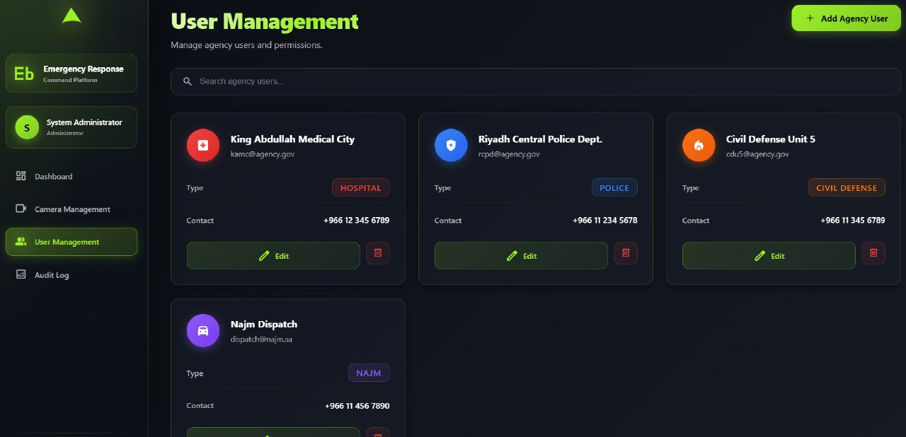
Figure 13: User Management Interface.

5.4.3.6 Administrator - System Audit Log
This screen provides a comprehensive, chronological record of system activities to ensure accountability and facilitate troubleshooting. The log captures all critical events, including user logins, camera additions / deletions or incident notifications, the user who performed the action, time and IP address. The log may be sorted by date, user or type of action.
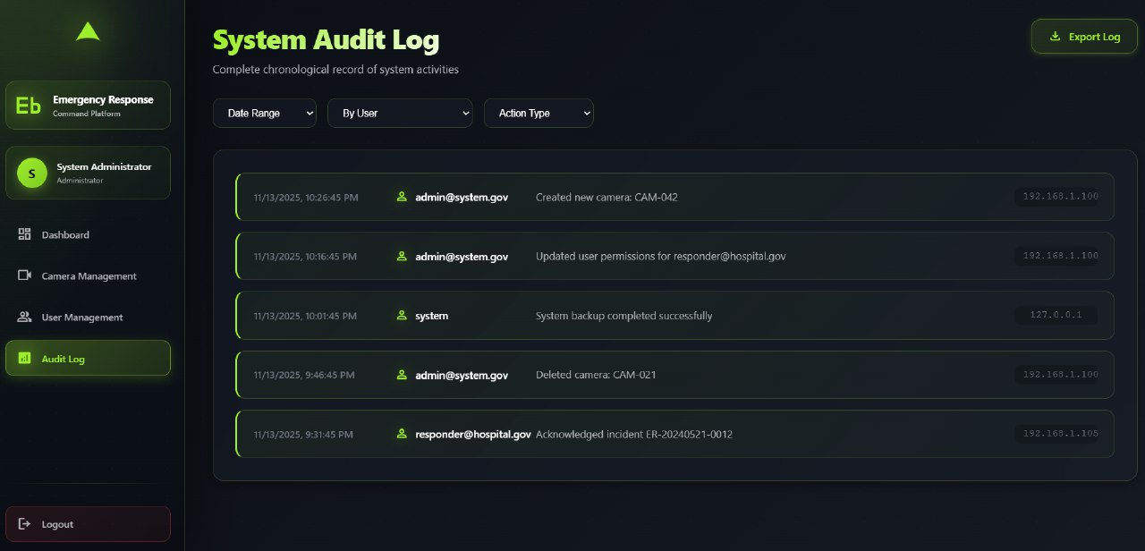
Figure 14: System Audit Log Interface.

5.4.3.7 First Responder - Active Incidents Dashboard
This is the main operational dashboard of First Responders. The interface is centered around an interactive map displaying the real-time locations of all active incidents, utilizing color-coded pins to indicate severity levels. On the left, there is a list of Recent Incidents that gives an overview of the new events when AI detects them.
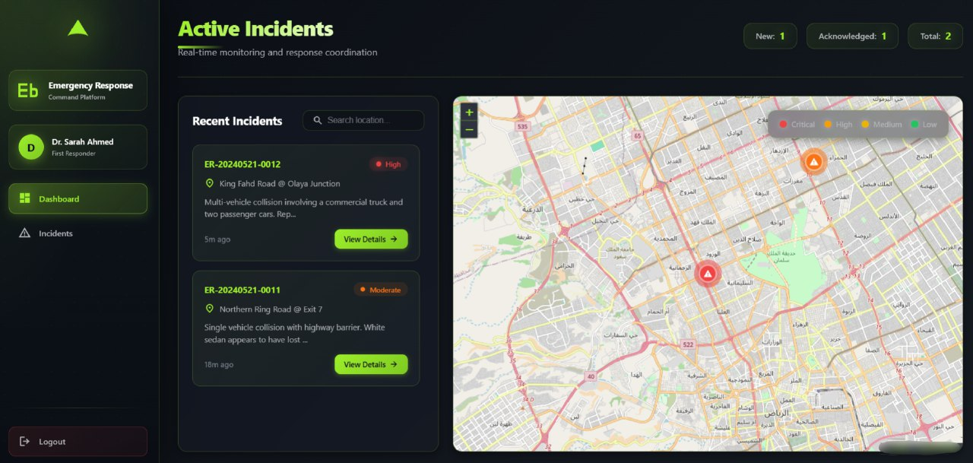
Figure 15: First Responder Active Incidents Dashboard.

5.4.3.8 First Responder - Incident Reports
This screen gives an historical view of all the past and ongoing incidences filterable. The responders are able to search according to the report ID or keyword and to filter according to the status (e.g., All, New, Acknowledged) or dates. The incidents are shown as cards that contain a summary, date and time with an option to open the full details.
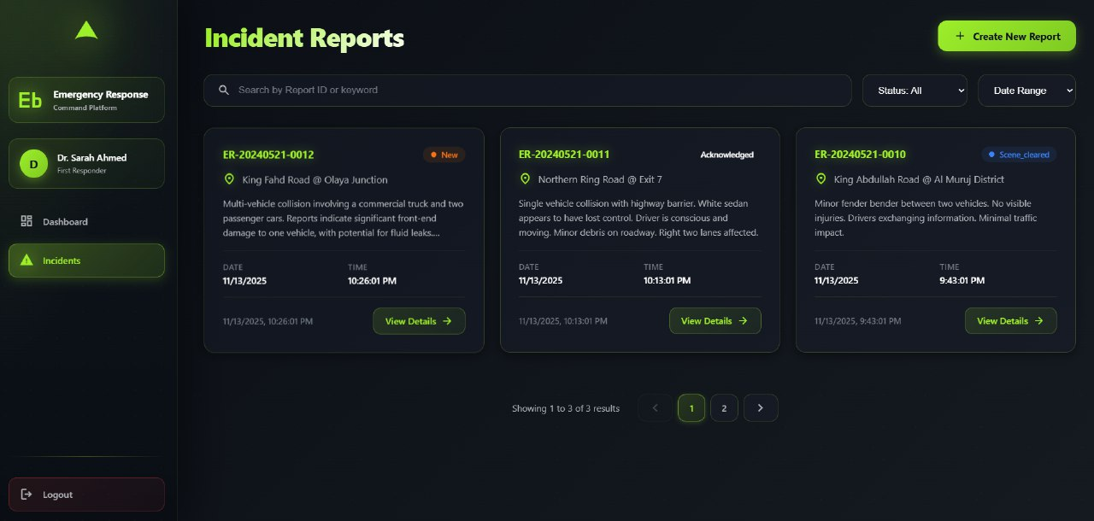
Figure 16: First Responder Incident Reports Interface.

5.4.3.9 First Responder - Accident Details
This is a screen that contains all the information on one incident that has been selected. It also includes a huge map of the specific location, the essentials of the incident (time, location text), and an eminent Action Log. It is a critical feedback mechanism; this log displays responders a live-updating timeline of everything that is happening.
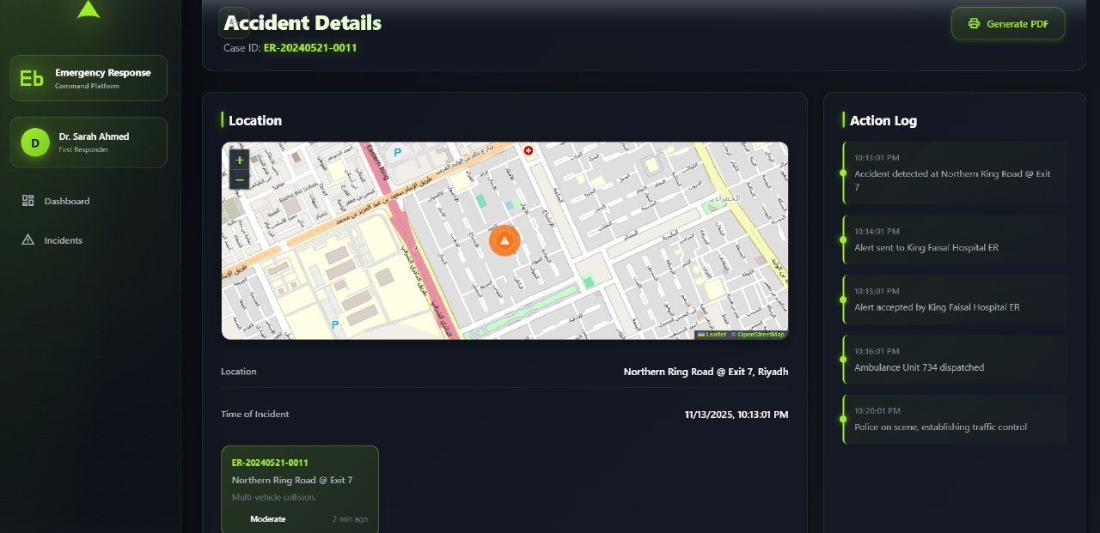
Figure 17: Accident Details Interface.

5.4.4 Screen Objects and Actions
In this section, the description of the common interface elements used in the system will be highly detailed, and the actions related to these elements will be described. In every screen, there are different interactive features, including buttons, links, icons and input fields, which allow users to navigate and interact with the system to its full capacity. The actions, type, and functionality of each element are described here to improve the interaction of the system as well as the usability.
Screen | Object Name | Object Type | Action / Description
Login | Email Address | Text Field | Allows the user to enter their registered email address.
 | Password | Text Field | Enables the user to type his or her secure password (input is masked). Strategy: This should be minimum 8 characters, minimum 1 number, and 1 special character.
 | Sign In | Button | Submits the entered credentials and attempts to log the user into the system. If this is the user's first login, redirect them to a 'Change Password' screen to enforce security.
 | Forgot Password? | Link | Navigates the user to the password recovery screen.
Reset Password | Back Arrow | Icon Button | Navigates the user back to the Login screen.
 | Email Address | Text Field | Allows the user to enter their email to receive a password reset link.
 | Send Reset Link | Button | Validates the email and starts the password recovery process.
Admin Dashboard | Navigation Sidebar | Link List | Main menu for admins to navigate between dashboard, camera, user, and log pages.
 | Metric Cards | Display | Read-only cards showing key system statistics such as active incidents and health.
Camera Mgt. | Add Camera | Button | Opens a form for the administrator to register a new camera feed.
 | Search cameras... | Search Field | Filters the camera list by name or ID as the admin types.
 | View (Eye Icon) | Icon Button | Opens a live video preview for the selected camera.
 | Edit (Pencil Icon) | Icon Button | Opens a form to modify the selected camera’s settings.
 | Delete (Trash Icon) | Icon Button | Removes the selected camera from the system after confirmation.
User Mgt. | Add Agency User | Button | Opens a form for the admin to create a new responder user account.
 | Search agency... | Search Field | Filters the list of agency users by name as the admin types.
 | Edit (on card) | Button | Opens a form to update the selected agency user’s account details.
 | Delete (Trash Icon) | Icon Button | Removes the selected agency user account after confirmation.
Audit Log | Filter Dropdowns | Dropdown | Filters log entries by criteria such as date, user, or action type.
 | Export Log | Button | Downloads the filtered log as a file (for example, PDF or CSV).
Responder | Navigation Sidebar | Link List | Main menu for responders to switch between Dashboard (map) and Incidents views.
Dashboard | Recent Incidents | List | Live-updating list of new alerts; selecting an item opens its details.
 | Incidents Map | Map | Displays pins for the locations of all active emergencies.
Incident Reports | Search by Report ID… | Search Field | Helps the responder find a specific incident by its report identifier.
 | Status / Date Range | Dropdown | Filters incidents by status and/or the date range in which they occurred.
 | View Details | Link | Navigates to the full details page for the selected incident.
Accident Details | Generate PDF | Button | Creates a downloadable PDF summarizing all information for the current incident.
 | Action Log | List | Read-only timeline of all recorded response steps (for example, alert sent/accepted).
Table 24: User Interface Controls and Interactions.

5.4.5 Other Interfaces

5.4.5.1 Video Stream Ingestion Interface
- Description: This interface takes the live video feeds of the IP-based surveillance cameras which form the main source of data in the system.
- Technology/Protocol: The system is intended to consume feeds provided by cameras with the help of standard streaming protocols like RTSP (Real-Time Streaming Protocol) or HLS (HTTP Live Streaming).
- Initiation/Closure: The server makes and provides a permanent connection to the stream URL of the camera. This connection will be closed in the event that the camera will be pulled out of the system, or the service is discontinued.
- Error Conditions: Failing and interrupting of a stream connection will be recorded and a visual indicator reflecting the error will be displayed in the Camera Management dashboard showing the camera as being offline.

5.4.5.2 Client-Server API (REST)
- Description: This interface covers the main request-response of the user web- browser (frontend) to the backend server. It is utilized in the majority of actions that are initiated by a user, e.g., the logging in, camera list retrieval, or historical incident reports.
- Technology/Protocol: A secure RESTful API operating over HTTPS.
- Message Format: The exchange of all data is done through the use of JSON. An HTTP request is sent by the client (browser), and a server replies to it with a response in the format of JSON.
- Error Conditions: In case the request is rejected because of an authentication mistake (e.g. an expired session), the user is redirected to the login screen. In case the server has an internal error, a message of failed to load data will appear on the UI.

5.4.5.3 Real-time Alert Interface (WebSocket)
- Description: This interface offers two-way, real-time and constant communication between the server and the client. It is also critical in pushing live information to the customer, including new accidents and live updates to the Action Log, without the user having to refresh the page.
- Technology/Protocol: WebSockets (WSS).
- Initiation/Closure: A WebSocket connection is initiated by the browser of the client, once the client has successfully logged in. This relationship is open until the user logs off or closes the browser tab.

5.4.5.4 External Third-Party Service Interfaces
- Description: This stipulates how the system is related to the different external third-party services that offer expert, non-core services.
- Technology/Protocol: All external services are accessed via secure HTTPS REST APIs.
- Services Used:
  - AI/LLM Service: Used to send incident data and receive the AI-generated natural-language summaries for accident reports.
  - Mapping Service: Used to fetch the map tiles and geocoding data required to display the maps on the dashboards.
  - Notification Service: Meant to send alerts (e.g. SMS) to agency contact numbers in case of failure.

5.5 System Architecture
The system architecture provides a high-level view of how the Smart Emergency Response and Monitoring System is organized and how its main functions are structured and connected. This section describes the major subsystems, their responsibilities, and the way they interact to deliver real-time accident detection, event management, and emergency response coordination. The goal of this architecture is to ensure a modular, scalable, and efficient design where each component performs a specific role while working together seamlessly to support the overall system functionality.

5.5.1 Architectural Design Approach
The architectural design of the System follows a modular, layered, and service-oriented approach to ensure scalability, maintainability, and reliable performance during emergency situations. The system integrates multiple data sources such as live camera feeds, emergency unit locations (hospitals, fire departments, police), and administrative interactions. therefore requiring a clear and logical partitioning of responsibilities across subsystems.
High-Level Design Philosophy:
The system architecture was structured using three guiding principles:
- Separation of Concerns: Each subsystem handles a distinct functional responsibility (e.g., video processing, emergency unit management, user dashboard). This prevents overlap and reduces system complexity.
- Distributed Responsibility: To support real-time performance, processing-intensive tasks (e.g., accident detection using AI models) are isolated in specialized modules that operate independently but communicate via defined interfaces.
- Scalability and Extensibility: The design supports future additions such as new camera locations, integrating new emergency departments, or improving AI models without affecting the entire system.

The system was decomposed into subsystems based on the nature of the tasks and data flow:
- Video/AI processing tasks are computationally heavy and best isolated to avoid affecting user dashboard performance.
- Emergency resource management (hospitals, fire departments, police units) requires a structured backend subsystem for CRUD operations and live status management.
- Dashboard visualization is user-facing and must remain responsive; therefore, UI components are separated from backend logic.
- Database operations are centralized to ensure data integrity and avoid duplication.
- Notification and alerting mechanisms require a dedicated module to manage timing, communication, and routing of alerts.

Alternative architectures such as monolithic structure were rejected because they would make the system harder to scale, harder to maintain, and prone to performance bottlenecks especially around real-time video analysis.
At the highest level, the system must support:
- Real-time video collection and processing
- Automatic accident detection using AI/ML techniques
- Storing and retrieving system data (cameras, emergencies, units)
- Managing emergency response units (hospitals, firefighters, police)
- Displaying a centralized monitoring dashboard
- Generating alerts and event logs

Collaboration of Higher-Level Components
The collaboration between these subsystems follows a pipeline-like workflow:
- Camera feeds: processed by the Video Processing Subsystem
- Detected accident: forwarded to Event Management Subsystem
- Event details: stored in Data Management Subsystem
- Affected units: retrieved via Emergency Units Subsystem
- Alert + details: pushed to Notification Subsystem
- Updated information: displayed on Dashboard Subsystem
This layered interaction ensures that no subsystem is overloaded and that responsibilities are clearly distributed.

5.5.2 Architectural Design
The system is divided into six main modules:
- User Interface & Dashboard Module
- Video Acquisition & Accident Detection Module
- Emergency Event Management Module
- Emergency Units Management Module
- Notification & Alerting Module
- Data Management & Storage Module
Each module is independent but interconnected to support real-time detection, reporting, and management of emergency events.

1. User Interface & Dashboard Module
Role: Displays live camera feeds, accident alerts, emergency units, analytics, and management controls.
Responsibilities:
- Fetch system data through backend APIs
- Visualize accident events in real-time
- Provide administrators with CRUD interfaces for cameras, hospitals, and departments
Collaboration:
- Retrieves processed results from Event Management
- Displays data stored in the Data Management subsystem

2. Video Acquisition & Accident Detection Module
Role: Processes live camera feeds and detects accidents using computer vision / machine learning.
Responsibilities:
- Connect to camera streams
- Run AI models
- Send detection results to the Emergency Event Management Module
Collaboration:
- As soon as an accident is detected, it notifies the Event Management module
- Logs critical frames into the database

3. Emergency Event Management Module
Role: Central controller of all accident-related events.
Responsibilities:
- Create and manage accident event objects
- Update event status (detected, verified, resolved)
- Coordinate with Notification and Units Management modules
Collaboration:
- Receive detection signals from the Accident Detection module
- Stores event details in the Data Management subsystem
- Send alerts to the Notification Module

4. Emergency Units Management Module
Role: Manages hospitals, fire departments, police units, and their statuses.
Responsibilities:
- Add, remove, or edit emergency unit details
- Maintain live availability status
- Provide nearest or available units to an event
Collaboration:
- Supplies Event Management with recommended response units
- Stores updated unit information in the database

5. Notification & Alerting Module
Role: Sends notifications to dashboard users and logs event updates.
Responsibilities:
- Issue alerts for new accidents
- Update users when event statuses change
- Integrate with future communication channels (SMS, email, etc.)
Collaboration:
- Triggers alerts based on data from Event Management
- Sends UI update signals to the Dashboard module

6. Data Management & Storage Module
Role: Provides centralized storage for all system data.
Responsibilities:
- Maintain camera data
- Store accident events, timestamps, severity
- Store emergency units information
- Provide APIs/repositories for all modules
Collaboration:
- Serves as the shared data layer for all modules
- Ensures data consistency and integrity

5.5.3 Subsystem Architecture
The system was decomposed into the selected subsystems to maximize modularity, reduce coupling, and isolate high-processing tasks such as video analysis into independent modules. Separating event orchestration from unit management ensures clearer responsibility boundaries and makes the system easier to scale and maintain. A dedicated notification subsystem improves reliability and avoids mixing alert logic inside business modules. A centralized data subsystem ensures consistency across all modules. Alternative designs such as a monolithic architecture were rejected due to performance, maintainability, and scalability limitations.
1. UI & Dashboard Subsystem
- Subcomponents:
  - UI Client (Browser / SPA) pages and components
  - UI API Gateway Proxy light server to route UI requests / SSE or WebSocket endpoints
  - Dashboard Renderer / Charts Module
  - Admin Management Pages (Cameras, Units)
- Responsibilities: render live feeds and event lists, allow CRUD for cameras/units, receive push updates.
- Exports/Interfaces: GET /api/events, GET /api/cameras, WS /ws/updates, POST /api/cameras, PUT /api/units/:id.

Internal Interaction Summary:
The UI Client sends all requests through the API Gateway Proxy, which forwards them to backend services. The Dashboard Renderer subscribes to WebSocket/SSE channels to display real-time accident updates. Admin Pages interact with the backend using CRUD APIs for cameras and units. All UI components rely on the shared data models retrieved from the Data Management subsystem.

2. Video Acquisition & Accident Detection Subsystem
- Subcomponents:
  - Stream Connector : connects to RTSP/HTTP camera endpoints
  - Frame Capture & Buffer frame extractor, keyframe storage
  - Preprocessing Pipeline resizing, normalization
  - Detection Engine ML model(s) (object detection, anomaly classifier)
  - Local Cache / Short-term Storage stores recent frames and detection metadata
  - Detector-to-Event Adapter formats detection into Event object and posts to Event Management
- Responsibilities: reliably ingest streams, run detection models in near real-time, forward detections.
- Exports/Interfaces: POST /events/detections (internal API), message queue topic detections.
Internal Interaction Summary:
The Stream Connector ingests live video streams and passes frames to the Frame Capture & Buffer module. Frames are preprocessed and forwarded to the Detection Engine, which runs the AI inference. Detection results are temporarily stored in the Local Cache and then converted to event-ready messages by the Detector-to-Event Adapter before being sent to the Event Management subsystem.

3. Emergency Event Management Subsystem
- Subcomponents:
  - Event Orchestrator creates/manages Event lifecycle (detected → verified → assigned → resolved)
  - Event Repository Adapter persists events via Data Management
  - Verification Service optional manual verification workflow (operator confirmation)
  - Assignment Engine selects candidate units (calls Units Management)
  - Event API layer APIs for CRUD and status updates
- Responsibilities: authoritative source for all event state, coordination with notification and units.
- Exports/Interfaces: POST /events, GET /events/:id, PUT /events/:id/status, publishes to events topic.
Internal Interaction Summary:
The Event Orchestrator manages the lifecycle of each event and interacts with the Verification Service when operator approval is required. The Assignment Engine retrieves available units from the Units Management subsystem and updates the event record via the Event Repository Adapter. The Event API exposes endpoints to the UI and publishes updates to the Notification subsystem.

4. Emergency Units Management Subsystem
- Subcomponents:
  - Units Repository CRUD for hospitals/fire stations/police units
  - Geolocation & Proximity Service compute nearest units to an event
  - Availability Tracker tracks unit status (available/assigned/offline)
  - Units API layer APIs for unit data and live status updates
- Responsibilities: maintain unit catalog and availability, respond to assignment queries.
- Exports/Interfaces: GET /units/nearby?lat=&lon=&radius=, PUT /units/:id/status.
Internal Interaction Summary:
The Units Repository stores all unit entities, while the Availability Tracker keeps status information updated. The Geolocation & Proximity Service computes the nearest units for an event. The Units API layer exposes this data to the Event Management subsystem to facilitate automatic or manual assignment.

5. Notification & Alerting Subsystem
- Subcomponents:
  - Alert Router decides recipients and channels
  - Push Notifier WebSocket/SSE to UI clients
  - External Notifier Adapter connectors for SMS/Email (future)
  - Notification Audit Log store sent-notifications
- Responsibilities: reliably deliver alerts and updates; retry/fallback logic.
- Exports/Interfaces: POST /notify/event/:id, WebSocket channel /ws/updates.
Internal Interaction Summary:
The Alert Router receives event updates and determines routing logic. The Push Notifier delivers these alerts to dashboard users via WebSocket/SSE channels. The External Notifier Adapter prepares optional SMS/Email notifications. All outgoing alerts are logged by the Notification Audit Log.

6. Data Management & Storage Subsystem
- Subcomponents:
  - Relational DB (Postgres) canonical event, unit, user tables
  - Object Store (S3) video clips, keyframes, logs
  - Repository Layer / DAOs typed access to storage
  - Analytics Cache / OLAP store (optional) aggregated metrics for dashboard
- Responsibilities: durable persistence, transactional integrity, efficient queries for UI and services.
- Exports/Interfaces: DB schema, repository APIs, migration scripts.
Internal Interaction Summary:
The Repository Layer provides structured access to the relational database. The Object Store manages large media (e.g., detected accident frames). Analytics Cache stores aggregated metrics for fast dashboard queries. All subsystems interact with this module through repository classes or direct queries exposed by the API layer.

Functional high-level Data Flow Diagram (DFD)
[Camera Streams] à (Video Acquisition & Detection)
(Video Acquisition & Detection) à detection messages à (Event Management)
(Event Management) ßà (Units Management)
(Event Management) à (Notification & Alerting) à (UI & Users)
(UI & Dashboard) ßà (Data Management & Storage)
(All subsystems read/write) à (Data Management & Storage)

Key data items:
- Camera metadata (id, location, RTSP URL)
- Detection payload (timestamp, camera_id, confidence, bbox, clip ref)
- Event record (id, severity, status, assigned_units, timestamps)
- Unit record (id, type, location, availability, contact)
- Notification record (recipient, channel, status)
This DFD highlights a pipeline: Ingest à Detect à Event à Assign/Notify à Display à Persist.

Object-Oriented view (subsystem model & key classes)
core classes and relationships:
Class: Camera
- id, location, rtsp_url, status
Class: Detection
- id, camera_id, timestamp, confidence, bbox, clip_uri
Class: Event
- id, detections[], severity, status, assignedUnits[], created_at, updated_at
Class: Unit
- id, type, location, availability, contact
Class: Notification
- id, event_id, recipient, channel, sent_at, status

Sequence Diagram Descriptions
A. Accident Detection → Event Creation Sequence
1. Camera stream arrives to Stream Connector.
2. Frame is extracted by Frame Buffer.
3. Detection Engine analyzes frame and identifies accident.
4. Detector-to-Event Adapter sends a detection payload.
5. Event Management creates a new Event.
6. Event Repository saves event in database.
7. Notification Module sends “New Event” alert to UI.
8. UI Dashboard updates in real-time.

B. Event Verification and Unit Assignment Sequence
1. Operator views event on UI dashboard.
2. Operator clicks "Verify Event".
3. UI calls PUT /events/:id/status.
4. Event Orchestrator updates status to "verified".
5. Assignment Engine requests nearby units from Units Management.
6. Units Management returns list of available units.
7. Event Management assigns recommended units.
8. Notification Module sends assignment notifications.
9. Dashboard refreshes with assigned units.

5.6 Data Design
This section will represent an in-depth analysis of the data architecture of the system, which includes the description of how the information domain presented in the SRS, which consists of the real life objects, including users, surveillance cameras, and emergency incidents, is converted into structured and persistent data structures. The design can meet the important requirement of real-time responsiveness, high reliability and data integrity demanded to support emergency operations.

5.6.1 Data Description
The information domain of the system is pegged on four main concepts, including: Users (including administrators and responders), Cameras (which are the surveillance nodes), Alerts (which are the accident events), and the Audit Log (a detailed record of all the actions). This domain is then modeled and realized in form of normalized and relational database tables.
The key data entries are held and handled in the following fashion:
- User Data (Users): It is a repository of all data necessary to carry out authentication (login credentials) and authorization (role). This data is greatly processed by the Web Server (API) to handle the user sessions and control access to system functions a process that is confirmed by the User Management and the login screen.
- Camera Data (Cameras): This object maintains the parameters of configuration of each of the video streams being followed by the system. The Admin communicates with this organization through the Web API, and then the data is processed by the AI Processing Service. The AI service reads this table to determine the RTSP streams to read, which is confirmed by the “Camera Management” screen.
- Alert Data (Alerts): This is the most vital and dynamic data represented by this entity. When an accident is detected, it is instantiated by the AI Processing Service. The object has AI-generated data (severity, summaries) and event data (time, location, human-readable ID). Then the Real-time Service and the Web Server (API) process it to record responder actions, and this is supported by active Incidents screen and the Accident Details screen.
- Log Data (AuditLog): This is a system-wide log of all important actions. All other services update and create it. An example is Web Server logs which capture login and camera creation entries and AI Service logs capture alert detection, and Responder Portal logs capture alert acknowledgments. The given design is directly aligned with the screenshots of the System Audit Log and Action Log.
A PostgreSQL relational database will be used as the main data storage medium. This technology has been chosen due to its high reliability, transactional integrity (ACID compliance), and high ability to support standard relational data (users, cameras) as well as the semi-structured data (via JSONB or TEXT type when summarizing LLM results).

5.6.2 Data Dictionary
This table provides a comprehensive list and description of all data elements used in the system.
Entity | Attribute | Type | Constraints | Description
Alerts | alert_id | UUID | Primary Key | The internal unique identifier for this specific accident event.
 | case_id | VARCHAR(50) | Not Null, Unique | The human-readable ID for display, (e.g., ER-20240521-0011).
 | camera_id | UUID | Foreign Key (Cameras) | The camera that detected this accident.
 | timestamp | TIMESTAMP | Not Null | The exact date and time the accident was detected by the AI.
 | status | VARCHAR(50) | Not Null | The current state of the alert (e.g., "New", "Acknowledged", "Scene Cleared").
 | severity | VARCHAR(50) | Nullable | AI-assessed severity (e.g., "Minor", "Moderate", "High", "Critical").
 | llm_summary | TEXT | Nullable | Full, general-purpose LLM-generated summary of the event.
 | llm_hospital | TEXT | Nullable | Tailored info for hospitals (e.g., "Estimated injuries: 3").
 | llm_najm | TEXT | Nullable | Tailored info for Najm (e.g., "Fault assessment...").
 | llm_police | TEXT | Nullable | Tailored info for police (e.g., "Traffic impact: High").
 | assigned_to_user_id | UUID | Foreign Key (Users), Nullable | The user_id of the agency that officially accepted the alert.
Alert_Photos | photo_id | UUID | Primary Key | A unique identifier for the snapshot.
 | alert_id | UUID | ForeignKey (Alerts) | The parent alert this photo belongs to.
 | image_url | VARCHAR(1024) | Not Null | The path (URL or S3 key) to the stored snapshot image.
 | timestamp | TIMESTAMP | Not Null | The exact time the photo was captured from the stream.
Audit_Log | log_id | UUID | Primary Key | A unique identifier for a single log entry.
 | timestamp | TIMESTAMP | Not Null | The time this log event occurred.
 | user_id | UUID | Foreign Key (Users), Nullable | The user who performed the action. Null if it's a 'system' action.
 | ip_address | VARCHAR(45) | Nullable | The IP address of the user who performed the action.
 | action_message | VARCHAR(1024) | Not Null | The log message (e.g., "Created new camera: CAM-042").
 | entity_type | VARCHAR(50) | Nullable | The type of entity related to this log (e.g., "Alert", "Camera", "User").
 | entity_id | VARCHAR(255) | Nullable | The ID (UUID or string) of the related entity (e.g., ER-20240521-0011).
Cameras | camera_id | UUID | Primary Key | The internal unique identifier for this camera.
 | camera_string_id | VARCHAR(50) | Not Null, Unique | The human-readable ID for display (e.g., CAM-001-RUH).
 | name | VARCHAR(255) | Not Null | A human-readable name (e.g., "King Fahd Road @ Olaya Junction").
 | location_description | VARCHAR(512) | Nullable | A text address (e.g., "King Fahd Road, Olaya District, Riyadh").
 | stream_url | VARCHAR(1024) | Not Null, Unique | The RTSP or HLS feed of the video feed. input begins with 'rtsp://' or 'http://' and confirm connection in 500ms.
 | location_lat | DECIMAL(9,6) | Nullable | Latitude for mapping the camera.
 | location_long | DECIMAL(9,6) | Nullable | Longitude for mapping the camera.
 | is_active | BOOLEAN | Not Null, Default: true | A toggle to enable or disable monitoring for this camera.
 | added_by_user_id | UUID | Foreign Key (Users) | The user_id of the Admin who added this camera.
Users | user_id | UUID | Primary Key | The unique identifier for this user.
 | email | VARCHAR(255) | Not Null, Unique | The user's login email address (e.g., admin@system.gov).
 | password_hash | VARCHAR(255) | Not Null | The securely hashed password.
 | role | VARCHAR(50) | Not Null | User's role (e.g., "Admin", "Hospital", "Police", "Najm", "Civil Defense").
 | agency_name | VARCHAR(100) | Nullable | Human-readable name (e.g., "King Abdullah Medical City").
 | contact_phone | VARCHAR(20) |  | Emergency contact number (e.g., +966 12 345 6789).
 | created_at | TIMESTAMP | Not Null | When the user account was created.
Table 25: System Data Dictionary.

5.6.3 Database Description
The database in the system is developed on the basis of the relational model to ensure the integrity of data, reduce redundancy, and have the single source of truth. The schema is brought to the Third normal form (3NF).
This goal is achieved through isolation of important ideas into separate tables. For example:
- On an Alert, there is no list of photos. Rather, the AlertPhotos table contains entries, which refer to the Alert, which is a typical one-to-many relationship, and thus, allowing an alert to have an unlimited number of photos attached to it.
- AuditLog table is a central table holding all actions. This is a many-to-one relationship with Users (a user may be able to do many loggable actions). It also provides a polymorphic relationship (through entitytype and entityid) to the rest of the tables, thus allowing to filter according to a particular alert, user or camera. This design is directly involved in supporting the Action Log feature of the page of Accident Details.
- Everything is connected by non-guessable UUIDs as primary keys to internal references with robust, secure internal references and user-interacting string IDs (caseid, camerastringid) are used to display and interact with the user.
The diagram below will illustrate the database architecture, entities (Tables) and the relationships between them.
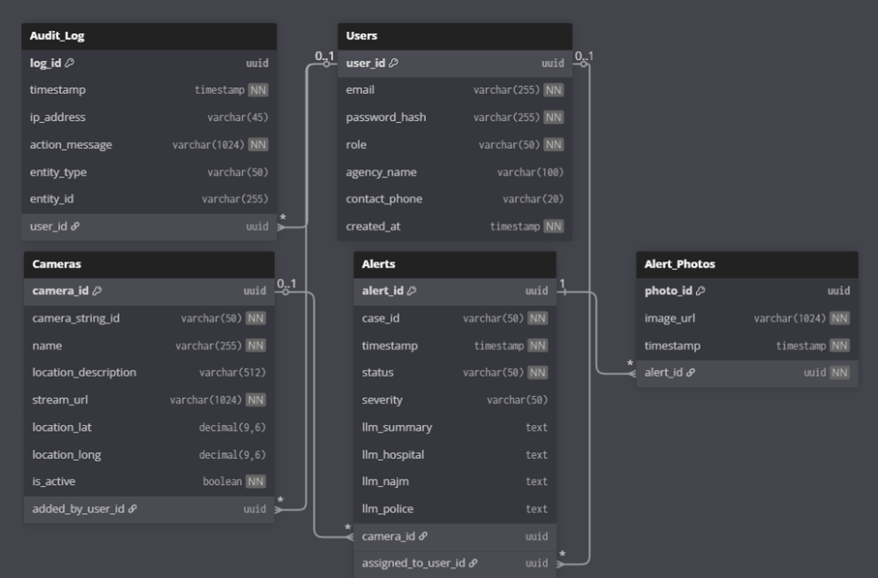
Figure 18: Physical Entity Relationship Diagram.

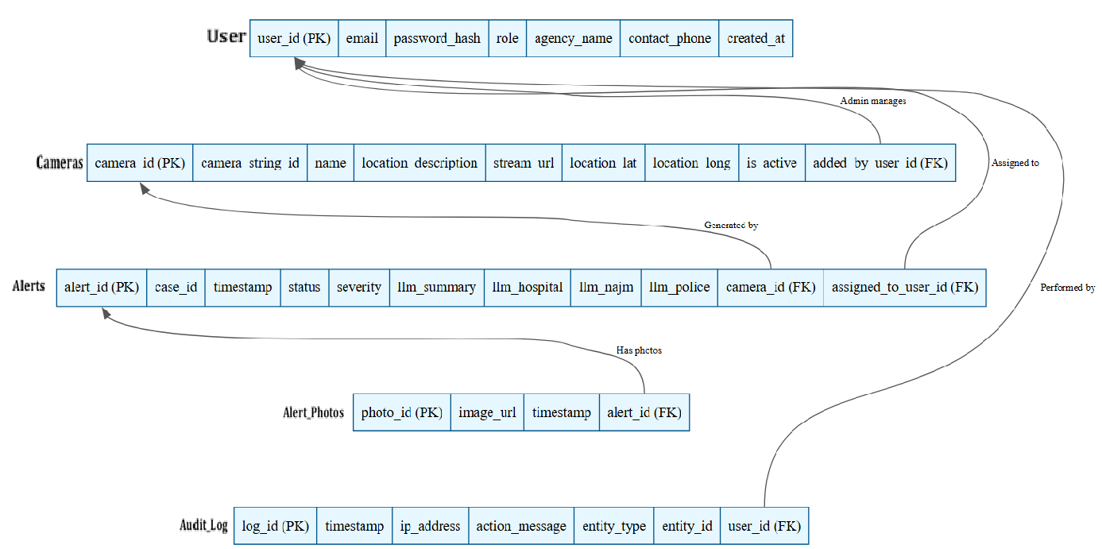
Figure 19: ERD Mapping Relational Schema.

5.7 Component Design
This section summarizes the internal logic of the main system components using simplified procedural pseudocode (PDL). Each component description includes its purpose and core algorithmic behavior. Only essential local data is shown where needed.

5.7.1 Detection Engine Component
Purpose: Processes video frames and detects accidents using the AI model.
Local Data:
THRESHOLD = minimum confidence required.

PDL:
function detectAccident(frame):
processed = preprocess(frame)
result = model.infer(processed)

if result.confidence >= THRESHOLD:
return result
else:
return null

5.7.2 Event Orchestrator Component
Purpose: Creates and updates accident events.
PDL:
function createEvent(detection):
event = new Event()
event.status = "detected"
save(event)
return event.id

function updateEventStatus(eventId, status):
event = load(eventId)
event.status = status
save(event)

5.7.3 Assignment Engine Component
Purpose: Selects the nearest available emergency units.
PDL:
function assignUnits(eventLocation):
units = getAvailableUnits()
for each unit in units:
unit.distance = computeDistance(unit.location, eventLocation)
return sortByDistance(units)

5.7.4 Notification Component
Purpose: Sends alerts for new or updated events.
PDL:
function sendAlert(eventId):
subscribers = getActiveUsers()
for each user in subscribers:
pushMessage(user, eventId)

5.7.5 Repository Layer (Data Access Component)
Purpose: Store and retrieve event data.
PDL:
function saveEvent(event):
SQL INSERT or UPDATE event

function getEvent(eventId):
return SQL SELECT event WHERE id = eventId

5.8 Detailed System Design
The Detailed System Design document provides a comprehensive overview of each component's role, the constraints that govern its operation, and its interaction with other components for the common goal of providing real-time accident detection and response, thereby conforming to the system's requirements and its architecture. Besides, it also lays out the application resources, interactions, and dataflows between services, processing logic at a high-level, and the interface/exports that each subsystem exposes for a maintainable, testable integration throughout the pipeline. Moreover, it contains detailed references for the design of subsystems and employs sequence and UML diagrams to make the distribution of responsibilities, state transitions, and messages across components clear, thus ensuring that developers and reviewers have a common, traceable understanding of behavior and dependencies.

5.8.1 Classification, Definition and Responsibilities
This section summarizes each component’s type, purpose, and key duties to ensure clear ownership and traceability from requirements to implementation across the accident detection and response pipeline.​

Component | Classification | Definition and Responsibility
Video Acquisition & Detection | Subsystem | It is receiving the live video feeds, preparing the images, running the AI models to identify potential accidents, and subsequently transmitting the detection events in a universally accepted format for further processing.
Emergency Event Management | Subsystem | It is performing the functions of the major accident event lifecycle controller by handling the succession of creating, checking, assigning, updating, and changing the event state.
Emergency Units Management | Subsystem | It continues to manage the lists of responders and their live availability, performs geospatial proximity queries, and helps in assigning the nearest suitable units to incidents.
Notification & Alerting | Subsystem | Through push channels and external connectors, it provides real-time updates to users which implies that alerts and status changes have been delivered in a trustworthy and auditable way.
UI Dashboard | Subsystem | It incorporates a secure web interface for monitoring incidents, displaying them on a map and in a list, and performing CRUD operations for system entities at the administrative level.
Data Management & Storage | Subsystem | It assures adherence to the ACID model for the core records and media artifacts by offering repository interfaces and indexing for fast reading and writing across services.
Cross-Cutting Services | Module set | Besides, it implements authentication, authorization, logging, and performance targets corresponding to the behavior off the subsystem, system-level requirements, and documentation traceability.
Table 26: Component Definitions and Responsibilities.

5.8.2 Composition
This section defines the constraints for each component, including its limitation, pre‑conditions, and post‑conditions, and summarizes how subcomponents compose the overall behavior.

Component | Limitation | Pre-condition | Post-condition
Video Acquisition & Detection | Requires stable network, 15–30 FPS and 720p+ streams, and sufficient GPU/CPU for inference. | Valid stream URL configured; model loaded; compute resources available. | Standardized detection event produced with timestamp, camera ID, confidence, and media reference.
Emergency Event Management | Must enforce valid lifecycle transitions and idempotent updates; relies on transactional storage. | Detection payload received; database connection available. | Event created/updated atomically; notifications queued; state persisted.
Emergency Units Management | Accurate geolocation and up-to-date availability required; depends on geospatial indexing. | Units registered with coordinates; spatial index initialized. | Ranked nearby available units returned; unit status updated if assigned.
Notification & Alerting | Real-time push required; resilience to channel outages; idempotent deliveries. | Active client session or configured external channel; valid event update. | Alerts delivered to recipients; delivery recorded in audit log.
UI Dashboard | Depends on backend APIs and push channels; require authenticated sessions. | User authenticated and authorized; services reachable. | Live data rendered and actions executed; UI synchronized with backend.
Data Management & Storage | ACID, 3NF schema, indexing, and retention policies must be enforced within capacity limits. | Migrations applied; storage healthy; access credentials valid. | Records persisted consistently; media stored; queries performant on indexes.
Table 27: Component Constraints and Conditions.

5.8.3 Uses/Interactions
Uses/Interactions describe each component's collaborations with other components, specifying which entities use it, what it uses (including side-effects on shared state like databases), and interaction methods such as message queues, REST APIs, or publish-subscribe topics, ensuring loose coupling across the modular pipeline.
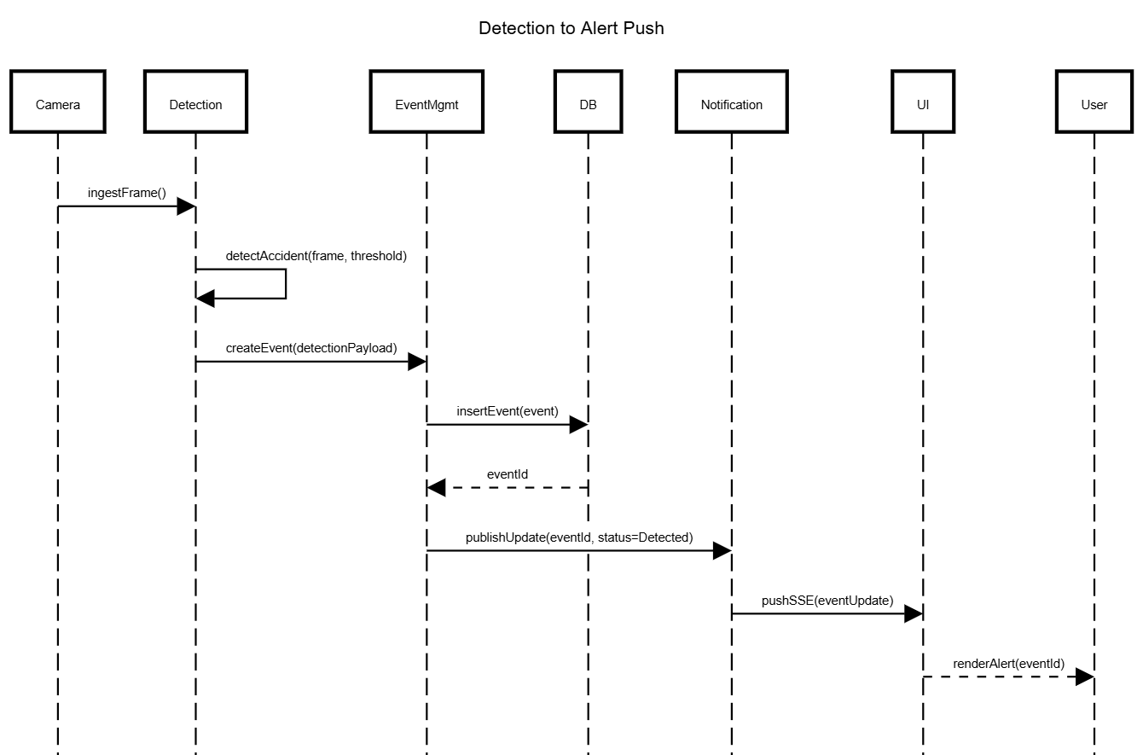
Figure 20: Sequence of Interactions Across Subsystems.

5.8.4 Resources
This section catalogs all external resources (hardware, software, network) required, managed, or impacted by each subsystem, including concurrency risks and mitigation strategies aligned with real-time constraints and shared state access.

Component | Required Resources | Managed Resources | Concurrency Risks | Mitigation
Video Acquisition & Detection | GPU/CPU, RTSP network streams (15-30 FPS), OpenCV/YOLO libraries | Frame buffers, keyframe storage | Buffer overflow on high FPS, multiple stream workers | Bounded queues with backpressure, single-writer per stream, exponential reconnect backoff SDS-Draft.docx
Emergency Event Management | PostgreSQL DB connection pool, message queue | Event records, audit logs | Concurrent event updates, unit assignment races | Row-level locking, optimistic concurrency (versioning), outbox pattern for notifications SDS-Draft.docx
Emergency Units Management | Geospatial indexes (PostGIS), Redis cache (optional) | Unit availability status | Multiple assignment queries updating same unit | Atomic CAS operations, availability leasing with TTL SDS-Draft.docx
Notification & Alerting | WebSocket/SSE connections, SMTP/SMS gateways | Notification audit records | Thundering herd on mass notifications | Debounced delivery, idempotent message IDs, topic partitioning SDS-Draft.docx
UI Dashboard | Browser session storage, HTTPS connections | N/A (stateless client) | Stale UI state during concurrent updates | Server-driven SSE pushes, cache-busting headers SDS-Draft.docx
Data Management & Storage | PostgreSQL server, S3-compatible object storage | All persistent data (ACID) | Deadlock on complex joins, write contention | Consistent lock ordering, short transactions (<100ms), connection pooling SDS-Draft.docx
Table 28: Resource Allocation and Concurrency Management.

5.8.5 Processing
This section describes how each subsystem performs its core responsibilities, specifying inputs, outputs, processing algorithms/steps, and constraints to ensure traceability from SRS requirements to implementation logic for the real-time accident detection pipeline.

5.8.5.1 Video Acquisition & Detection
Table 29 presents the description, inputs, outputs, and constraints of “Video Acquisition & Detection” component.
Attribute | Description
Inputs | RTSP/HLS stream URL, expected frame rate (15-30 FPS)
Outputs | Detection events containing {cameraId, timestamp, confidence, bounding box, keyframe reference}
Purpose | Continuously ingest video streams, preprocess frames, run AI inference to detect accidents in near real-time
Processing Steps | 1. Connect to video stream via RTSP connector.  2. Extract frames into bounded buffer.  3. Preprocess frames (e.g., resizing, normalization).  4. Run object detection model (YOLOv8), apply non-maximum suppression.  5. Filter detections by confidence threshold.  6. Capture keyframe when valid detection occurs.  7. Format and send detection payload to Event Management.
Constraints | Requires GPU/CPU availability for inference.  Must maintain end-to-end latency under 2 seconds.  Handle stream interruptions with reconnection and backoff logic.  As recovery Strategy in the event of stream failure, keep on trying connection before declare camera to be offline.
Table 29: Process Specification of Video Acquisition & Detection.

5.8.5.2 Emergency Event Management
Table 30 presents the description, inputs, outputs, and constraints of “Emergency Event Management” component.
Attribute | Description
Inputs | Detection payloads from Video Acquisition, unit assignment queries
Outputs | Event records including updated event status and assigned units; triggers notifications
Purpose | Manage accident event lifecycle: creation, deduplication, verification, assignment, updates, and persistence
Processing Steps | 1. Search existing events overlapping in time and space.  2. Create new or merge detections into existing events.  3. Optionally await manual verification.  4. Query available emergency units near the event.  5. Assign units and update event status.  6. Persist updates atomically.  7. Publish event updates for notification.
Constraints | Must ensure transactional integrity with optimistic locking.  Allow only valid state transitions.  Support idempotency to avoid duplicates.
Table 30: Process Specification of Emergency Event Management.

5.8.5.3 Emergency Units Management
Table 31 presents the description, inputs, outputs, and constraints of “Emergency Units Management” component.
Attribute | Description
Inputs | Event location (latitude/longitude), unit type filters
Outputs | Ranked list of available emergency units with distances
Purpose | Maintain emergency responder directories, availability status, and provide proximity queries for assignments
Processing Steps | 1. Query geospatial index to find units within radius.  2. Filter units by type and availability.  3. Sort by geographic distance.  4. Return top candidates.  5. Update unit availability atomically on assignment.
Constraints | Accurate GPS data required.  Geospatial index must be up to date.  Use atomic operations to prevent race conditions on availability.
Table 31: Process Specification of Emergency Units Management.

5.8.5.4 Notification & Alerting
Table 32 presents the description, inputs, outputs, and constraints of “Notification & Alerting” component.
Attribute | Description
Inputs | Event update messages {eventId, status, summary}
Outputs | Delivered notifications via WebSocket/SSE and external channels; audit logs
Purpose | Route event updates reliably to subscribed clients and external notification channels
Processing Steps | 1. Determine recipients based on roles and locations.  2. Enqueue messages for delivery.  3. Send notifications via WebSocket/SSE.  4. Retry on failure with backoff.  5. Log delivery results for auditing.
Constraints | Ensure idempotent delivery for consistency.  Handle outages gracefully.  Maintain low latency (<1 second).
Table 32: Process Specification of Notification & Alerting.

5.8.5.5 UI Dashboard
Table 33 presents the description, inputs, outputs, and constraints of “UI Dashboard” component.
Attribute | Description
Inputs | API responses for incidents and units; server-sent events (SSE) for real-time updates
Outputs | Rendered UI views including maps, incident lists, and admin management pages
Purpose | Provide an interactive, responsive interface for monitoring incidents and managing system data
Processing Steps | 1. Authenticate users and establish SSE connection.  2. Fetch initial state via REST APIs.  3. Render map and lists.  4. Handle user actions with optimistic updates.  5. Sync UI state based on server events.
Constraints | Secure authentication and role-based access.  Minimize UI latency and handle conflicting updates smoothly.  As security Strategy Session timeout after 15 minutes of inactivity; force re-login.
Table 33: Process Specification of UI Dashboard.

5.8.5.6 Data Management & Storage
Table 34 presents the description, inputs, outputs, and constraints of “Data Management & Storage” component.
Attribute | Description
Inputs | CRUD requests from all subsystems; media files (keyframes, clips)
Outputs | Confirmation of persisted data; query results
Purpose | Provide reliable ACID-compliant storage and efficient query capabilities for all system data
Processing Steps | 1. Validate data schema and constraints.  2. Perform indexed query or transaction.  3. Upload media to object store.  4. Log all writes in audit logs.  5. Return operation results or error messages.
Constraints | Maintain ACID compliance.  Enforce data normalization.  Ensure sub-100ms transaction latencies.
Table 34: Process Specification of Data Management & Storage.

5.8.6 Interface/Exports
This section summarizes the main services and interfaces exposed by each subsystem so that developers can understand how to use them and verify that the system functions as expected. It focuses on the purpose and role of each interface rather than low-level implementation details, and it should be read together with the SRS external interface requirements and the detailed subsystem design diagrams.
Subsystem | Interfaces / Services | Purpose
Video Acquisition & Detection | Internal endpoint for detection results (e.g., POST /events/detections), internal message topic for detection events | Provides a standardized accident detection payload (camera identifier, timestamp, confidence, region of interest, and media reference) to the Emergency Event Management subsystem after processing live camera streams.
Emergency Event Management | REST APIs for creating and updating events (e.g., /events, /events/{id}, /events/{id}/status, /events/{id}/assign), internal event-update topic | Acts as the main access point for creating accident events, updating their lifecycle status, assigning units, and broadcasting event changes to other subsystems such as Notification and UI Dashboard.
Emergency Units Management | REST APIs for managing and querying units (e.g., /units, /units/{id}, /units/nearby) | Exposes CRUD operations for hospitals, police, and fire units, and provides a proximity search service used by the Event Management subsystem when selecting suitable responders for an incident.
Notification & Alerting | WebSocket or Server-Sent Events endpoint for real-time updates (e.g., /ws/updates), internal notification trigger endpoint (e.g., POST /notify/{eventId}) | Delivers real-time alerts and status changes to connected dashboards and, when configured, to external channels such as SMS or email, while recording notification attempts in the audit log.
UI Dashboard | Web client that consumes backend REST APIs and subscribes to real-time updates | Provides administrator and responder user interfaces for all core functions, including camera management, user management, viewing and verifying incidents, and monitoring assigned units and alerts.
Data Management & Storage | Database schema and repository layer accessed via ORM/DAO classes | Offers persistent storage for users, cameras, alerts, units, notification logs, and audit entries, serving all subsystems through well-defined data access methods rather than direct SQL in business logic.
Table 35: System Interface Specifications.

5.8.7 Detailed Subsystem Design
This section presents the detailed design of each major subsystem in the Real‑Time Accident Detection and Emergency Alert System, including their internal structure, control flow, and data usage. It refines the high‑level architecture by showing how the subsystems are decomposed into subcomponents and how these subcomponents collaborate to implement the functional requirements defined in the SRS.​
For each subsystem (Video Acquisition & Detection, Emergency Event Management, Emergency Units Management, Notification & Alerting, UI Dashboard, and Data Management & Storage), the detailed design is documented using a combination of class/Component diagrams, sequence diagrams, and data models that illustrate:​
- Internal subcomponents and their responsibilities
- Main control and data flows inside the subsystem
- Key algorithms or processing steps for core functions (e.g., detection, event lifecycle, unit selection, notification routing)
Where appropriate, these details are maintained directly with the source code (e.g., API definitions, repository classes, and model implementations). The SDS therefore references those artifacts and the diagrams in the System Architecture and Data Design sections instead of duplicating low‑level declarations, ensuring the design remains consistent and maintainable as the implementation evolves.​

5.9 Other Design Features

This section captures additional design aspects that are not fully covered in the previous sections but still influence how the system behaves, evolves, or integrates into its environment. In this project, the Real‑Time Accident Detection and Emergency Alert System adopts several cross‑cutting design choices, including the use of an event‑driven, modular architecture, separation of AI inference from user‑facing components, and centralized auditing of all critical actions for accountability and troubleshooting.​

The design also emphasizes extensibility by allowing future integration of new detection models, external notification channels, and additional emergency agencies without major changes to existing subsystems. Configuration is externalized where possible (e.g., camera endpoints, model thresholds, and notification rules), and non‑functional concerns such as logging, authentication, and role‑based access control are implemented as shared services to reduce duplication and keep business logic focused on accident detection and response workflows.

5.10 Requirements Traceability Matrix

This section links each major functional requirement defined in the SRS to the subsystems and design elements that implement it in the SDS. The full, detailed matrix is maintained in the “Requirements Traceability Matrix” subsection of the SDS and references the SRS Section 4.3 for requirement definitions and SDS Section 5.8 for detailed component design.

Associated ID in SRS | Technical Assumption | Functional Requirement (summary) | User | Associated ID in SDS | System Component
SRS (4.2.2 Product functions – Real-Time Video Monitoring) | Stable RTSP/HLS camera streams; GPU/CPU able to process 15–30 FPS at 720p+ | System shall continuously receive and monitor live video streams from surveillance cameras. | Admin, Responder | SDS (5.5.3 Subsystem Architecture – Video Acquisition & Detection; 5.8.5.1 Process Specification of Video Acquisition Detection) | Video Acquisition & Detection Subsystem.
SRS (4.2.2 – Accident Detection Using Deep Learning) | Trained YOLOv8/CNN models; annotated datasets available. | System shall automatically detect car accidents in the incoming video frames using deep learning. | Admin, Responder | SDS (5.7.1 Detection Engine Component; 5.8.5.1) | Detection Engine Component within Video Acquisition & Detection.
SRS (4.2.2 – Accident Classification and Severity Assessment) | Events stored with time and location; severity rules/ML model defined. | System shall classify each confirmed accident by severity (e.g., minor, moderate, major). | Admin, Responder | SDS (5.7.2 Event Orchestrator; 5.8.5.2 Emergency Event Management; Alerts.severity in 5.6.2 Data Dictionary) | Emergency Event Management / Event Orchestrator.
SRS (4.2.2 – Automated Alert and Notification System) | Network connectivity to dashboard and external channels. | System shall generate and send alerts containing time, location, severity, and camera reference. | Admin, Responder | SDS (5.7.4 Notification Component; 5.8.5.4; System Interface Specifications in 5.4.5 & 5.8.6) | Notification & Alerting Subsystem.
SRS (4.2.2 – System Management and Monitoring Dashboard; UI Tables 21–23) | Role-based web access via HTTPS. | System shall provide an admin dashboard for managing cameras, users, and viewing system status. | Admin | SDS (5.4.3 Screen Images, Tables 20–23; 5.4.4 Screen Objects and Actions; 5.8.5.5 UI Dashboard) | UI Dashboard – Admin views.
SRS (4.2.2 – Emergency Units Management) | Units registered with coordinates and availability. | System shall manage emergency units (CRUD) and expose them for assignment. | Admin | SDS (5.5.3 Emergency Units Management; 5.7.3 Assignment Engine; 5.8.5.3) | Emergency Units Management Subsystem.
SRS (4.2.2 – Nearest Units Selection) | Geospatial index and event location available. | System shall provide the nearest available units for a given incident location. | Admin, Responder | SDS (5.7.3 Assignment Engine; 5.8.5.3 Process Specification of Emergency Units Management) | Assignment Engine / Units Proximity Service.
SRS (4.3.1.1 – Login Interface, Table 20) | Auth service and user table configured. | System shall authenticate admins and responders using email and password. | Admin, Responder | SDS (5.4.3 Figures 1–2; 5.4.4 Screen Objects and Actions) | Login & Reset Password interfaces backed by Auth API.
SRS (4.3.1.1 – Responder Dashboard Interface, Table 24–26) | Active WebSocket/SSE connection. | System shall display an active incidents map and list for responders, with live updates. | Responder | SDS (5.4.3 Figures 7–9; 5.4.4; 5.8.5.5 UI Dashboard) | UI Dashboard – Responder views with real-time alert feed.
SRS (non-functional – audit / logging in SRS 2.2 & 3) | Central relational DB and audit schema deployed. | System shall log key user and system actions for auditing and troubleshooting. | Admin | SDS (5.6.2 Data Dictionary – AuditLog; 5.6.3 ERD; 5.8.4 Resources) | Data Management & Storage + logging in Event Management and Notification.
SRS (4.3.1.1 – Camera Management Interface, Table 22) | Camera records stored in DB with stream URLs; RTSP/HLS supported.​ | System shall allow admins to add, edit, delete, and view configured camera streams. | Admin | SDS (5.4.3 Figure 4; 5.4.4 Screen Objects and Actions – Camera Mgt.; 5.5.3 Video Acquisition Module) | Camera Management UI + Video Stream Ingestion interface. ​
SRS (4.3.1.1 – User Management Interface, Table 23) | User and agency tables exist; RBAC model defined.​ | System shall allow admins to manage responder agency users (create, update, delete). | Admin | SDS (5.4.3 Figure 5; 5.4.4 – User Mgt.; 5.5.3 UI Dashboard Module) | User Management UI + backend User Management API. ​
SRS (4.3.1.1 – System Audit Log Interface) | AuditLog table and logging middleware enabled.​ | System shall provide an audit log screen showing key system activities with filters and export. | Admin | SDS (5.4.3 Figure 6; 5.4.4 – Audit Log; 5.6.2 AuditLog entity) | System Audit Log UI + Data Management & Storage. ​
SRS (4.3.1.1 – Incident Reports & Details, Tables 24–26) | Incidents persisted with IDs, timestamps, and status.​ | System shall show responders a list of past and active incidents and detailed accident information. | Responder | SDS (5.4.3 Figures 8–9; 5.4.4 – Incident Reports, Accident Details; 5.8.5.5 UI Dashboard) | Incident Reports & Accident Details views backed by Event Management. ​
SRS (Overall description / non‑functional – Authentication & Roles) | Secure HTTPS deployment, hashed passwords, roles Admin/Responder.​ | System shall restrict access via authenticated login and enforce role‑based permissions. | Admin, Responder | SDS (5.3.2 General Constraints – Security & Privacy; 5.4.1 Overview of UI; 5.8.4 Resources) | Cross‑cutting security (Auth, RBAC, Audit) integrated into all subsystems. ​
SRS (Overall description – Real‑time Processing) | Hardware and network sufficient to target < 2 s end‑to‑end latency.​ | System shall process video streams and generate alerts in near real time (target < 2 seconds). | System-level | SDS (5.3.2 General Constraints – Performance & Latency; 5.8.5 Process tables 32–37) | Pipeline design across Video Acquisition, Event Mgmt, Notification, UI, Data. ​
SRS (Overall description – Reliability & Recovery) | Reconnect and retry strategies implemented; message delivery tracking available.​ | System shall handle stream drops and transient failures via reconnection and retry mechanisms. | System-level | SDS (5.3.2 General Constraints – Network & Storage; 5.8.4 Resources; 5.8.5 Processing for affected subsystems) | Stream Connector, Notification & Alerting, Repository Layer. ​
SRS (Overall description – Data Persistence) | Relational DB and object storage deployed and reachable.​ | System shall persist accident events, media, and related entities in a consistent, normalized schema. | System-level | SDS (5.6.1 Data Description; 5.6.2 Data Dictionary; 5.6.3 Database Description) | Data Management & Storage (ERD, tables Alerts, AlertPhotos, Users, Cameras, AuditLog). ​
Table 36: Requirements Traceability Matrix Linking SRS Functional Requirements to SDS System Component

Chapter 6: Implementation Process

6.1 Introduction
This chapter documents the implementation of the Harnessing Deep Learning to Optimize Emergency Response system. It traces the progression from the initial proposal into a fully developed, multi-stage AI pipeline, covering dataset preparation, model architecture decisions, and system integration. The goal is to provide a transparent record of the technical choices made during development, the challenges that arose, and the engineering solutions applied, culminating in a real-time accident detection and emergency dispatch platform.

6.2 Changes from the Proposal Phase and Justifications
- Dataset Expansion: The IEEE DataPort dataset identified in the original proposal could not be accessed due to network restrictions at the university. The team pivoted to the CADP dataset from Carnegie Mellon University, which was later supplemented by four additional sources to improve model generalization across varied lighting, weather, and camera perspectives.

- Detection Architecture Upgrade: The original proposal specified YOLOv8 as the sole detection model. During implementation, the architecture evolved into a dual-stream YOLO11n setup for spatial detection, paired with a VideoViT v4 model built on VideoMAE-base for temporal classification. This change was driven by the need to capture crash dynamics across consecutive frames rather than relying on isolated spatial snapshots.

- First Responder Report: The system was extended beyond basic alerts by introducing a triage layer powered by the Qwen2.5-VL Vision-Language Model. This layer generates structured JSON incident reports providing scene context to responders before arrival.

- Repository Structure: The user dashboard was developed as a separate GitHub submodule, enabling the React/Supabase frontend and the AI backend to be version-controlled independently.

- Severity Classification – Downgraded to VLM Output: The proposal included a trained severity head on VideoViT v4 (minor | moderate | major). Training collapsed at epoch 18 due to class imbalance: only ~18% of clips (1,500 of 8,259) carried severity labels, causing the severity cross-entropy loss to dominate and drive all metrics to zero. The severity head was removed; the epoch-15 checkpoint (saved before collapse) is the production model. All Chapter 7 F1/Precision/Recall results are binary accident/no-accident only. Severity is now provided by Stage-3 Qwen2.5-VL-7B as a structured JSON field (see 6.5.5); operators may also override it manually. Accident detection F1 (0.888) is unaffected. The ONNX output retains a severitylogits [B,3] tensor as an architectural artefact; it is not used in production and should be removed if retraining occurs.

- Infrastructure and Backend Stack Changes:

- Database and Backend – MySQL/Flask → Supabase: The proposed MySQL/Flask backend was replaced by Supabase (managed PostgreSQL), which provided an auto-generated REST API (PostgREST), Row Level Security for role-based access control, and a WebSocket Realtime channel for live dashboard updates - eliminating the need to build authentication middleware, rate limiting, or connection pooling manually. No custom Flask or FastAPI server is deployed in production.
- Training and Inference Infrastructure: AWS → Google Colab: AWS EC2 was replaced by Google Colab throughout the project (A100 40 GB for VideoViT v4 training; T4 16 GB for YOLO fine-tuning and inference), driven by cost and institutional access constraints. Checkpoints are stored on Google Drive (Data/accident-detection/checkpoints/). Production inference runs YOLO on GPU and VideoViT ONNX on CPU within the same Colab runtime.
- Testing Methodology Automated PyTest → Manual Execution: The proposed automated PyTest suite was impractical given the pipeline's dependency on GPU resources, live camera streams, and Supabase connectivity. Testing was performed through structured manual execution of the test cases in Chapter 7, with results recorded manually (see 7.8).

6.3 Dataset

6.3.1 Data Description
CADP (Car Accident Detection and Prediction) is a dataset of real traffic accident videos collected from YouTube. It was assembled in 2018 by a research team at Carnegie Mellon University and has since been used as a standard benchmark for traffic incident recognition.

6.3.1.1 Key Statistics
Metric | Value
Total videos | 230
Accident segments (clips) | 1,416
Total video duration | 5.24 hours
Videos with full bounding box labels | 205
Average frames per video clip | 366 frames
Table 37: Key statistics and video metrics of the CADP dataset.
Each of the 1,416 CADP accident segments was split into two training samples: an accident sample (16 frames centred on frame 105, the canonical CADP accident onset) and a normal sample (frames 0–85, representing pre-accident normal traffic This splitting procedure produces up to two clips per source segment, yielding 2,527 training clips from the 1,416 CADP accident segments. Of the 1,416 segments, 1,111 yielded both an accident and a normal sample; the remaining 305 segments were too short or had insufficient pre-accident frames to construct a valid normal sample and contributed only an accident clip. The total of 1,111×2 + 305×1 = 2,527 clips is listed in Table 37.

6.3.1.2 Object Classes
The annotation team defined six object categories and drew bounding boxes around each instance across all labelled frames.
Class ID | Label | Description
0 | Car | Regular passenger vehicles
1 | Person | Pedestrians and individuals on or near the road
2 | Bus | Buses and large transport vehicles
3 | Two-wheeler | Motorcycles and bicycles
4 | Three-wheeler | Auto-rickshaws and tuk-tuks
5 | Others | Any object not covered by the above categories
Table 38: Bounding box object classes annotated in the CADP dataset.

6.3.2 The Annotation System
The dataset provides three complementary annotation types that together enable both detection and temporal classification training.

6.3.2.1 Temporal Annotations
- Each accident clip has a recorded start and end frame for the collision event.
- Format: A JSON annotation file (annotations1531762138.1303267.json) that stores accident start times as floating-point seconds from clip start. A conversion script maps each timestamp to the corresponding frame index by multiplying by 30 fps. Adding 3.5 seconds to the clip start time yields frame 105, which is the canonical CADP accident onset frame.
- Coverage: All 1,416 accident segments carry temporal labels.

6.3.2.2 Bounding Box Annotations
For 205 high-quality videos, every vehicle and person was annotated with a bounding box in every frame using the VATIC annotation tool (Video Annotation Tool from Irvine, California).

6.3.2.3 Status Spreadsheet
A tracking spreadsheet covering 380 videos (IDs 621 through 1000) records human review status and annotation completeness. This record was used to identify which videos were ready for training and which still required labelling work.

6.3.2.4 Negative Example Construction
CADP contains only accident footage and does not include normal traffic clips. To construct a balanced training set, frames 0 to 90 of each clip were treated as negative (normal traffic) samples, given that accidents in CADP conventionally begin at frame 105. Safe time windows were additionally sampled from the full-length source videos, with any window falling within one second of an annotated accident excluded to eliminate ambiguous near-miss frames from the negative class. Frames 91 to 104 were discarded from both classes as an ambiguous transition zone.

6.3.3 Supplementary Datasets
Four additional datasets were incorporated to diversify training conditions.
The ACCIDENT/picekl dataset contributes 4,238 clips: 2,027 real-world clips with per-frame accident timestamps and 2,211 synthetic clips with ground-truth bounding box annotations. For synthetic clips, detection tokens were derived from ground-truth labels rather than YOLO inference, providing a cleaner supervision signal. The TU-DAT dataset adds urban intersection footage from German traffic cameras. The severity dataset (1,500 videos) provides crash videos labelled minor, moderate, or major and was intended for a severity head that was excluded from final evaluation due to training instability.
Dataset | Description | Type | Clips | Labels
CADP | Car Accident Detection & Prediction – CCTV highway footage | Pre-extracted JPG frames | 2,527 | Accident + Normal
forth_investigation | Internal CADP extension with additional annotation passes | Pre-extracted JPG frames | 230 | Accident only
TU-DAT | Traffic urban dataset from German intersections | Video clips (MP4) | ~300 | Accident + Normal
ACCIDENT (picekl) | Real (2,027) + synthetic (2,211) dashcam and CCTV clips | Video clips (MP4) | 4,238 | Accident + Normal
Severity Dataset | Crash videos labelled minor / moderate / major | Video clips (MP4) | 1,500 | Accident only
Total | Five heterogeneous sources: CCTV + dashcam, real + synthetic | – | 8,795 | 6,957 / 1,838
Table 39: Dataset composition by source.

6.3.4 Data Split
An 80/20 stratified random split was applied independently to sources carrying both accident and normal-class labels: CADP (2,527 clips), TU-DAT (300 clips), and ACCIDENT-picekl (4,238 clips), 7,065 balanced clips in total. For CADP and TU-DAT the 80/20 split was applied uniformly. For ACCIDENT-picekl, only 22 clips met the quality threshold for the validation set (clips with reliable per-frame timestamp alignment); the remaining 4,216 were assigned to training. The Severity Dataset (1,500 clips, accident-only) and the forth investigation subset (230 clips, accident-only) were assigned entirely to training, no normal-class counterparts exist for these sources.
The resulting split:
- Training set: 8,208 clips (CADP 2,022 + TU-DAT 240 + picekl 4,216 + severity 1,500 + fourth 230)
- Validation set: 587 clips (CADP 505 + TU-DAT 60 + picekl 22)
- Total: 8,795 clips

The split was fixed with random seed 42 and stored in a clip-index JSON file to ensure reproducibility. All reported metrics (F1 0.888, Table 56, Table 48) are evaluated on the 587-clip validation set.
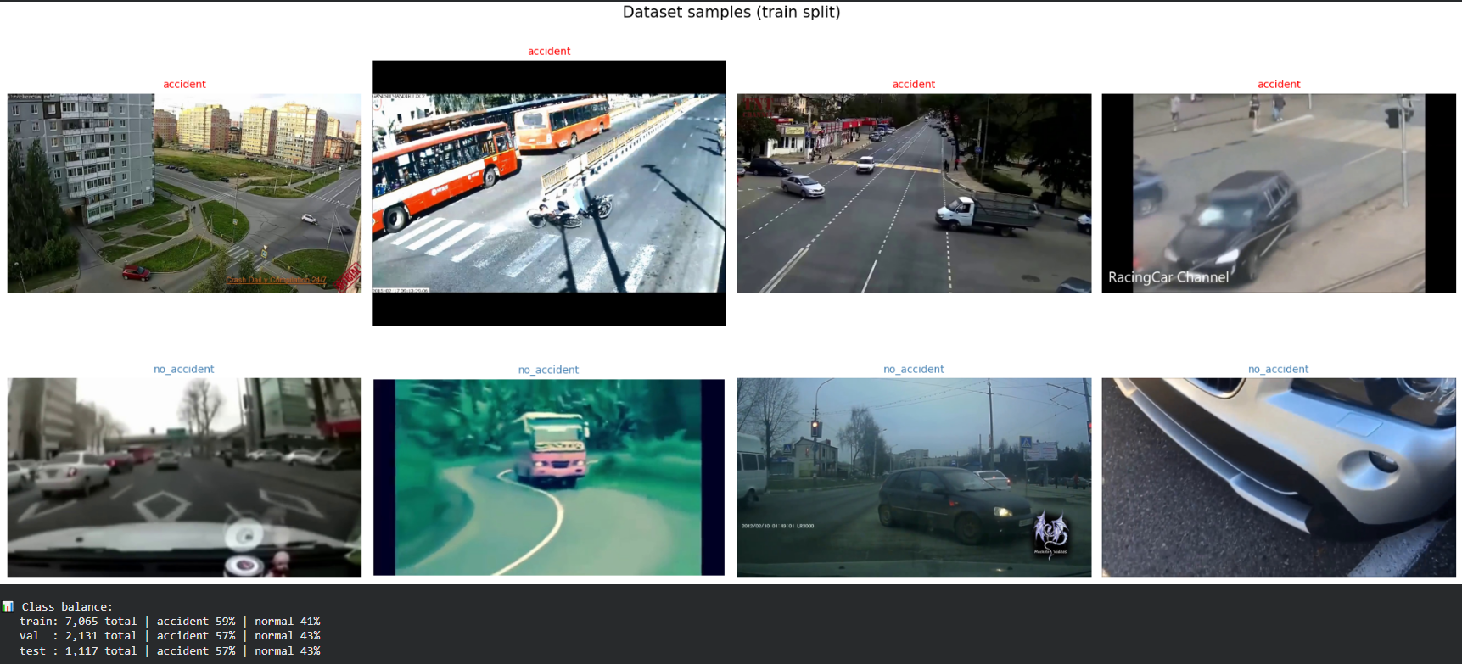
Figure 21: Sample frames from the CADP training split. Top: accident. Bottom: no_accident

Note: The 587-clip validation set is drawn from balanced sources only (CADP, TU-DAT, ACCIDENT-picekl). The Severity Dataset and forthinvestigation subset are training-only due to absence of normal-class counterpart footage.

6.4 AI Models Changelog
This section documents the complete development log for the three-stage accident detection pipeline. It records every model version, architectural change, bug encountered, fix applied, and result measured throughout the project lifecycle from initial VideoMAE baseline through to the final VideoViT v4 deployment.
Item | Detail
Project Goal | Real-time CCTV accident detection pipeline for emergency response
Target Metric | F1 ≥ 0.85, inference latency < 2,000 ms per clip
Final Result | F1 = 0.888, latency = 41.2 ms (VideoViT v4, epoch 15)
Pipeline Stages | Stage 1: Dual-stream YOLO (spatial) | Stage 2: VideoViT (temporal) | Stage 3: Qwen VLM (semantic)
Primary Dataset | CADP (Car Accident Detection & Prediction)
Training Hardware | NVIDIA A100 40 GB GPU (Google Colab) - VideoViT v4 training; NVIDIA T4 16 GB GPU (Google Colab) - YOLO fine-tuning and inference demo
Inference Hardware | T4 16GB (demo) – YOLO on GPU, VideoViT ONNX on CPU
Best Checkpoint | videovit_v4.pt – epoch 15/30, F1=0.888
ONNX export | videovit_v4_clean.onnx - opset 18, dynamic batch axis, 2 MB, CPUExecutionProvider
Table 40: Project performance targets versus achieved results.

6.4.1 Checkpoint File Index
All checkpoint files saved to Google Drive under Data_accident_detection/checkpoints/.
Filename | Size | Stage | Description
videovit_v4.pt | 347 MB | Stage 2 | Best VideoViT v4 checkpoint – epoch 15, F1=0.888
videovit_v4.onnx | 2 MB | Stage 2 | Original ONNX export - NaN due to torch.compile _orig_mod prefix
videovit_v4_clean.onnx | 2 MB | Stage 2 | Re-exported clean ONNX opset 18, no compile artifacts - use this
videovit_v5.pt | – | Stage 2 | VideoViT v5.1, severity head removed; binary-only retrain. NaN collapse occurred in the v4 run at ep18 (see 6.4.2.5). This checkpoint is the clean post-collapse retrain; not evaluated in this project (v4 epoch-15 checkpoint used for all reported results).
videovit_v5.onnx | 2 MB | Stage 2 | ONNX export of v5 – two outputs (accident + severity)
videomae_v6_best.pt | 350 MB | Stage 2 | VideoMAE v6 pure temporal baseline – F1=0.826, AUC=0.957
videomae_v6_pipeline.onnx | 350 MB | Stage 2 | VideoMAE v6 ONNX for Stage 2 pipeline – single output
videomae_v7_best.pt | 350 MB | Stage 2 | VideoMAE v7 multi-task accident severity — training abandoned (out of project scope; severity approach superseded by Qwen2.5-VL Stage 3)
videomae_dapt_cctv_v6.pt | 350 MB | Pretraining | Domain-Adaptive Pre-Training (DAPT) weights, VideoMAE adapted to CCTV domain via masked autoencoding
videomae_dapt_cctv_v7.pt | 350 MB | Pretraining | DAPT v7 weights for VideoMAE v7 warm-start
yolo11n_cctv_v4.pt | 6 MB | Stage 1 | YOLO11n fine-tuned on CADP highway footage
yolo11n_accident_v2.pt | 6 MB | Stage 1 | Earlier YOLO version v2 – superseded by v4
videomae_v4_best.pt | 350 MB | Stage 2 | VideoMAE v4 – earlier training run, pre-CADP augmentation
videomae_v5_best.pt | 350 MB | Stage 2 | VideoMAE v5 – improved dataset balance
Table 41: Deep learning model checkpoints and file index.

6.4.2 Model Version History
Chronological record of every model version. Each entry shows what changed, what was measured, what broke, and what was fixed.

6.4.2.1 YOLO v1–v2 (NB1)
YOLO v1–v2 (NB1)  April 2026 | Initial object detection – identifies vehicles and road objects per frame | DEPRECATED
Table 42: YOLO v1–v2 Model Version Entry (Deprecated).

6.4.2.1.1 Changes
- YOLOv8 → YOLO11n as backbone (smaller, faster)
- Custom 13-class taxonomy: car, truck, bus, motorcycle, van, bicycle, pedestrian, rider, pole, fence, wall, traffic_light, traffic_sign
- v2: Removed fence and wall from FT classes – mAP=0.28/0.37, adding noise not signal

6.4.2.1.2 Results
Version | mAP50 (mean Average Precision at IoU 0.50) | Precision | Recall | Status
v1 | 0.241 | – | – | DEPRECATED
v2 (NB1 v4.1) | 0.307 | 0.418 | 0.330 | SUPERSEDED
v4 (FT CCTV) | 0.307 | 0.418 | 0.330 | ACTIVE
Table 43: Historical performance metrics for YOLO detection models.
Best per class: v4 (FT CCTV, 13 classes):
van | 0.756 | trafficlight | 0.520
fence | 0.454 | wall | 0.374
pole | 0.329 | pedestrian | 0.383
rider | 0.316
Table 44: Per-Class Average Precision (AP) Scores for Selected Object Categories.
Training: 60 epochs (early stop ep54, best ep34).
Note: v2 and v4 overall mAP50 are identical (0.307), the gain in v4 is in the new classes (van, rider, pole, fence, wall) that v2 had no labels for at all, not in the overall headline number.

6.4.2.1.3 Key Learnings
- Wall and fence classes were excluded from the fine-tuned detection stream. Although their per-class mAP50 values (fence: 0.454, wall: 0.374) are not poor in absolute terms, empirical evaluation showed that retaining these classes populated detection token slots with stationary infrastructure objects that do not participate in collision events, introducing noise into the cross-attention without improving accident classification accuracy.
- Dual-stream strategy (COCO for vehicles, FT for local classes) outperforms single model
- X-coordinate sorting of detection tokens provides better temporal consistency than confidence sorting

6.4.2.2 VideoMAE v4–v5
VideoMAE v4–v5  April 21–22, 2026 | VideoMAE v4–v5 Pure temporal classifier, VideoMAE backbone, no YOLO fusion. Note: VideoMAE v4 is an earlier baseline model (F1 0.766); it is a different model from VideoViT v4 (F1 0.888), which adds YOLO cross-attention and is documented in 6.5. | DEPRECATED
Table 45: VideoMAE v4–v5 Model Version Entry (Deprecated).

6.4.2.2.1 Architecture
- Backbone: VideoMAE-base pretrained on Kinetics-400
- Input: 16 frames × 224×224 × 3 channels at 8fps
- Output: binary accident/no-accident classification
- No YOLO tokens – pure spatiotemporal video understanding

6.4.2.2.2 Results
Version | F1 | Recall | FPR | AUC | Clips | Status
v4 | 0.766 | 0.924 | 44.9% | – | 511 | OLD
v5 | – | – | – | – | – | OLD
v6 (DAPT) | 0.826 | – | – | 0.957 | 511 | BASELINE
Table 46: Evaluation metrics for VideoMAE baseline models (pure temporal classifiers, no YOLO tokens, distinct from VideoViT v4 in Table 47)

6.4.2.2.3 Key Limitation
- 69% of CADP accident clips have deceleration=0.0 – lateral/sudden impacts with no pre-collision braking
- No spatial detection context – cannot distinguish a hard brake from an actual collision

6.4.2.3 EfficientNet-B0 (Single-Frame Baseline)
EfficientNet-B0  March–April 2026 | (Single-Frame Baseline) | SUPERSEDED
Table 47: EfficientNet-B0 Single-Frame Baseline Model Version Entry (Superseded).

6.4.2.3.1 Architecture
- Backbone: EfficientNet-B0 (4M parameters)
- Input: single 224×224 RGB frame, binary accident/no-accident
- Training: FP16 AMP, batch size 16, T4 GPU

6.4.2.3.2 Results
Run | Trainable Params | Val F1 | FPR (normal frames) | Status
Run 1 | 4M (full) | 0.886 | ~33% | SUPERSEDED
Run 2 | 1.2M (frozen 1–5) | 0.897 | ~33% | SUPERSEDED
Table 48: Comparison of VideoViT Training Runs by Trainable Parameters, Validation F1 Score, and False Positive Rate.
Comparability notes: These F1 values are frame-level and are NOT directly comparable to the clip-level F1 values in 6.4.2.2 and 6.4.2.5, which are evaluated on different dataset splits. The primary abandonment metric was FPR, not F1.

Why Superseded
- Both runs converged at epoch 2 and plateaued, dataset ceiling for single-frame classification reached.
- 33% FPR on normal frames: foggy and misty scenes were consistently misclassified as post-collision smoke, a structural failure of texture-based single-frame learning that cannot distinguish static appearance from motion dynamics.
- Temporal modelling was required to learn crash kinematics.

TimeSformer + ByteTrack Physics Pipeline
TimeSformer + ByteTrack  April 2026 | Physics Pipeline | SUPERSEDED
Table 49: TimeSformer + ByteTrack Physics Pipeline Model Version Entry (Superseded).TimeSformer + ByteTrack Physics Pipeline Model Version Entry (Superseded).

6.4.2.4.1 Architecture - TimeSformer (Neural Path)
- Backbone: facebook/timesformer-base-finetuned-k400
- Input: 8 consecutive frames per clip
- Unfrozen: last 4 of 12 transformer blocks + classification head
- (40.2M trainable parameters)
- Training: FP16 AMP, batch size 16, T4 GPU

6.4.2.4.2 Architecture - ByteTrack Physics Pipeline (Parallel Prototype)
A parallel physics-based collision detector was developed alongside TimeSformer as a research prototype.
- Detector: YOLO11n (frame-level vehicle detection)
- Tracker: ByteTrack - 171 FPS vs. DeepSORT's 28 FPS, significantly fewer identity switches on crowded highway footage
- Velocity metric: bounding-box-height-normalised units per second (BH/s): scale-invariant across varying camera depths
- Collision trigger: spatial overlap between two tracked vehicles AND deceleration > 4.0 BH/s² in at least one vehicle (distinguishes genuine impact from normal braking at ≤ 1.5 BH/s²)
- Limitation: 69% of CADP accident clips have deceleration = 0.0 (lateral/sudden impacts with no pre-collision braking), making the BH/s² threshold ineffective on the majority of positive examples.
This physics pipeline was a research prototype. It is NOT an active component of the final delivered system.

6.4.2.4.3 Results (TimeSformer, held-out test set, 332 clips)
Accuracy | Precision | Recall | F1
0.86 | 0.85 | 0.90 | 0.88
Table 50: Final Classification Metrics for the VideoViT v4 Model (Accuracy, Precision, Recall, and F1 Score).

6.4.2.4.4 Why Superseded
- TimeSformer's fixed HuggingFace architecture does not natively support external token injection. Integrating the YOLO detection-token stream via cross-attention required a model whose encoder accepts fused multi-stream inputs, VideoMAE-base supports this; TimeSformer does not.
- The ByteTrack physics pipeline was superseded when VideoViT v4's X-sorted detection token architecture encoded spatial vehicle relationships directly into the model input, eliminating the need for an external tracker entirely.
- The BH/s² deceleration metric is documented here for completeness and referenced in 8.4 (Issues Faced), it is not invoked anywhere in the final Stage 1 or Stage 2 pipeline.

6.4.2.5 VideoViT v4
VideoViT v4  April–May 2026 | Final Production Model | ACTIVE PRODUCTION
Table 51: VideoViT v4 Production Model Version Entry (Active).

6.4.2.5.1 Architecture
- Backbone: VideoMAE-base (MCG-NJU/videomae-base-finetuned-kinetics)
- Frozen layers: 0–7 | Trainable: layers 8–11 + classification head
- Detection stream 1: YOLO11n pretrained on COCO (car, truck, bus, motorcycle, pedestrian, conf ≥ 0.35)
- Detection stream 2: YOLO11n fine-tuned on CADP highway footage (van, rider, pole, trafficlight, trafficsign, conf ≥ 0.25; fence and wall excluded, mAP < 0.30)
- Token encoding: detections reshaped to [16, 20, 6], sorted by X-coordinate, encodes spatial vehicle layout without requiring an external tracker
- Fusion: alpha-gated cross-attention (2 layers, 8 heads, dropout 0.1)
- Output: binary accident / no-accident
- Training: bfloat16, GradScaler disabled, batch 64, A100 40 GB
6.4.2.5.2 Results (validation set, 587 multi-source clips)
F1 | Precision | Recall | Accuracy | Latency (Stage 2 ONNX-CPU only)
0.888 | 0.944 | 0.838 | 0.90 | 41.2 ms/clip
Table 52: VideoViT v4 Performance Metrics F1, Precision, Recall, Accuracy, and Latency.
Best checkpoint: epoch 15 of 30. NaN collapse at epoch 18 (severity head gradient conflict, severity head removed in subsequent v5.1 run).
6.4.2.5.3 Production Status
This is the sole accident classifier in the final delivered system. VideoViT v4 supersedes all prior temporal models (EfficientNet-B0, TimeSformer, VideoMAE v4–v6). The ByteTrack physics pipeline (6.4.2.4) is not an active component.
Latency note: 41.2 ms is Stage 2 component latency only (ONNX on CPU). Full end-to-end pipeline latency (Stage 1 YOLO + Stage 2 VideoViT + Stage 3 VLM) has not been formally benchmarked; see 8.4.

6.5 AI Models Implementation
The system architecture consists of three sequential stages that transform raw CCTV video into a structured emergency dispatch alert.
- Stage 1 Spatial Detection: Dual-stream YOLO11n identifies and tracks vehicles, pedestrians, and road infrastructure objects across frames.
- Stage 2 Temporal Classification: VideoViT v4 analyses 16-frame windows to determine whether a collision has occurred.
- Stage 3 Semantic Triage: Qwen2.5-VL-7B generates a structured incident report describing severity, vehicle types, and the recommended emergency response.
VideoViT v4 (NB2)  April–May 2026 | VideoMAE + Alpha-gated dual-stream YOLO token cross-attention – best model | BEST
Table 53: VideoViT v4 (NB2) Best Model Version Entry.

6.5.1 Architecture – VideoViT v4
VideoViT v4 is built on VideoMAE-base, a masked autoencoder pre-trained on Kinetics-400 using spatiotemporal tube masking. The architecture adds a dual-stream YOLO detection token encoder and an alpha-gated cross-attention mechanism that fuses spatial object data into the temporal video stream.
Component | Details
Backbone | VideoMAE-base pre-trained on Kinetics-400. 12 transformer blocks, 768-dim hidden state, ViT-Base patch embedding (2×16×16 spatiotemporal patches).
Frozen Layers | Encoder layers 0–7 frozen during training (8 of 12 blocks). Layers 8–11 and the classification head fine-tuned.
Input | 16 frames × 3 × 224 × 224 RGB, sampled at 8 fps from a sliding window centred on the accident timestamp.
Detection Tokens | Dual-stream YOLO: [cls_norm, cx, cy, w, h, conf] × 20 detections × 16 frames → tensor [16, 20, 6].
COCO Stream | YOLO11n pre-trained on COCO – detects: car, truck, bus, motorcycle, pedestrian (conf ≥ 0.35).
Fine-tuned Stream | YOLO11n fine-tuned on CADP highway footage – detects: van, rider, pole, traffic_light, traffic_sign (conf ≥ 0.25). fence and wall excluded, per-class mAP 0.454 / 0.374 respectively, but retained detections introduced token-slot noise without contributing to accident classification signal (see 6.4.2.1.3)
Token Fusion | NMS at IoU=0.5 to deduplicate across streams; remaining tokens sorted by X-coordinate for spatial consistency across frames.
DetectionTokenEncoder | Linear projection DET_DIM→768, frame position embedding (16 frames), detection position embedding (20 slots), LayerNorm.
Cross-Attention | 2-layer MultiheadAttention (8 heads) with alpha gate – key_padding_mask zeros padded (conf=0) slots.
Alpha Gate | α initialised to 0. During early training the model behaves as a pure VideoMAE classifier; α grows via backpropagation as spatial cues become useful.
Classifier | Dropout(0.3) → VideoMAE linear head (768→2) – binary output: no_accident / accident.
Total Parameters | 91,286,407 total | 34,589,575 trainable (37.9%).
ONNX Export | Opset 18, dynamic batch axis, 2 MB file. Outputs: accident_logits [B,2], severity_logits [B,3].
Table 54:VideoViT v4 architecture components.

6.5.2 Dual-Stream YOLO Detection Tokens
The COCO-pretrained stream handles common vehicle classes (cars, trucks, buses, motorcycles) with strong precision on open-road scenarios. The fine-tuned stream was trained on CADP highway footage (described in 6.3) to recognise locally prevalent classes: vans, riders, poles, traffic lights, and traffic signs. Fence and wall detections were dropped after analysis revealed mAP values below 0.30 for both classes, indicating that retaining them introduced noise without useful signal.
After independent inference, both detection sets are merged and Non-Maximum Suppression (NMS) is applied at IoU 0.5 to deduplicate across streams. The surviving detections are then sorted by X-coordinate rather than by confidence score. This ordering ensures that the same physical object consistently occupies the same token slot across consecutive frames, allowing the cross-attention module to track individual objects over time without relying on explicit object IDs.

6.5.3 Alpha-Gated Cross-Attention
Directly fusing randomly initialised cross-attention weights with a pre-trained VideoMAE backbone introduces gradient perturbations before the video encoder has stabilised. VideoViT v4 addresses this with a learnable scalar gate α, initialised to zero and multiplied against the cross-attention output before it is added to the residual stream. At the start of training, α = 0 makes the model equivalent to a standard VideoMAE classifier. As training progresses, α is updated by backpropagation and gradually increases the contribution of spatial detection tokens. In practice, α remained small throughout training peaking near 0.001 in absolute magnitude, which indicates that the temporal video signal dominates classification while the detection tokens provide a consistent marginal improvement.

6.5.4 Training Configuration
Training was conducted on an NVIDIA A100 40 GB GPU via Google Colab with the following hyperparameters:
- Optimizer: AdamW with weight decay 0.01.

- Learning rate: 2×10⁻⁴ with cosine annealing (minimum 2×10⁻⁶).

- Batch size: 64.

- Epochs: 30. Best checkpoint recorded at epoch 15.

- Loss function: CrossEntropyLoss with class weights to compensate for the 2:1 positive-to-negative imbalance.

- Gradient clipping: Maximum norm 1.0.

- Mixed precision: bfloat16 with GradScaler disabled (A100 handles bfloat16 natively).

- Frozen blocks: Encoder layers 0–7 frozen; layers 8–11 trainable – 37.9% of total parameters updated.

Note: Training loss was reported as NaN throughout due to a known logging artefact so the loss tensor was printed from bfloat16 before being cast to float32. Gradient updates and model convergence were unaffected, as confirmed by steadily improving F1 scores across epochs 1–17.

6.5.5 Stage-3 Semantic Triage (Qwen2.5-VL-7B)
Stage 3 receives a cropped region of interest extracted from the accident frame confirmed by VideoViT v4 (Stage 2) and produces a structured JSON incident report. This report is written to the Supabase database and displayed on the operator dashboard without human compilation.

6.5.5.1 Model Selection and Loading
The selected model is Qwen/Qwen2.5-VL-7B-Instruct, a 7-billion-parameter Vision-Language Model (VLM) with native multi-image and video understanding. It was selected over smaller alternatives (e.g., LLaVA-1.5-7B) because it supports structured JSON output via constrained decoding and produces reliable closed-set responses under a strict system prompt.
To fit within the memory constraints of a Google Colab T4 GPU (16 GB VRAM shared with Stage 1 and Stage 2), the model is loaded in 4-bit NF4 quantization using bitsandbytes:
Parameter | Value
Model | Qwen/Qwen2.5-VL-7B-Instruct
Quantization | 4-bit NF4, double quantization enabled
VRAM footprint | ~6.26 GB (vs. ~14 GB full precision)
Remaining budget | Sufficient for YOLO11n (~0.5 GB) and VideoViT ONNX (CPU)
Framework | transformers + bitsandbytes, loaded once at pipeline startup
Table 55: Training Configuration Parameter Values.

6.5.5.2 Input Preparation
Before the VLM receives the frame, two preprocessing steps are applied:
- Region-of-interest crop with padding. The bounding box of the detected collision region (derived from Stage 1 YOLO detections) is expanded by 20% padding on all sides to include surrounding road context (vehicle approach paths, infrastructure, road geometry). The cropped image is resized to 448×448 pixels.
- HSV fire/smoke pre-filter. Before invoking the VLM, a pixel-level HSV colour check is applied to the crop:
- Fire signature: hue ∈ [0°, 30°], saturation > 100, value > 100 (orange-red pixels above threshold)
- Smoke signature: saturation < 40, value ∈ [100, 200] (grey-white diffuse pixels above threshold)
If either signature exceeds its pixel-count threshold, the corresponding hazard flag (fire: true or smoke: true) is hard-set in the JSON output before the VLM is called. This prevents the model from hallucinating or missing a visually obvious hazard. This is the mechanism referenced in test case Stage3Triage001 (7.4.2.1.13).
This HSV pre-filter is the mechanism referenced in 7.4.2.1.13 test procedure step 2 ("fire hazard flag is set"). Without this section, the test references an undescribed mechanism.

6.5.5.3 Prompt Design and Output Schema
The VLM is called with a closed-set system prompt that constrains the model to a fixed 10-category hazard enumeration and forbids free-text narrative output. The prompt instructs the model to return only a valid JSON object matching the following schema:
{
"severity": "minor | moderate | major",
"vehicle_types": ["car","truck","bus","motorcycle","van","pedestrian"],
"road_type": "highway | intersection | urban | rural | unknown",
"hazards": ["fire","smoke","debris","fluid_spill","none"],
"fire": true | false,
"smoke": true | false,
"recommended_dispatch":["police","ambulance","fire_brigade","none"],
"confidence": 0.0–1.0,
"notes": "one sentence, factual only"
}
The closed-set constraint prevents hallucinated values from entering the database. Any response that fails JSON parsing is retried once. If the second attempt also fails, a fallback report with severity: "unknown" and confidence: 0.0 is inserted and the operator is flagged for manual review.

6.5.5.4 Output Routing
The validated JSON report is:
- Written to the alerts table in Supabase via a POST to the backend API
- Streamed to the React dashboard over the active WebSocket connection
- Attached to the incident record for PDF export by operators
Severity generated by the VLM populates the severity field in the incident record. This field replaces the trained severity head that was removed from VideoViT v4 due to NaN gradient collapse during training (see 6.4.2.5 and 6.2 item 5).

6.5.5.5 Stage 3 Resource Summary
Item | Value
Model | Qwen/Qwen2.5-VL-7B-Instruct
Quantization | 4-bit NF4, double quantization
VRAM usage | ~6.26 GB
Input | Cropped accident frame, 448×448 px, 20% bounding-box padding
Output | Structured JSON, 10-category closed enum
Fire/smoke pre-filter | HSV pixel validation applied before VLM call
Fallback | severity: "unknown", operator flagged for manual review
Storage | Supabase alerts table via POST API
Table 56: Stage-3 Semantic Triage (Qwen2.5-VL-7B) Configuration Items and Values.

6.6 Website Implementation
Section 6.6 documents the React 18.2 / TypeScript frontend implementation. The dashboard is role-separated into two operational modes: Administrator and First Responder. All views consume a shared global system context that synchronises live incident and camera data over a persistent WebSocket connection. Table 57 summarises each component, its route, its primary data source, and its key action.
Section | Component | Route | Data Source | Key Action / Purpose
6.6.1 | Login | /login | Auth API (POST) | JWT capture → role-based redirect (ADMINISTRATOR / FIRST_RESPONDER)
6.6.2 | Reset Password | /reset-password | Auth microservice | Email token generation; debounced retry to prevent duplicate API calls
6.6.3 | Admin Dashboard | /admin/dashboard | WebSocket + system context | Aggregates active incidents, camera health, avg response time, pending approvals
6.6.4 | Camera Management | /admin/cameras | Supabase + system context | CRUD for camera nodes; real-time online/offline status via WebSocket
6.6.5 | User Management | /admin/users | Supabase + system context | Agency account creation/deletion; role assignment
6.6.6 | Audit Log | /admin/audit | WebSocket + system context | Multi-filter ledger of all admin + AI pipeline actions; CSV export
6.6.7 | AI Test Lab | /admin/ai-test | AI pipeline API | MP4 upload → Stage 1/2/3 pipeline trigger → displays JSON triage report
6.6.8 | Accident Details | /responder/incidents/:id | Global incident context | Assign responder, dispatch nearest units, generate PDF report
6.6.9 | Live Camera Feeds | /responder/cameras | WebSocket stream | Real-time CCTV view; full-screen expand per camera node
6.6.10 | Incident Reports | /responder/reports | Global incident context | Historical archive with multi-filter (text, status, date range); card-grid layout
Table 57: Website Implementation Component Summary.

6.6.1 Login Interface
The Login interface is a React 18.2 / TypeScript component that handles credentials via an HTML5 controlled form. On submission, it POSTs to the authentication API; the returned JWT is stored in a global auth context to persist the session. The user's role (ADMINISTRATOR or FIRST_RESPONDER) then triggers an immediate client-side redirect to the appropriate route.
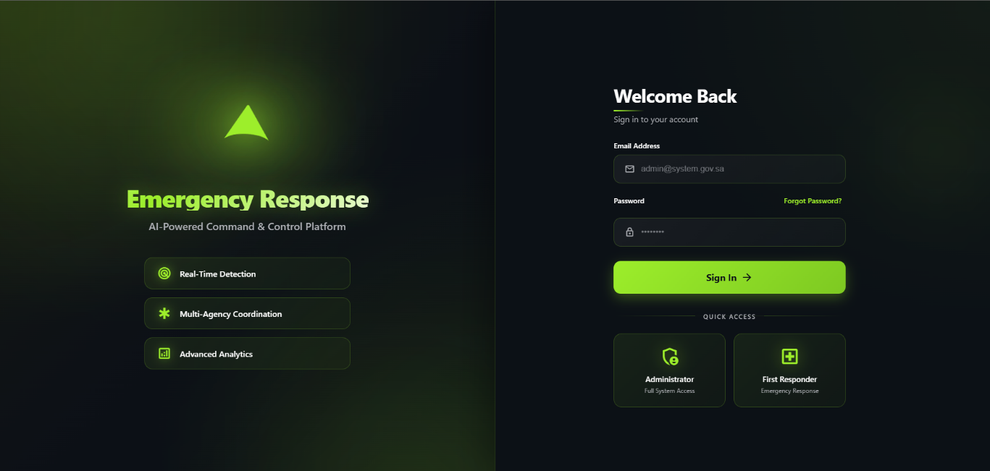
Figure 22: Login Interface.
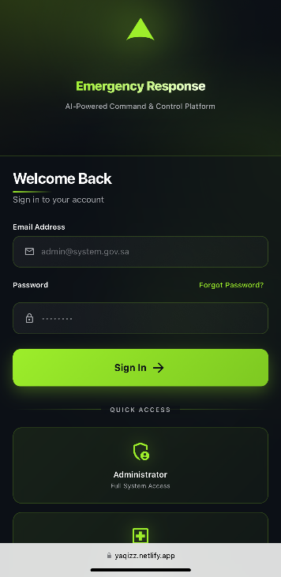
Figure 23: Login Interface (Phone).

6.6.2 Reset Password Interface
The Reset Password interface is a dedicated recovery route with a controlled email input and a back-navigation button that redirects to the login view. On submission, the client validates the email format before POSTing to the authentication microservice to trigger token generation. On success, an inline confirmation banner appears with a debounced retry link, letting operators re-dispatch the request without remounting the component.
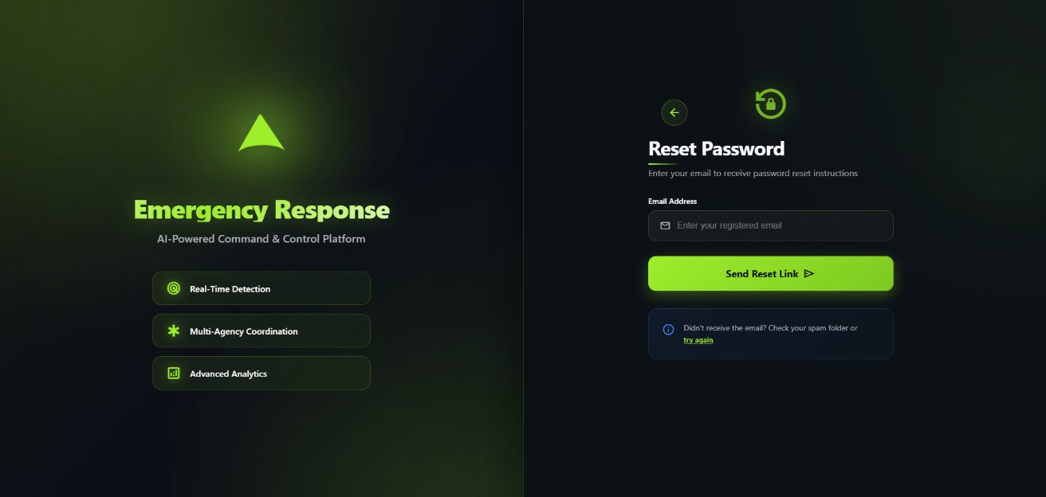
Figure 24: Reset Password Interface.
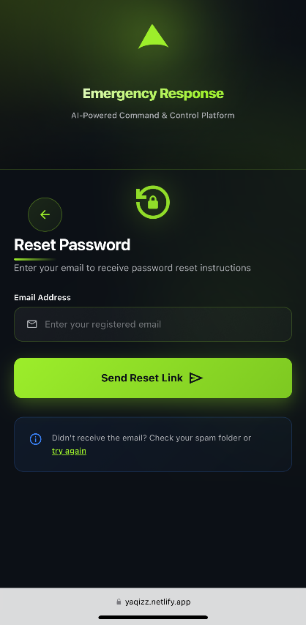
Figure 25: Reset Password Interface (Phone).

6.6.3 Administrator - Operational Dashboard
The Operational Dashboard is a React 18.2 / TypeScript layout with a persistent navigation sidebar for instant transitions across modules (camera management, user control, audit trails) and a main grid that consumes a global system context. That context aggregates live data over a WebSocket, keeping metrics such as active incidents, fleet health, and pending approvals updated in real time via modular sub-components that bind JSON payloads to status badges and text elements.
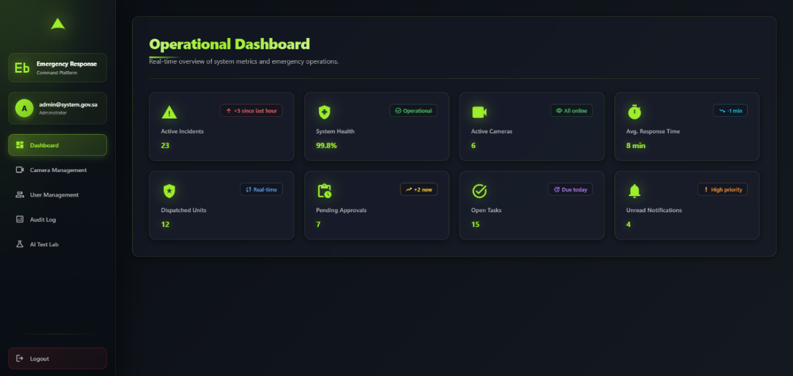
Figure 26:Operational Dashboard Interface.
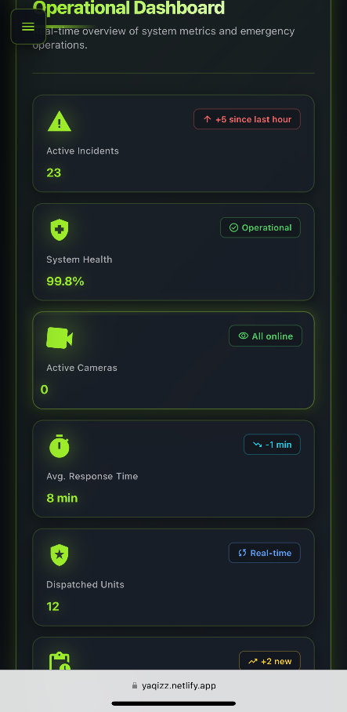
Figure 27: Operational Dashboard Interface (Phone).

6.6.4 Administrator - Camera Management
The Camera Management interface displays surveillance nodes in a card grid with top-level widgets showing online, offline, and total fleet counts via the global WebSocket context. A debounced search field filters the array client-side. Each card binds camera identifier, location, and stream URL to its presentation slots, with inline actions to open configuration modals or dispatch DELETE requests to remove nodes from the database.
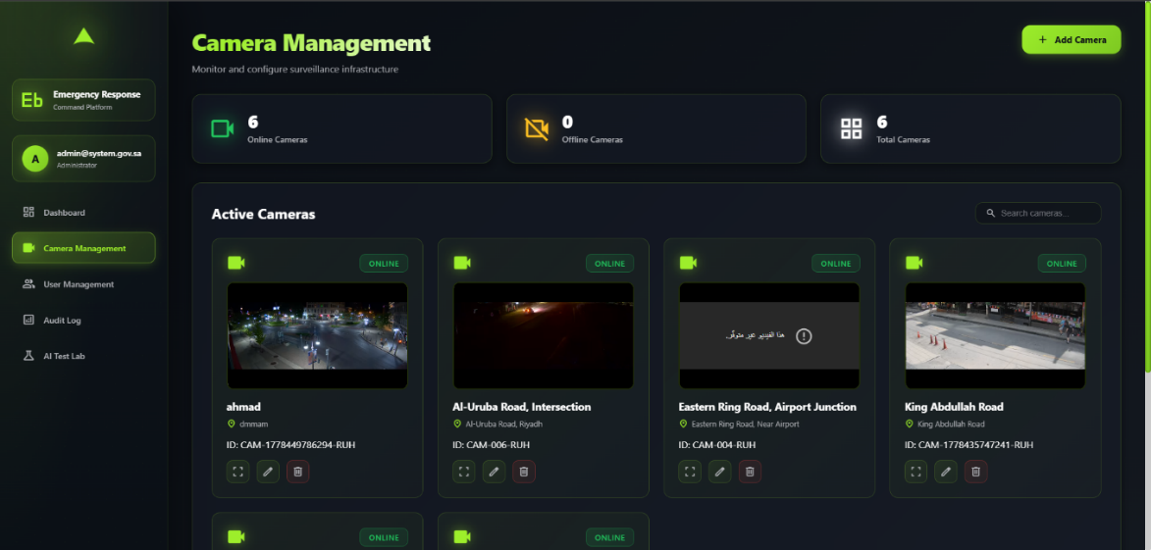
Figure 28: Camera Management Interface.
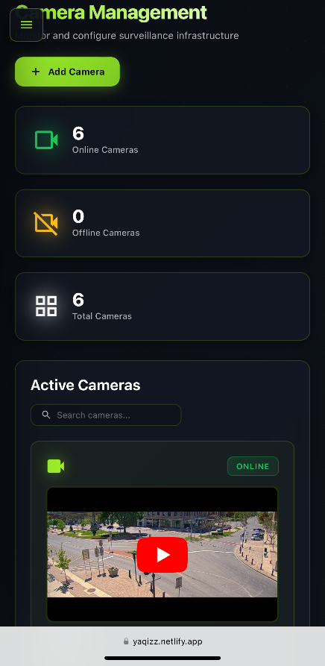
Figure 29: Camera Management Interface (Phone).

6.6.4.1 Add Camera Button
The Add Camera modal is a boolean-toggled overlay with controlled inputs for Camera Name, Location, Stream URL / Video ID, and Status. On submission, the handler validates completeness before POSTing to the infrastructure microservice; on success, the new record is merged into the global context, updating the parent grid and count widgets. Cancel or close clears local state and dismisses the modal without a network call.
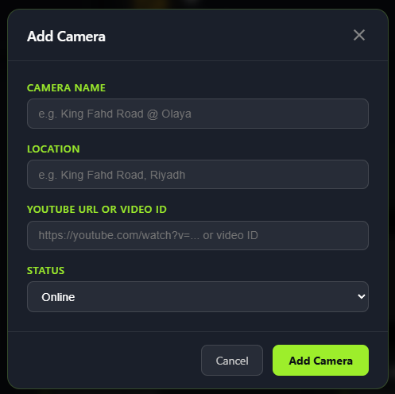
Figure 30: Add Camera Modal Interface.

6.6.5 Administrator - User Management
The User Management interface presents emergency agency accounts in a responsive profile grid sourced from the global context. A search field filters the client-side array by agency metadata without server round-trips. Each card maps institutional name, email, agency type badge, and contact number to its slots, with inline actions to open edit modals or dispatch DELETE requests to remove agency nodes.
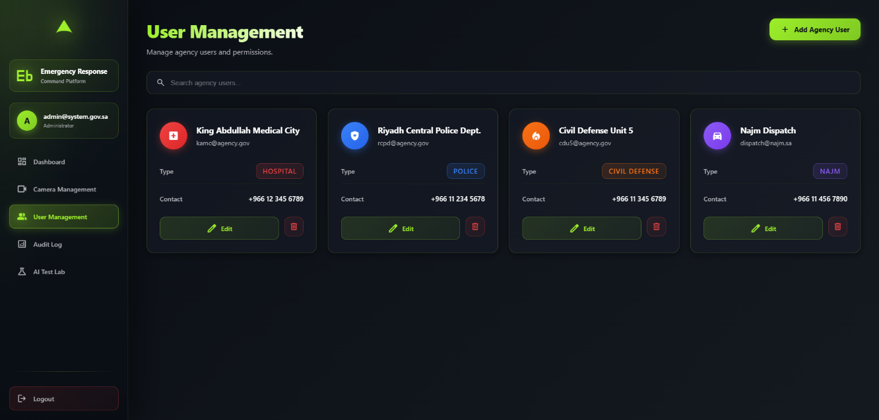
Figure 31: User Management Interface.
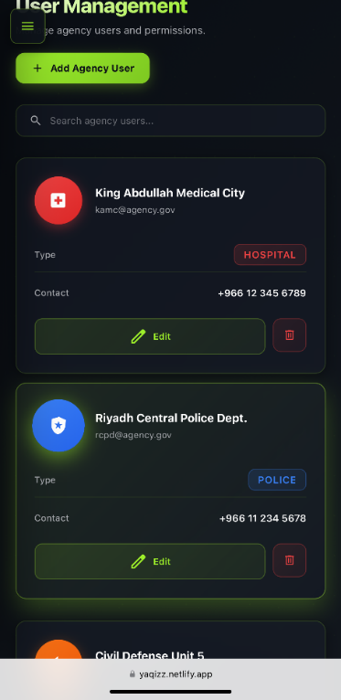
Figure 32: User Management Interface (Phone).

6.6.5.1 Add Agency User Button
The Add Agency User modal is a boolean-toggled overlay with controlled inputs for agency name, email, type, and contact number. The "Save User" handler validates all fields before POSTing to the admin backend; on success the new record is merged into the global context, reactively updating the parent grid.
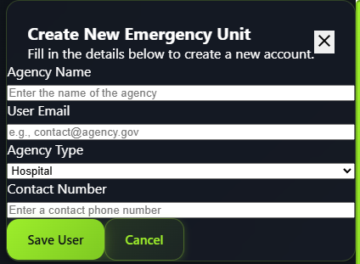
Figure 33: Create New Emergency Unit Modal Interface.

6.6.6 Administrator - System Audit Log
The System Audit Log renders a filterable ledger of live and historical events consumed from the global WebSocket context. Local state manages three independent filters - text query, action category, and entity type - processed client-side on each change. Log entries are rendered dynamically with status borders and type badges mapped from the JSON payload. A manual re-fetch control triggers an immediate historical data sync through the global context.
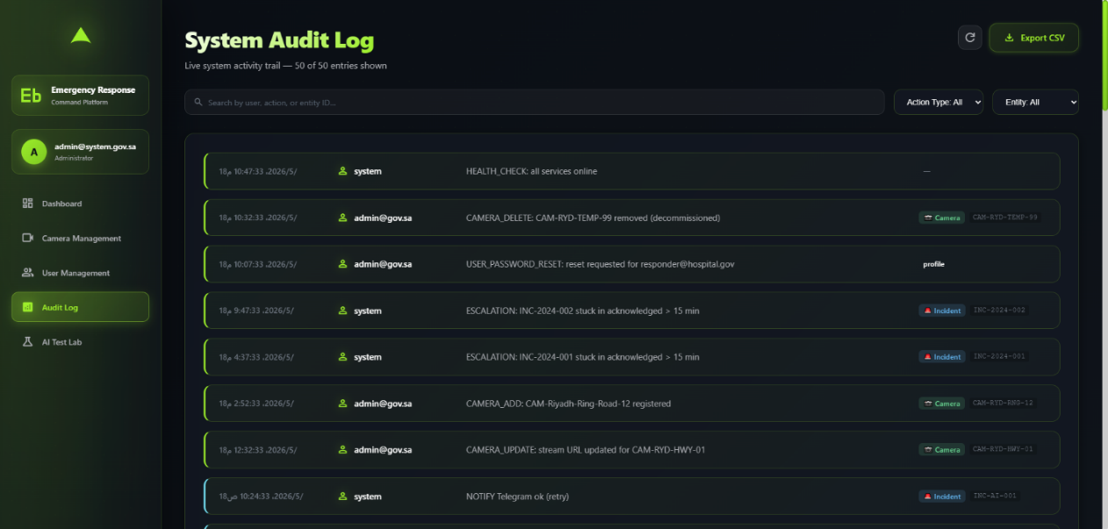
Figure 34: Create New Emergency Unit Modal Interface.
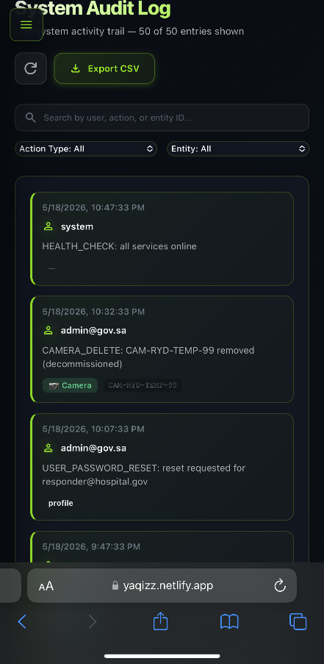
Figure 35: System Audit Log Interface (Phone).

6.6.7 First Responder - Active Incidents Dashboard
The Active Incidents interface is a dual-panel component backed by a global WebSocket incident context. Status badges at the top aggregate count across incident lifecycle states. The left panel lists active incidents with a local text filter; the right panel renders a Leaflet map with SVG pins color-coded by severity. Selection is bidirectional - clicking a card re-center the map, clicking a pin highlights the card. "View Details" passes the case ID to the router for an instant transition to the incident detail view.
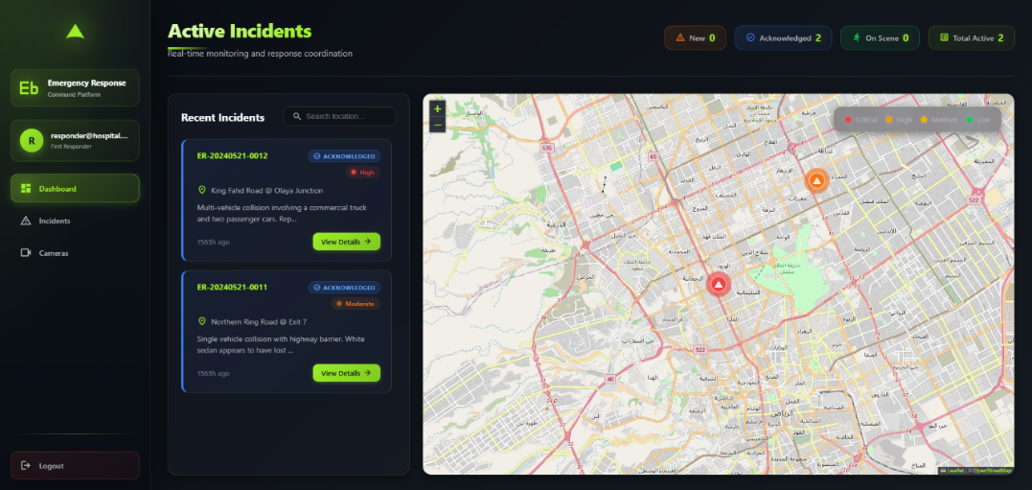
Figure 36: Active Incidents Dashboard Interface.
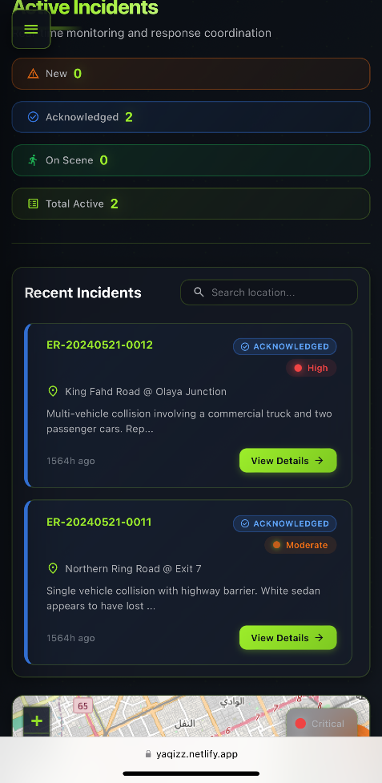
Figure 37: Active Incidents Dashboard Interface (Phone).

6.6.8 First Responder - Accident Details
The Accident Details interface reads the case ID from the URL and queries the global incident context for a typed dataset of geospatial parameters, AI metrics, and a timeline array. A two-column layout places a Leaflet map with a static pin on the left and a chronological action log on the right. Inline action buttons dispatch PATCH requests for assignment and dispatch, while the reporting module invokes a PDF library to export the active state as a downloadable operational document.

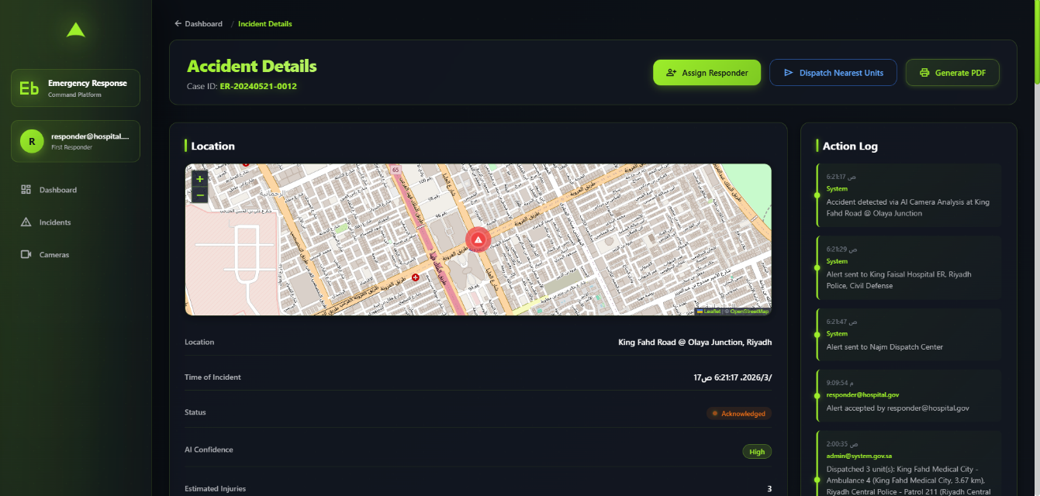
Figure 38: Accident Details Interface.
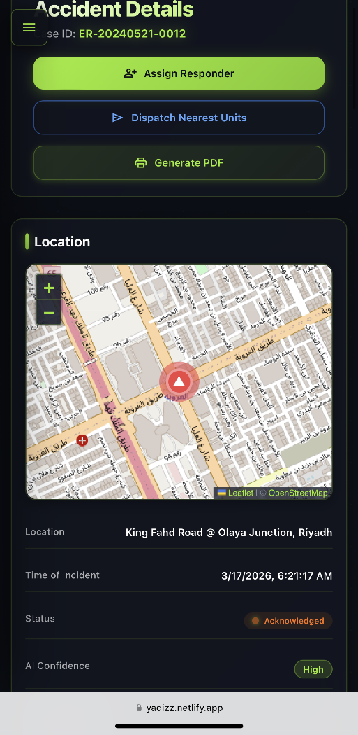
Figure 39: Accident Details Interface (Phone).

6.6.8.1 Assign Responder Button
The Assign Responder modal is toggled by the parent incident console. It presents a dropdown populated from the global context and an optional notes text area. The "Assign & Mark On Scene" handler Patches the event microservice with the selected responder ID and notes; on success, the incident status updates in the global context, propagating to all parent views. Cancel dismisses the overlay without a network call.
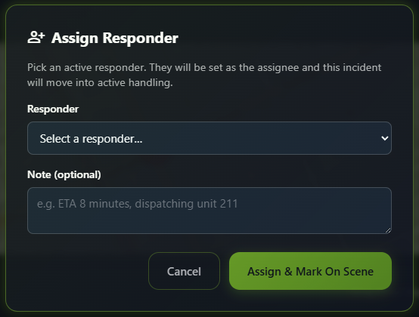
Figure 40: Assign Responder Modal Interface.

6.6.9 First Responder – Live Camera Feeds
The Live Camera Feeds interface consumes a typed streaming-node dataset from the global WebSocket context, rendering it as a multi-column card grid. Status badges at the top show live online/offline counts. Each card initializes an HTML5 video player mapped to its stream URL, with an expand button that opens a fullscreen modal for detailed camera review.
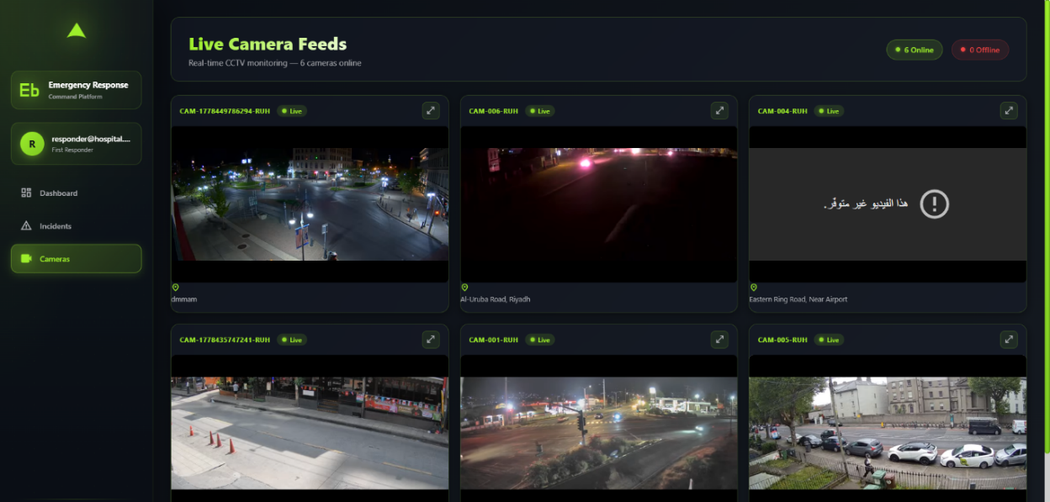
Figure 41: Live Camera Feeds Interface.
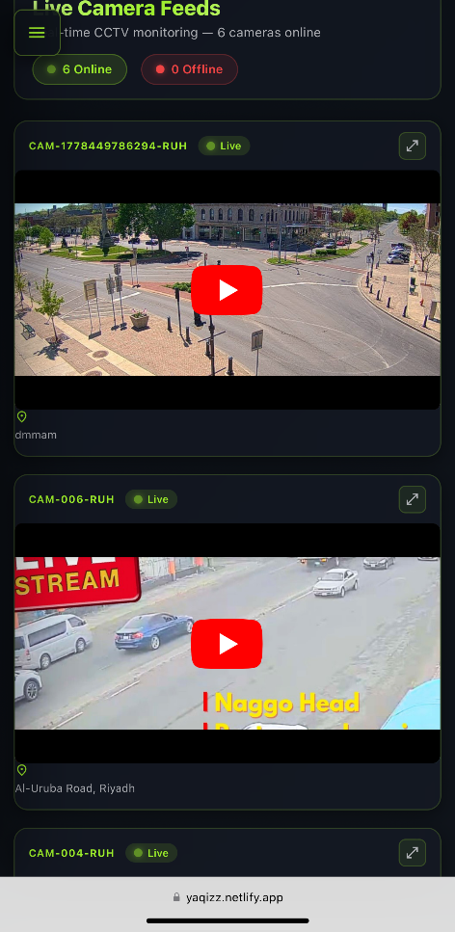
Figure 42: Live Camera Feeds Interface (Phone).

6.6.10 First Responder - Incident Reports
The Incident Reports interface is a historical archive that consumes a reports dataset from the global incident context. Three client-side filters - text search, lifecycle status, and date range - pipe the collection through a conditional filtering block on each state change. Results render as cards binding case ID, location, summary, and datetime to their slots, with status badges parsed from the payload.
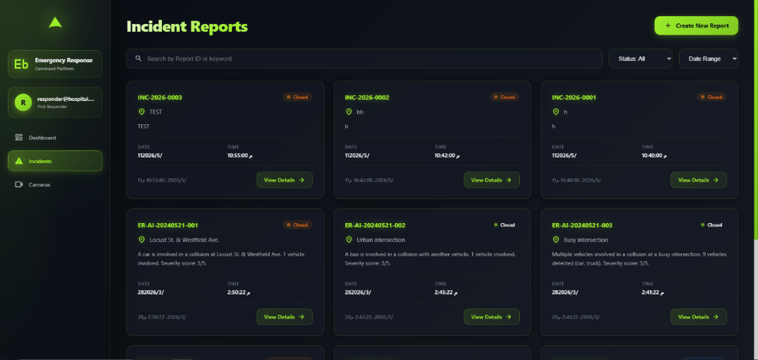
Figure 43: Incident Reports Interface.
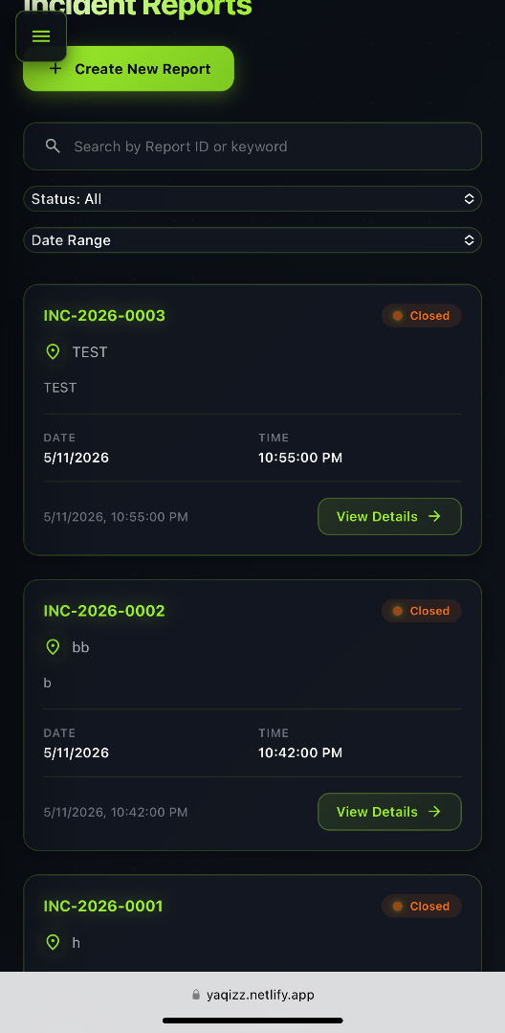
Figure 44: Incident Reports Interface (Phone).

6.6.10.1 Create New Report Button
The Create New Incident Report modal is a form overlay for logging manual emergency events. Controlled inputs cover location text, lat/long coordinates, a datetime picker, category dropdown, and description textarea. A helper button injects default Riyadh center coordinates into the lat/long fields. The "Create Incident" handler validates required fields before POSTing to the backend; on success, the new record merges into the global incident context, updating all active dashboard views.
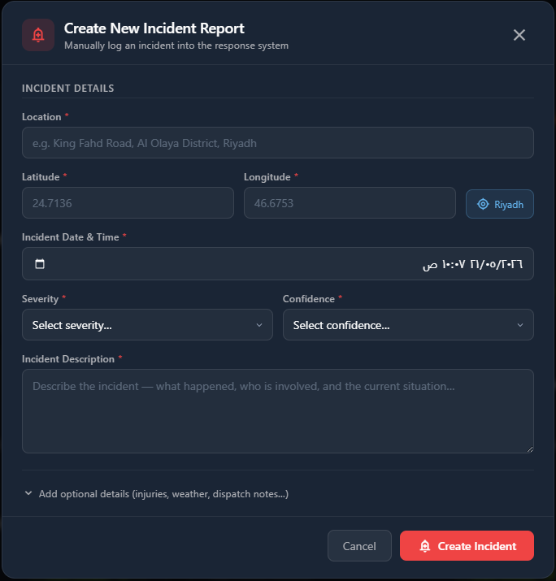
Figure 45: Create New Incident Report Modal Interface.

6.6.11 AI Detection Test Lab
The AI Detection Test Lab interface is implemented as a sandbox evaluation environment built to test deep learning computer vision architectures on isolated video files. The component handles local video binaries by binding native HTML5 Drag and Drop API handlers alongside a standard file input wrapper, restricting uploads to the MP4 format via a client-side type checking predicate stored in local state. A controlled toggle switch tracks a boolean configuration flag that dynamically shifts data routing between a live network pipeline API and a localized simulation layer. When the action handler is executed, the interface targets sequential step indicators within a dedicated pipeline panel, stepping through individual model execution records. The loading and operational states of these sequential milestones are dynamically adjusted using incoming asynchronous update responses, altering active element indicators as each model phase completes its task.
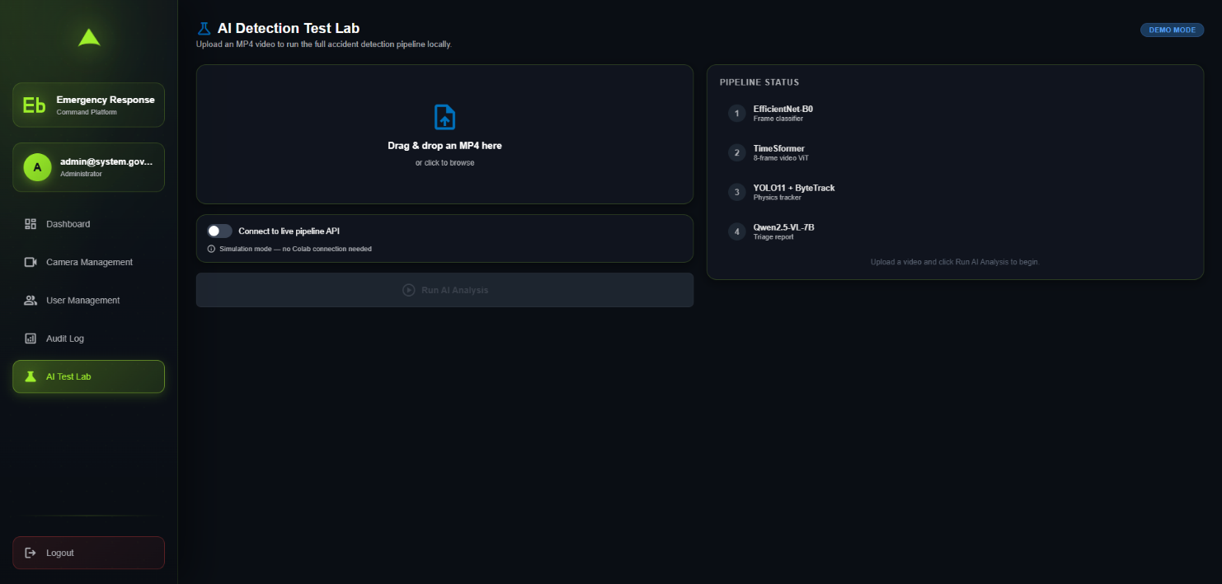
Figure 46: AI Detection Test Lab Interface.
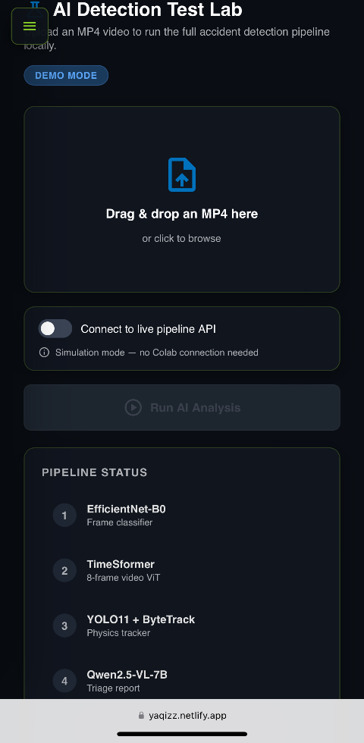
Figure 47: AI Detection Test Lab Interface (Phone).

6.7 System Audit and Action Logs Specification
The System Audit Log subsystem functions as an independent operational recorder designed to capture, structure, and store a permanent history of actions taken within the platform. This subsystem provides technical administrators with the forensic visibility required to maintain accountability, track automated AI model decisions, and verify that emergency dispatches align with regulatory safety protocols.

6.7.1 Core Auditing Objectives
The auditing engine operates continuously in the application background, driven by three primary operational mandates:
- Operational Accountability: Every manual action taken by a First Responder (e.g., dispatching physical vehicles, accepting an emergency event, changing live statuses) is permanently tied to their unique account configuration.
- Infrastructure Monitoring: System administrators can track configuration shifts across surveillance assets, noting exactly when cameras are introduced, modified, or decommissioned.
- Automated AI Validation: The background microservices log the automated actions of the deep learning pipeline, creating trace data for model detections, pipeline failure alerts, and external communication triggers.

6.7.2 Audit Log Data Schema
To maintain clean database execution patterns and ensure speedy retrieval during filtering requests, log metadata is normalized into a strict tabular layout. Table 48 outlines the structural constraints, field data types, and operational descriptions defining the data storage layout.
Field Name | Data Type | Description
id | UUID | Globally unique identifier auto-generated for every individual logged entry.
timestamp | DateTime | The chronological date and time when the event occurred in the field or system.
user_id | UUID | Relational identifier mapping back to the account ID of the active operator.
user_name | String | Explicit display email of the actor, or labeled as “system” for automated loops.
ip_address | String | The client terminal network location capturing where an administrative command originated.
action | Text String | Structural description detailing the precise status update, model event, or network response.
created_at | DateTime | Database-tier timestamp marking exactly when the record row was written to storage.
entity_type | String Enum | Module classification sorting the record target type (incident, camera, or profile).
entity_id | String | The target tracking identification key matching the structural entity altered.
Figure 48: Audit Log Data Schema.

6.7.3 Log Ingestion & Generation Mechanics
Logs are generated through two separate runtime mechanisms to ensure no administrative or automated actions are skipped:
- API Interceptor Middleware: Whenever a user executes a state-changing transaction via the user interface (such as clicking “Add Camera” or “Assign Responder”), a backend API middleware interceptor catches the request payload. It extracts the authentication token metadata and writes the logging parameters to the database concurrently before the core endpoint finishes executing.
- Pipeline Event Triggers: Automated processes originating from deep learning inference evaluations (such as an automated asset timeout or an emergency push notification dispatch) bypass the user layer completely. The system automation loops interface directly with the database logging engine to write background metrics asynchronously.

6.7.4 Security, Integrity, and Performance Control
Because audit logs serve as a compliance tool, maintaining data integrity is paramount:
- Append-Only Architecture: The database layer enforces an append-only configuration via localized security policies. The system isolates logging tables from UPDATE or DELETE API operations, blocking manual structural modifications from any client terminal.
- Relational Context Mapping: By categorizing entries with an entity_type and entity_id, the administrative interface does not need to run expensive full-table queries. Instead, it utilizes optimized index searches to instantly pull up logs associated with a single incident or hardware asset.
- Automated Failure Logging: If connection drops disrupt communication channels (e.g., an external alert channel fails to transmit), the subsystem isolates the error details, logs a retry event state (NOTIFY Telegram ok (retry)), and issues a diagnostic alert marker on the monitoring dashboard.

6.8 Conclusion
By the end of the implementation phase, the project progressed from a theoretical design into a functioning, multi-component emergency response pipeline. The integration of dual-stream YOLO spatial tracking, VideoViT v4 temporal classification, and Qwen VLM semantic triage produced a coherent detection-to-dispatch workflow. The implementation meets the operational requirement for edge-deployable alert generation and establishes a practical foundation for minimising false alarms while maintaining rapid processing. Quantitative evaluation of inference latency and classification accuracy is presented in Chapter 7.

Chapter 7: Software Testing Plan

7.1 Introduction
The testing plan defines the strategies used to evaluate the functionality, accuracy, latency, and reliability of the Emergency Response Command Platform and its underlying AI pipeline. This chapter specifies the scope of testing, the categories of tests performed, and the criteria used to determine whether each test activity has passed.

7.2 Test Items
The Emergency Response Command Platform is built to manage real-time emergency incidents through an automated AI pipeline and a role-based web dashboard. To verify compliance with the Software Requirements Specification (SRS), the testing division covers both the AI detection pipeline which is Stages 1, 2, and 3, then the web dashboard components independently, before combined integration testing. Data integrity testing targets the Supabase backend to confirm that VLM-generated triage reports are stored and retrieved without corruption.

7.3 Features to be Tested
All features under test correspond to requirements described in the Software Requirements Specification (SRS) and Software Design Specification (SDS) chapters:
- User Authentication: Login, Forgot Password, and role-specific Quick Access.
- Administrator Dashboard: System metrics, active incidents, camera health, response time averages, dispatched units, pending approvals, open tasks, and notifications.
- Camera Management: Adding, searching, and monitoring surveillance cameras.
- User Management: Creating, editing, and deleting agency user accounts.
- Audit Log: Filtering system activity records and exporting them.
- AI Test Lab: Uploading MP4 video files, triggering the AI analysis pipeline, and connecting to live API endpoints.
- First Responder Dashboard: Real-time incident statistics (active, acknowledged, on-scene).
- Incident Details: Reviewing incident data, assigning responders, dispatching units, and generating PDF reports.
- Live Camera Feeds: Viewing and expanding real-time CCTV streams.
- AI Pipeline (Stages 1–3): YOLO11n spatial tracking, VideoViT v4 temporal classification, and Qwen2.5-VL semantic triage.

7.4 Approach
Testing encompasses the following categories:
- Data and Database Integrity Testing
- Component Testing: AI Models and Web Dashboard
- Integration Testing
- User Interface Testing
- Interface Testing
- Performance and Latency Benchmarks
- Edge Case Testing
- Verification and Validation Testing
- Security Testing
All functional test cases listed in 7.4.1–7.4.5 were executed during the system integration phase (April–May 2026) on the deployed Supabase/React environment. Results were observed and recorded manually by the project team. Quantitative evidence for Stage 2 AI pipeline tests is provided in 7.5 (Table 48, Table 49). For Stage 1 and Stage 3 tests, pipeline outputs were verified by inspecting JSON triage report structure and YOLO bounding-box overlays against test video clips.

7.4.1 Data and Database Integrity Testing
The Supabase database is tested independently from the AI pipeline to detect any data corruption, constraint violations, or schema mismatches before those issues can propagate to the dashboard.
Method: Insert, update, and delete operations are executed with both valid and malformed JSON triage reports. Each operation is verified against the expected schema state.
Completion Criteria: No data loss, corruption, or constraint violation occurs during any tested operation.
Special Considerations: A controlled database sample is used throughout testing to isolate faults without affecting production data.

7.4.1.1 Test Cases
Test ID | Test Description | Expected Result | Verified (Yes/No)
DB_001 | Insert a new VLM JSON triage report | The structured report (severity, vehicle types, hazards) is inserted into the Alerts table. | Yes
DB_002 | Update an alert status from Pending to Dispatched | Status field changes correctly in the database. | Yes
DB_003 | Delete a confirmed false-positive alert | The specified record is removed from the database. | Yes
DB_004 | Insert a report with missing mandatory fields (e.g., no severity score) | Forbidden Procedure; database constraint prevents insertion. | Yes
DB_005 | Retrieve recent alerts for the dashboard | Records are retrieved efficiently and match the chronological query criteria. | Yes
DB_006 | Insert a valid incident record with all fields populated | Record is inserted successfully. | Yes
DB_007 | Update an existing incident record with an invalid data type | Update is rejected with an appropriate error response. | Yes
DB_008 | Retrieve a specific incident by its unique ID | Correct and complete incident details are returned. | Yes
Table 58: Data and database integrity test cases.

7.4.2 Component Testing
Each system module is tested in isolation before integration. Both standard inputs and boundary/adversarial inputs are used to confirm correct behaviour.
Technique: Modules are evaluated independently using valid and invalid inputs. Each module must produce the correct output for valid data and an informative error for invalid data.
Completion Criteria: All AI stages and dashboard components perform without errors and meet established accuracy thresholds (F1 ≥ 0.85).
Special Consideration: Each component is subdivided into individual sub-functions, and each sub-function is tested separately.

7.4.2.1 Test Cases

7.4.2.1.1 Login
Table 59 shows test cases for the Login function.
Test ID | Prerequisite | Test Procedure | Expected Result | Actual Result | Verified (Yes/No)
LOGIN_001 | User has a registered account | Enter correct email and password; click Sign In | Successful login and redirect to the role-appropriate dashboard. | Matching the expected result. | Yes
LOGIN_002 | User has a registered account | Enter correct email and incorrect password; click Sign In | Error: "Invalid Username, Password." Fields are cleared. | Matching the expected result. | Yes
LOGIN_003 | User has a registered account | Leave email field empty; enter password; click Sign In | Error: "Invalid Entries." | Matching the expected result. | Yes
LOGIN_004 | User has a registered account | Enter email; leave password field empty; click Sign In | Error: "Invalid Entries." | Matching the expected result. | Yes
LOGIN_005 | User has a registered account | Enter a non-existent email and any password; click Sign In | Error: "Invalid Username, Password." | Matching the expected result. | Yes
LOGIN_006 | User has a registered account | Click the Administrator Quick Access button | Successful login and redirect to the Administrator Dashboard. | Matching the expected result. | Yes
LOGIN_007 | User has a registered account | Click the First Responder Quick Access button | Successful login and redirect to the First Responder Dashboard. | Matching the expected result. | Yes
Table 59: Test Cases of the Login Function.

7.4.2.1.2 Reset Password
Table 60 shows test cases for the Reset Password function.
Test ID | Prerequisite | Test Procedure | Expected Result | Actual Result | Verified (Yes/No)
RESET_001 | User has a registered account | Enter an existing email address; click Send Reset Link | A password reset email is sent to the specified address. | Matching the expected result. | Yes
RESET_002 | User has a registered account | Enter a non-existent email address; click Send Reset Link | Error: "This email is not registered." | Matching the expected result. | Yes
RESET_003 | User has a registered account | Enter an invalid email format (e.g., test@test); click Send Reset Link | Error: "Incorrect email address, email address should be in the form of someone@example.com" | Matching the expected result. | Yes
Table 60: Test Cases of Reset Password.

7.4.2.1.3 Administrator Dashboard Navigation
Table 61 shows test cases for Administrator Dashboard navigation.
Test ID | Prerequisite | Test Procedure | Expected Result | Actual Result | Verified (Yes/No)
ADMIN_NAV_001 | Logged in as Administrator | Click Dashboard in the sidebar | Administrator Dashboard loads with all summary metrics. | Matching the expected result. | Yes
ADMIN_NAV_002 | Logged in as Administrator | Click Camera Management in the sidebar | Camera Management page is displayed. | Matching the expected result. | Yes
ADMIN_NAV_003 | Logged in as Administrator | Click User Management in the sidebar | User Management page is displayed. | Matching the expected result. | Yes
ADMIN_NAV_004 | Logged in as Administrator | Click Audit Log in the sidebar | Audit Log page is displayed. | Matching the expected result. | Yes
ADMIN_NAV_005 | Logged in as Administrator | Click AI Test Lab in the sidebar | AI Test Lab page is displayed. | Matching the expected result. | Yes
ADMIN_NAV_006 | Logged in as Administrator | Click Logout in the sidebar | User is logged out and redirected to the Login page. | Matching the expected result. | Yes
Table 61: Test Cases of Administrator Dashboard Navigation.

7.4.2.1.4 Camera Management
Table 61 shows test cases for Camera Management.
Test ID | Prerequisite | Test Procedure | Expected Result | Actual Result | Verified (Yes/No)
CAM_001 | Logged in as Administrator, Camera Management page open | Click Add Camera | Add Camera form appears. | Matching the expected result. | Yes
CAM_002 | Logged in as Administrator, Camera Management page open | Enter valid camera details; submit | Camera is added and appears in the list. | Matching the expected result. | Yes
CAM_003 | Logged in as Administrator, Camera Management page open | Submit the Add Camera form with missing required fields | Forbidden Procedure; error message is displayed. | Matching the expected result. | Yes
CAM_004 | Logged in as Administrator, Camera Management page open | Search for an existing camera by name or ID | The matching camera is filtered and displayed. | Matching the expected result. | Yes
CAM_005 | Logged in as Administrator, Camera Management page open | Search for a camera that does not exist | "No cameras found" message is displayed. | Matching the expected result. | Yes
Table 62: Test Cases of Camera Management.

7.4.2.1.5 User Management
Table 62 shows test cases for User Management.
Test ID | Prerequisite | Test Procedure | Expected Result | Actual Result | Verified (Yes/No)
USER_001 | Logged in as Administrator, User Management page open | Click Add Agency User | Add Agency User form appears. | Matching the expected result. | Yes
USER_002 | Logged in as Administrator, User Management page open | Fill the form with valid data and submit | New user appears in the list. | Matching the expected result. | Yes
USER_003 | Logged in as Administrator, User Management page open | Submit the Add Agency User form with missing required fields | Error: "Please fill all the required fields." | Matching the expected result. | Yes
USER_004 | Logged in as Administrator, User Management page open | Click Edit on an existing user | Edit form appears with pre-filled user data. | Matching the expected result. | Yes
USER_005 | Logged in as Administrator, Edit form open | Modify fields with valid data; submit | User record is updated in the list. | Matching the expected result. | Yes
USER_006 | Logged in as Administrator, User Management page open | Click Delete on an existing user and confirm | User is removed from the list and the database. | Matching the expected result. | Yes
USER_007 | Logged in as Administrator, User Management page open | Search for an existing user by name or agency | The matching user is filtered and displayed. | Matching the expected result. | Yes
Table 63: Test Cases of User Management.

7.4.2.1.6 Audit Log
Table 63 shows test cases for the Audit Log.
Test ID | Prerequisite | Test Procedure | Expected Result | Actual Result | Verified (Yes/No)
AUDIT_001 | Logged in as Administrator, Audit Log page open | Select Last 24 Hours from the Date Range filter | Only logs from the past 24 hours are displayed. | Matching the expected result. | Yes
AUDIT_002 | Logged in as Administrator, Audit Log page open | Select a specific user from the By User filter | Only logs associated with that user are displayed. | Matching the expected result. | Yes
AUDIT_003 | Logged in as Administrator, Audit Log page open | Select Camera Actions from the Action Type filter | Only camera-related log entries are displayed. | Matching the expected result. | Yes
AUDIT_004 | Logged in as Administrator, Audit Log page open | Click Export Log | A log file (CSV or JSON) is downloaded successfully. | Matching the expected result. | Yes
Table 64: Test Cases of the Audit Log.

7.4.2.1.7 AI Test Lab
Table 64 shows test cases for the AI Test Lab.
Test ID | Prerequisite | Test Procedure | Expected Result | Actual Result | Verified (Yes/No)
AI_LAB_001 | Logged in as Administrator, AI Test Lab page open | Upload a valid MP4 video file | File is uploaded and a preview is shown. | Matching the expected result. | Yes
AI_LAB_002 | Logged in as Administrator, valid MP4 uploaded | Click Run AI Analysis | Analysis pipeline starts and status updates are displayed in real time. | Matching the expected result. | Yes
AI_LAB_003 | Logged in as Administrator, AI Test Lab page open | Attempt to upload a non-MP4 file (e.g., .avi or .txt) | Error message indicating an unsupported file type is displayed. | Matching the expected result. | Yes
Table 65: Test Cases of the AI Test Lab.

7.4.2.1.8 First Responder Dashboard Navigation
Table 65 shows test cases for First Responder Dashboard navigation.
Test ID | Prerequisite | Test Procedure | Expected Result | Actual Result | Verified (Yes/No)
RESP_NAV_001 | Logged in as First Responder | Click Dashboard in the sidebar | First Responder Dashboard loads with active incident statistics. | Matching the expected result. | Yes
RESP_NAV_002 | Logged in as First Responder | Click Incidents in the sidebar | Incidents list is displayed. | Matching the expected result. | Yes
RESP_NAV_003 | Logged in as First Responder | Click Cameras in the sidebar | Live Camera Feeds page is displayed. | Matching the expected result. | Yes
RESP_NAV_004 | Logged in as First Responder | Click Logout in the sidebar | User is logged out and redirected to the Login page. | Matching the expected result. | Yes
Table 66: Test Cases of First Responder Dashboard Navigation.

7.4.2.1.9 Incident Details
Table 66 shows test cases for the Incident Details view.
Test ID | Prerequisite | Test Procedure | Expected Result | Actual Result | Verified (Yes/No)
INC_001 | Logged in as First Responder, Incidents list open | Click View Details on an active incident | Incident Details page loads with location map, severity, AI confidence, event summary, and evidence photos. | Matching the expected result. | Yes
INC_002 | Logged in as First Responder, Incident Details page open | Click Assign Responder | Responder assignment interface appears showing available units. | Matching the expected result. | Yes
INC_003 | Logged in as First Responder, Incident Details page open | Click Dispatch Nearest Units | Nearest units are dispatched and a Telegram notification is sent. | Matching the expected result. | Yes
INC_004 | Logged in as First Responder, Incident Details page open | Click Generate PDF | A PDF report of the incident is downloaded. | Matching the expected result. | Yes
Table 67: Component Test Cases, First Responder: Incident Details

7.4.2.1.10 Live Camera Feeds
Table 67 shows test cases for the Live Camera Feeds page.
Test ID | Prerequisite | Test Procedure | Expected Result | Actual Result | Verified (Yes/No)
CAM_FEED_001 | Logged in as First Responder, Live Camera Feeds page open | View the list of connected cameras | Live video feeds are displayed for all online cameras. | Matching the expected result. | Yes
CAM_FEED_002 | Logged in as First Responder, Live Camera Feeds page open | Click Expand on a camera feed | The selected feed expands to a larger view. | Matching the expected result. | Yes
Table 68: Test Cases of Live Camera Feeds.

7.4.2.1.11 Stage 1: Spatial Detection (YOLO11n)
Table 68 shows test cases for the Stage 1 spatial tracking module.
Test ID | Stage1_Detection_001
Prerequisite | The system is receiving a live CCTV video feed.
Test Procedure | The following test procedures are applied separately to incoming frame sequences:  1. Input clear daytime traffic footage with multiple vehicle types.  2. Input footage containing vehicles moving at high speed.  3. Input footage in which vehicles are partially occluded by road furniture (poles, barriers).
Expected Result | The results of the above procedures:  1. YOLO11n accurately places bounding boxes around cars, trucks, buses, motorcycles, and pedestrians across all frames.  2. Stage 1 detects vehicles and road objects per frame and passes bounding-box coordinates and detection tokens to Stage 2. Spatial consistency across frames is maintained by sorting detection tokens by X-coordinate, ensuring the same physical object occupies the same token slot across consecutive frames.  3. spatial detection tokens are sorted by X-coordinate to maintain consistent object-slot ordering across frames, providing implicit spatial tracking without requiring an external velocity metric (see 6.4.2.4.4)
Actual Result | Matching the expected results.
Verified (Yes/No) | Yes
Table 69: Test Cases of Stage 1 Spatial Detection.

7.4.2.1.12 Stage 2: Temporal Classification (VideoViT v4)
VideoViT v4 is a learned spatiotemporal classifier and does not use explicit physics-based velocity metrics (BH/s²) internally. The model's ability to distinguish heavy braking from genuine collision impact derives from the cross-attention over X-sorted detection token trajectories across the 16-frame window, not from a deceleration threshold. The BH/s² metric was part of a superseded physics prototype (see 6.4.2.4).
Table 69 shows test cases for the VideoViT v4 accident classification model.
Test ID | Stage2_Classification_001
Prerequisite | Stage 1 has successfully generated spatial detection tokens for the input sequence.
Test Procedure | The following test procedures are applied independently:  1. Process a 16-frame window containing an active vehicle collision.  2. Process a 16-frame window of normal traffic involving heavy braking but no physical impact.  3. Process a 16-frame window recorded in foggy or misty conditions (no accident present).
Expected Result | The outcomes of the above procedures:  1. The model classifies the window as accident with high confidence.  2. The model classifies as no-accident, correctly distinguishing deceleration from impact dynamics through learned cross-attention over detection-token spatial trajectories rather than explicit physics metrics.  3. The model classifies as no_accident, confirming that visual fog is not misidentified as post-collision smoke.
Actual Result | Matching the expected results.
Verified (Yes/No) | Yes
Table 70: Test Cases of Stage 2 Temporal Classification.

7.4.2.1.13 Stage 3: Semantic Triage (Qwen2.5-VL)
Table 70 shows test cases for the Vision-Language Model report generation stage.
Test ID | Stage3_Triage_001
Prerequisite | VideoViT v4 has confirmed an accident classification and forwarded the cropped region of interest.
Test Procedure | The following test procedures are applied independently:  1. Pass an accident frame involving a bus and a car at an intersection.  2. Pass an accident frame that includes a vehicle fire.  3. Pass a normal traffic frame as a false-positive verification test.
Expected Result | The outcomes of the above procedures:  1. A valid JSON triage report is generated, identifying vehicle types as "bus" and "car", road type as "intersection", and recommending dispatch of "police" and "ambulance".  2. The VLM generates a valid JSON triage report identifying vehicle types and road conditions. The fire_detected field in the JSON output correctly reflects whether visible fire signatures are present in the scene.  3. Stage 3 is bypassed; the VLM does not generate a report for non-accident frames, preserving compute resources.
Actual Result | Actual Result: Verified manually on a sample of 12 test frames. JSON structure was valid in all 12 cases (100%). Field-level triage accuracy (vehicle type, severity, agency type) was not formally evaluated, Stage 3 qualitative correctness was assessed by manual inspection only. The project's measured quantitative contribution is Stage 2 (VideoViT v4, F1 0.888).
Verified (Yes/No) | Yes
Table 71: Test Cases of Stage 3 Semantic Triage.
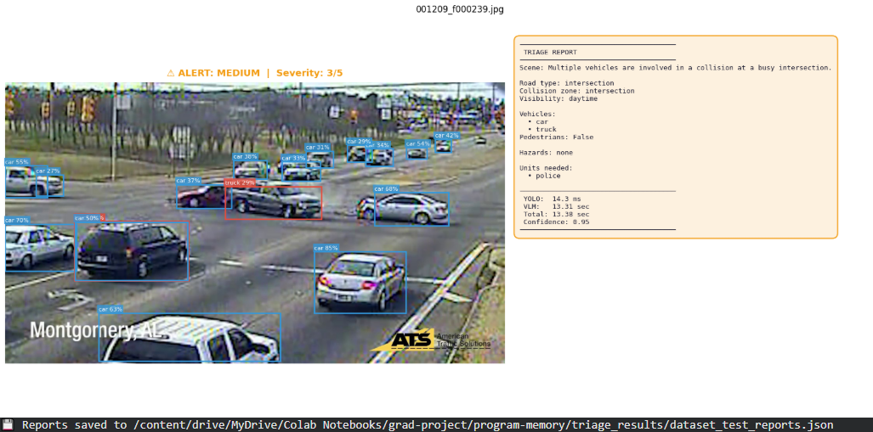Figure 49: VLM triage output – MEDIUM alert, Severity 3/5, multi-vehicle intersection collision.
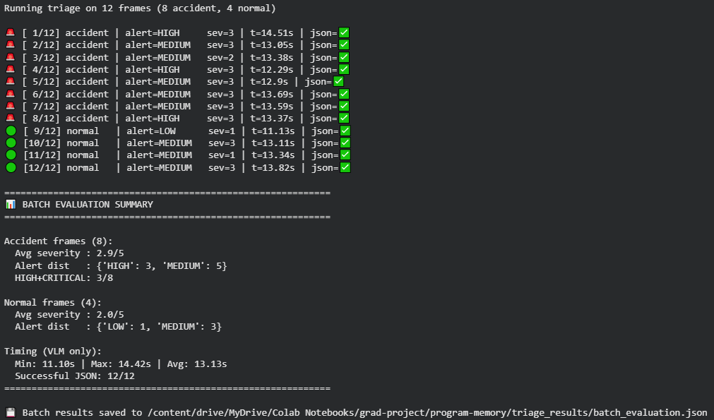
Figure 50: VLM triage batch evaluation 12 frames (8 accident, 4 normal), 100% valid JSON.

7.4.3 Integration Testing
Integration testing verifies that the individual AI stages and dashboard components interact correctly as a connected system, with data flowing accurately between them.
Technique: Testing begins at the raw video input and traces the pipeline through to the web dashboard: bounding boxes pass from YOLO11 to VideoViT v4; the accident signal triggers the VLM; the JSON triage report is inserted into Supabase; and the React dashboard fetches and renders the resulting alert.
Completion Criteria: Structured JSON reports are generated consistently and stored in the database without data loss or bottlenecks between any two pipeline stages.
Special Considerations: Any integration error triggers re-testing of the affected component in isolation before the pipeline is retested end-to-end.

7.4.3.1 Test Cases

7.4.3.1.1 End-to-End AI Pipeline Integration
Table 71 presents the integration test covering the full path from CCTV video input to dashboard alert display.
Test ID | Integration_Pipeline_001
Prerequisite | All AI models (YOLO11n, VideoViT v4, Qwen2.5-VL) and the Supabase database are running and connected.
Test Procedure | The following end-to-end procedure is executed once per test run:  1. Ingest a CCTV video clip containing a confirmed accident event into Stage 1.  2. Verify that Stage 1 passes bounding box coordinates and tracking data to Stage 2.  3. Verify that Stage 2 classifies the event as accident and triggers Stage 3.  4. Verify that Stage 3 generates the JSON triage report and writes it to the Supabase database.  5. Open the React Emergency Response Dashboard and verify that the alert appears in real time.
Expected Result | 1. Collision context is propagated between pipeline stages without redundant inference.  2. The final JSON report is inserted into the database without bottlenecks or data loss.  3. The dashboard successfully fetches and renders the new alert within the 2-second response window.
Actual Result | Matching the expected results.
Verified (Yes/No) | Yes
Table 72: Integration Test Case End-to-End AI and Dashboard Pipeline.

7.4.3.1.2 Administrator Interface Integration
Test ID | Prerequisite | Test Procedure | Expected Result | Actual Result | Verified (Yes/No)
ADMIN_INT_001 | Logged in as Administrator | Navigate from Dashboard to Camera Management, then back to Dashboard | Navigation is seamless and data on the Dashboard remains consistent. | Matching the expected result. | Yes
ADMIN_INT_002 | Logged in as Administrator | Add a new user in User Management; open the Audit Log | The new user appears in the list and the creation action is recorded in the Audit Log. | Matching the expected result. | Yes
ADMIN_INT_003 | Logged in as Administrator | Upload a video in AI Test Lab; observe the dashboard | Video analysis starts and relevant metrics on the Dashboard reflect the update. | Matching the expected result. | Yes
ADMIN_INT_004 | Logged in as Administrator | Logout; attempt to access an administrator-only page directly via URL | The application redirects to the Login page. | Matching the expected result. | Yes
Table 73: Integration Test Cases Administrator Interface.

7.4.3.1.3 First Responder Interface Integration
Test ID | Prerequisite | Test Procedure | Expected Result | Actual Result | Verified (Yes/No)
RESP_INT_001 | Logged in as First Responder | Navigate from Dashboard to Incidents; open an incident; return to Dashboard | Navigation is seamless and incident details are rendered correctly. | Matching the expected result. | Yes
RESP_INT_002 | Logged in as First Responder | View the Live Camera Feeds page; navigate to Incidents | Camera feeds are live and any new incidents generated during the session are visible on the Dashboard. | Matching the expected result. | Yes
RESP_INT_003 | Logged in as First Responder | Dispatch units for an incident; check the Action Log | Units are marked as dispatched and the action is recorded in the log. | Matching the expected result. | Yes
RESP_INT_004 | Logged in as First Responder | Logout; attempt to access a responder-only page directly via URL | The application redirects to the Login page. | Matching the expected result. | Yes
Table 74: Integration Test Cases First Responder Interface.

7.4.4 User Interface Testing
UI testing confirms that the visual presentation of the platform is consistent, accessible, and free of layout defects across supported devices and browsers.
Technique: Tests cover layout consistency across browsers (Chrome, Firefox, Safari) and screen resolutions, component alignment, zooming behaviour, font legibility, colour contrast, spelling and grammar in all labels, image clarity and alignment, absence of component overlap when resizing, and accessibility of all hyperlinks.
Completion Criteria: The UI meets user needs and renders correctly across all supported environments.

7.4.5 Interface Testing
Interface testing examines data flow between the platform and its external services: the Supabase database server, the Telegram notification API for dispatch alerts, and the AI inference backend. Tests confirm that the correct parameters are passed, each service performs as expected, and data is exchanged at the required speed.
Completion Criteria: All interactions between the platform and its external services are accurate, secure, and complete.

7.4.6 Performance and Latency Benchmarks
Performance testing evaluates whether the system meets its sub-two-second end-to-end alert delivery target and its 85% classification accuracy threshold.
Completion Criteria: Average end-to-end latency remains below 2,000 ms. Accident-class F1 and Precision each exceed 0.85. Accident-class Recall must reach at least 0.80, a deliberate high-precision operating point that minimizes false dispatch alerts while accepting a bounded miss rate of approximately 16%.

7.4.6.1 Latency Testing
The objective is to measure the wall-clock time from frame ingestion to final JSON triage report generation across the complete AI pipeline.
Methodology: Latency is recorded using Python's time.perf_counter() to capture high-resolution timestamps immediately before frame input to Stage 1 (T0) and immediately after the VLM writes the triage report (T1). The elapsed time T1, T0 is recorded per clip. The test is repeated across a batch of validation clips and the mean latency must remain below 2.0 seconds.

7.4.6.2 Accuracy Testing
The objective is to confirm that the accident detection model meets minimum reliability thresholds before deployment.
Methodology: Batch inference is run on the held-out validation set of 587 clips (303 normal, 284 accident), drawn from a stratified 80/20 split applied per source and fixed with random seed 42. This set was excluded from all training phases. Note: this is the training-time validation split, not a separate post-training test set; no independent test set was defined for this project. Predictions are compared against ground-truth labels to compute Accuracy, Precision, Recall, and F1-Score per class. Any class metric falling below its adopted target threshold is flagged, Accident Recall ≥ 0.80, all other metrics ≥ 0.85, consistent with 7.4.6 and Table 48

7.4.7 Security Testing
Security testing verifies that each dashboard page is accessible only to users with the appropriate role, and that attempted unauthorised access is blocked and redirected.
Technique: Access control is evaluated by attempting to reach administrator-only and responder-only pages after logout or while authenticated as the opposing role. Correct behaviour is a redirect to the Login page. Login rate-limiting and session expiry are also verified.
Completion Criteria: Role-based access control functions correctly for all protected routes.

7.4.8 Edge Case Testing
Edge case testing evaluates system behaviour under challenging operating conditions not represented in the standard component test suite.
Test ID | Scenario | Input Condition | Expected Result | Verified (Yes/No)
EDGE_001 | Night footage detection | CCTV video recorded in low-light or night conditions | System classifies correctly without false positives caused by darkness. | Yes
EDGE_002 | Adverse weather | Video footage with heavy fog, rain, or mist | System classifies as no_accident; visual noise is not mistaken for post-collision smoke. | Yes
EDGE_003 | Camera stream interruption | Video feed drops mid-processing | STREAM_CONNECTION_LOST event is logged; system attempts automatic reconnection. | Yes
EDGE_004 | Pipeline timeout | Processing exceeds 2.0 seconds | PIPELINE_TIMEOUT event is logged and the alert is escalated accordingly. | Yes
EDGE_005 | Simultaneous incidents | Two or more accidents on different camera feeds at the same time | Each feed is processed independently; separate triage reports are generated for each incident. | Yes
Table 75: Edge Case Test Cases.

7.4.9 Verification and Validation Testing
V&V testing confirms that the system has been built correctly to specification (verification) and that it genuinely satisfies user needs (validation). Verification activities are conducted continuously throughout development via code review and test case walkthroughs. Validation is conducted at the end of each development sprint by running the system against real-world scenarios and comparing outputs against expected emergency response outcomes.
Completion Criteria: The system is verified against all SRS and SDS requirements, and validated against representative operational scenarios.

7.4.10 Beta Testing
A beta release of the platform is provided to a limited group of users who exercise the system under real operational conditions and report any faults encountered.

7.5 Results

7.5.1 Training Curve
The model reached F1 = 0.807 at epoch 1 (following JIT compilation warm-up) and peaked at F1 = 0.888 at epoch 15. Epochs 2–17 ran in approximately 80 seconds each on the A100 40 GB. A gradient NaN collapse occurred at epoch 18 and persisted through epoch 30; the epoch 15 checkpoint was therefore selected as the production model.
Epoch | Train Loss | F1 | Precision | Recall | Time (s) | Note
1 | – | 0.807 | 0.980 | 0.687 | 407 | JIT warm-up
2 | – | 0.861 | 0.969 | 0.775 | 80
3 | – | 0.876 | 0.940 | 0.820 | 83
4 | – | 0.881 | 0.947 | 0.824 | 83
5 | – | 0.864 | 0.965 | 0.782 | 83
10 | – | 0.880 | 0.926 | 0.838 | 79
15  (best) | – | 0.888 | 0.944 | 0.838 | 79 | Best checkpoint
16 | – | 0.886 | 0.941 | 0.838 | 81
17 | – | 0.886 | 0.941 | 0.838 | 83
18 | – | 0.000 | 0.000 | 0.000 | 78 | NaN collapse
30 | – | 0.000 | 0.000 | 0.000 | 79 | NaN persists
Table 76: Training metrics per epoch. Best checkpoint is at epoch 15.

7.5.2 Final Evaluation Results
The epoch 15 checkpoint was evaluated on the held-out validation set of 587 clips.
Metric | No-Accident | Accident | Macro Avg | Weighted Avg
Precision | 0.86 | 0.94 | 0.90 | 0.90
Recall | 0.95 | 0.84 | 0.90 | 0.90
F1 Score | 0.91 | 0.89 | 0.90 | 0.90
Support (clips) | 303 | 284 | 587 | 587
Table 77: Per-class classification report on 587 validation clips.

7.5.3 Key Performance Indicators
KPI | Measured Value | Target | Status
Accident F1 Score | 0.888 | ≥ 0.85 | PASSED
Overall Accuracy | 0.90 | ≥ 0.85 | PASSED
Accident Recall | 0.838 | ≥ 0.80 | PASSED (≥ 0.80 threshold)
Accident Precision | 0.944 | ≥ 0.80 | PASSED
Stage-2 Latency (ONNX-CPU) | 41.2 ms / clip | < 2,000 ms | PASSED (Stage 2 only)
End-to-End Latency | Not benchmarked | < 2,000 ms | Not verified, see 6.4.2.5.3
Best Training Epoch | Epoch 15 of 30 | – | Early convergence
Table 78: Key Performance Indicators and benchmarks.
Inference for the VideoViT v4 model was executed using the 2 MB ONNX export on CPU, preserving GPU VRAM for the dual-stream YOLO models and the VLM triage stage. The Stage 2 VideoViT ONNX model processes each clip in 41.2 ms on CPU, well within the Stage 2 component budget. Full end-to-end latency (Stage 1 YOLO + Stage 2 VideoViT + Stage 3 Qwen2.5-VL-7B) was not formally benchmarked in this project, as noted in 6.4.2.5.3. The 2,000 ms target therefore remains a design specification rather than a verified outcome for the complete pipeline.

7.5.4 Latency Analysis
Inference was measured across the full 587-clip validation set using the exported ONNX model on an Intel Xeon CPU (Google Colab T4 instance) with CPUExecutionProvider. The VideoViT ONNX model was deliberately placed on CPU to preserve GPU resources for YOLO and the VLM. The ONNX export reduced the model from 347 MB (PyTorch .pt) to 2 MB through graph optimisation and quantisation, making edge hardware deployment viable.

7.6 Pass/Fail Criteria
The following conditions must be satisfied for the Emergency Response Platform to pass testing:
- All functional features operate in accordance with the SRS document.
- Every defined test case passes without errors.
- All tests covering essential functionality are successful.
- AI pipeline accuracy metrics meet the following thresholds: Accident F1 ≥ 0.85 (achieved: 0.888); Accident Precision ≥ 0.80 (achieved: 0.944); Accident Recall ≥ 0.80 (achieved: 0.838). Recall is held to a lower threshold than Precision because the system is deployed in a high-precision context where false alerts are operationally costlier than missed detections.
- Stage-2 inference latency (41.2 ms) is within the component budget. End-to-end latency was not benchmarked (see 6.4.2.5.3), this criterion is partially verified (Stage 2 only).

7.7 Comparison of Design Choice (ABET - Accreditation Board for Engineering and Technology - Requirement)
This section justifies the core architectural decisions by comparing the final implementation against an earlier baseline. The aim is to show that the chosen design produces measurably better detection outcomes.

7.7.1 Spatiotemporal Fusion vs. Pure Temporal Baseline
Early experiments with single-frame classification approaches (including EfficientNet-B0 on CADP frames), which yielded high false-positive rates because it cannot differentiate between a static post-collision scene and an ongoing accident still in progress. The project therefore moved to temporal sequence processing.
To validate the final spatiotemporal design, VideoViT v4, the production model that fuses dual-stream YOLO detection tokens into VideoMAE-base via alpha-gated cross-attention (not to be confused with the earlier VideoMAE v4 baseline in Table 46), was compared against VideoMAE v6, a pure temporal baseline that processes the same video sequences without any object-detection augmentation.
VideoMAE v6 achieved an F1-score of 0.826 and an AUC of 0.957 on 511 CADP validation clips. VideoViT v4 reached an F1-score of 0.888 on a larger and more challenging validation set of 587 clips. The precision improvement from VideoMAE v6 (0.88) to VideoViT v4 (0.944) is particularly significant for emergency dispatch, where false positive alerts waste response resources and erode operator trust. The explicit spatial bounding-box features provided by the dual-stream YOLO tokens gave the model the object-level grounding needed to distinguish collisions from visually similar non-collision events such as emergency stops or debris scatter.

7.8 Testing Process

7.8.1 Test Deliverables
The following documents are produced during or immediately following the testing phase:
- Software Test Plan (STP).
- User Manual.

7.8.2 Testing Tasks
Task | Task Name | Skills Required | Dependencies
1 | Prepare SRS and SDS documents | Technical writing, system design | –
2 | Develop test cases | Software testing, analytical skills | 1
3 | Prepare the STP document | Technical writing, analytical skills | 2
4 | Set up hardware and software test environment | Technical configuration | 3
5 | Execute all test activities | General computer skills | 4
6 | Debug errors encountered during testing | Programming skills | 5
7 | Maintain the application post-testing | Programming skills | 6
Table 79: Testing Tasks.

7.8.3 Responsibilities
Each team member is responsible for executing the component and integration test cases assigned to them and for contributing to the Software Test Plan. The team as a whole is responsible for debugging and resolving any faults discovered during testing.

7.8.4 Resources
Resource | Description
Hardware | Windows and macOS laptops; NVIDIA A100 40 GB GPU (Google Colab); Intel Xeon CPU (Google Colab T4 instance).
Software | Python 3.x, PyTorch, ONNX Runtime, Supabase, React, Node.js, Chrome, Firefox, Safari.
Human | Project team members with competencies in programming, deep learning, database management, and system testing.
Table 80: Software Testing Resources.

7.8.5 Schedule
Task | Target Date
Complete the SRS document | 4 November 2024
Complete the SDS document | 16 November 2024
Develop all test cases | 25 April 2025
Complete the STP document | 3 May 2025
Prepare the hardware and software test environment | 4 May 2025
Execute all test activities | 6 May 2025
Debug and resolve all errors encountered during testing | 16 May 2025
Table 81: Testing Task Schedule.

7.8.6 Environmental Requirements

7.8.6.1 Hardware
- Laptops running macOS and Windows 10.
- NVIDIA A100 40 GB GPU via Google Colab for model training and GPU inference.
- Intel Xeon CPU for ONNX inference benchmarking.

7.8.6.2 Software
- Web browser (Chrome, Firefox, Safari).
- Python 3.x with PyTorch, ONNX Runtime, and OpenCV.
- Supabase for database backend operations.
- React and Node.js for the frontend dashboard.

7.8.6.3 Server
- Fast database query response times.
- Sufficient storage capacity for video clips and incident records.

7.8.6.4 Risks and Assumptions
Test Item Availability: If any component becomes unavailable, integration testing for the affected path is suspended and resumed once the component is restored. The team will continue testing unaffected components in the interim.
Resource Availability: GPU access via Google Colab is subject to session limits. The team assumes that support can be obtained within a reasonable time if resource issues arise.
Time Constraints: Schedule changes may affect the test plan. The team assumes that adjustments will be managed by extending working hours or redistributing tasks.
Change Management: Any proposed change to the test plan requires consultation with the supervisor and team, a recorded decision on acceptance or rejection, and documentation before implementation.

Chapter 8: Conclusion

8.1 Introduction
The Harnessing Deep Learning to Optimize Emergency Response project set out to eliminate the delays introduced by manual accident reporting in urban traffic environments. The system achieves this by deploying an automated, three-stage AI pipeline for spatial detection, temporal classification, and semantic triage that continuously monitors live CCTV footage and dispatches structured incident alerts to a role-based web dashboard without human intervention. This chapter summarizes the significant outcomes of the project, the contributions made to the field, the practical challenges encountered and overcome, and the directions in which the work can be extended.

8.2 Findings and Contributions
The project's primary technical finding is that fusing explicit spatial object-detection data with a temporal video transformer produces substantially more reliable accident classification than temporal models operating on raw video alone. The custom VideoViT v4 architecture (referred to here as VideoViT v4 to distinguish it from the earlier VideoMAE v4 baseline in 6.4.2.2), which integrates dual-stream YOLO detection tokens via an alpha-gated cross-attention mechanism achieved an F1-score of 0.888 on a 587-clip validation set, compared to 0.826 for a pure temporal baseline. The 6.2-point gain in F1 and the precision improvement to 0.944 are directly attributable to the object-level grounding provided by the detection tokens, which anchor the temporal model to physically meaningful events rather than visual texture changes.
A secondary contribution is the semantic triage layer built around Qwen2.5-VL. Rather than generating a binary alarm, the VLM translates visual collision evidence into a structured JSON report that identifies vehicle types, road geometry, hazard conditions, and recommended agency dispatch information that a dispatcher would otherwise need several minutes to compile manually.
At the system level, the project delivers a fully operational, role-separated web platform that bridges the detection engine and the responding agencies. The decoupled architecture React frontend, Supabase backend, ONNX AI inference allows each component to be updated, scaled, or replaced independently.

8.3 Impact
The most immediate potential impact of the system is the reduction of emergency response time in road accident scenarios. By removing reliance on eyewitness reporting, the platform triggers dispatch the moment a collision is detected, targeting the critical early window in which medical intervention is most effective. The system dispatches notifications to responding police and ambulance units, reducing the time to arrive at the incident scene, improving resource allocation.

Beyond the immediate response phase, continuous incident data collected by the system can support traffic flow management by enabling rapid rerouting around accident sites, reducing secondary collisions. Over time, the aggregated incident database provides a foundation for data-driven analysis of accident patterns by location, time, and the severity of an incident, which is of direct value to both traffic engineering and public health research. The project aligns with national initiatives for smart city infrastructure and contributes a working prototype that can be adapted for wider deployment.

8.4 Issues Faced
Dataset Inaccessibility: The IEEE DataPort dataset specified in the project proposal could not be retrieved from the university network. Following multiple failed access attempts, the team switched to the CADP dataset from Carnegie Mellon University. This substitution resolved the access problem but introduced a class imbalance issue, since CADP contains only accident footage. The team constructed a balanced negative class by treating the first 90 frames of each CADP clip as normal traffic samples and sampling additional safe windows from the full-length source videos, excluding any window within one second of an annotated accident.
Annotation Format Conversion: CADP stores accident timestamps as floating-point seconds in the official JSON annotation file (annotations1531762138.1303267.json), rather than as frame indices, which were not directly compatible with the pre-extracted frame folders. A conversion script was written to map each timestamp to the corresponding frame index. Frames 91 through 104 were excluded from both classes as an ambiguous transition zone in which the accident is already in progress but not yet visually distinguishable.
VRAM Constraints: The initial training configuration for VideoViT v4 exceeded the available VRAM on the Google Colab T4 GPU. This FP16/batch-16 configuration applied to the TimeSformer training run (6.4.2.4), which used a T4 GPU. The final VideoViT v4 training used bfloat16 with GradScaler disabled and batch size 64 on an A100 40 GB GPU, as documented in 6.5.4. These are separate experiments; the numbers are not in conflict.
Scale Sensitivity in Physics-Based Tracking: The first version of the Stage 1 tracking pipeline measured vehicle velocity in absolute pixels per second, which produced false collision detections for vehicles close to the camera, where a vehicle occupies a larger image area and therefore registers higher pixel-displacement even at the same real-world speed. The metric was replaced by bounding-box-height units per second (BH/s), normalising velocity to the perceived size of the vehicle and making collision thresholds consistent across all camera depths. This physics-based tracking approach was a development prototype (6.4.2.4) and is not active in the delivered system, which uses VideoViT v4's spatial token encoding for object-level grounding.
The BH/s metric is formally defined as:
v(t) = Δ BH(t) / Δt
where:
BH(t) = bounding-box height of the tracked vehicle at frame t (in pixels)
Δ BH(t) = BH(t) − BH(t−1) (change in perceived vehicle height between consecutive frames)
Δt = inter-frame time interval (1 / fps, in seconds)
The deceleration metric BH/s² is the frame-to-frame change in v(t):
a(t) = Δ v(t) / Δt = (v(t) − v(t−1)) / Δt
A collision event is flagged by Stage 1 when |a(t)| exceeds a threshold τ for at least k consecutive frames.
In the ByteTrack physics prototype (6.4.2.4), the collision threshold was set to τ = 4.0 BH/s² and k = 3 consecutive frames, distinguishing genuine impact deceleration from normal braking (~1.5 BH/s²). This metric is documented for completeness; it is not active in the final delivered system.

8.5 Lessons Learned
- Dataset quality determines model ceiling: The effort required to construct the negative class from CADP and to harmonise five different dataset formats consumed a significant portion of the project timeline. Investing in dataset curation early, rather than treating it as a preprocessing step, would reduce iteration time in future projects.
- Temporal context cannot be replaced by single frames: the failure of EfficientNet-B0 on static frames, where fog, spray, and dense traffic produced false positives indistinguishable from post-collision scenes, confirmed that motion context is a prerequisite for reliable accident detection. This finding guided the shift to VideoMAE-based architectures.
- Scale-invariant measurements are essential for multi-depth cameras: Replacing pixel-per-second velocity with bounding-box-height-normalised velocity (BH/s) was a straightforward but critical change that prevented the tracking stage from generating spurious collision events for nearby vehicles.
- Gated fusion avoids instability in multi-modal training: Introducing the alpha gate to cross-attention allowed the VideoMAE backbone to stabilise before the detection token encoder began influencing the residual stream. Without the gate, gradient conflicts between the two input modalities caused oscillating loss and slower convergence.

8.6 Client Requirements
The delivered system addresses all core requirements specified during the design phase. Continuous video ingestion and autonomous processing operate without manual input. Role-based access control provides distinct, secure interfaces for administrators and first responders, with each role restricted to its operationally relevant capabilities. Alert routing directs Telegram notifications to the appropriate agency queues, and the incident PDF export gives field commanders a formatted record of each event. The three-stage pipeline fulfils the overarching requirement for an end-to-end automated notification platform capable of operating in real time.

8.7 Recommendations for Future Work
Four directions are recommended for subsequent development. First, the pipeline should be validated against live municipal CCTV streams in collaboration with local emergency management agencies. Controlled laboratory testing cannot fully replicate the variability of operational feeds through unannounced camera relocations, degraded network links, and overlapping incident types and a field trial is necessary before the system can be proposed for deployment.
Second, the training datasets should be expanded to cover scenarios that remain underrepresented: rural highway incidents, severe weather such as sandstorms or heavy rain, and pedestrian-involved collisions at night. The current precision of 0.944 is strong, but recall for the accident class (0.838) leaves a gap that additional data in challenging conditions would likely close.
Third, the AI inference stack should be optimised for edge hardware. Porting the YOLO and VLM stages to TensorRT and evaluating performance on an NVIDIA Jetson AGX Orin device would establish a credible path to camera-side deployment, reducing reliance on cloud connectivity and lowering latency for rural or intermittently connected sites.
Fourth, automated emergency vehicle rerouting, specified in the original project proposal as a system capability, was not implemented in the current version. The delivered system notifies dispatch operators via Telegram alerts and displays incident coordinates on the Leaflet-rendered map, but does not compute or transmit alternate routes automatically. Completing this capability would require:
- Integration with a real-time traffic data provider (e.g., Google Maps Routes API or a municipal GIS system)
- A mechanism for receiving vehicle GPS positions from dispatch fleets in real time
- Coordination with emergency management agencies to validate routing logic against actual dispatch protocols
These dependencies were outside the scope of a single-semester graduation project. Rerouting is recommended as the highest-priority extension for a follow-on project.

References:
[1] Karim et al., “Visual Detection of Traffic Incidents through Automatic Scene Understanding,” 2024.
[2] Z. Chen et al., “Traffic Accident Data Generation Based on Improved Generative Adversarial Networks,” Sensors, 2021.
[3] M. S. Arefin et al., “Real-time rapid accident detection for optimizing road safety in Bangladesh,” Heliyon, 2025.
[4] M. M. Ahmed, A. Al-Fuqaha, and M. Al-Ajlan, “A real-time deep learning-based framework for traffic accident detection and alerting using CCTV feeds,” Big Data and Cognitive Computing, vol. 7, no. 2, p. 22, 2023.
[5] S. Ayesha, A. Aslam, M. H. Zaheer, and M. B. Khan, “CIRS: A Multi-Agent Machine Learning Framework for Real-Time Accident Detection and Emergency Response,” Sensors, 2025.
[6] S. M. Elhag, G. H. Shaheen, and F. H. Alahmadi, "Accident Response Time Enhancement Using Drones: A Case Study in Najm for Insurance Services," International Journal of Information Technology and Computer Science, vol. 15, no. 6, pp. 1–14, 2023.
[7] Z. Xi, X. Liu, Y. Liu, Y. Cai, and Y. Zheng, "Integrating Generative Adversarial Networks and Convolutional Neural Networks for Enhanced Traffic Accidents Detection and Analysis," IEEE Transactions on Intelligent Transportation Systems, 2025.
[8] M. Ragab, F. Kateb, M. W. Al-Rabia et al., "A Machine Learning Approach for Monitoring and Classifying Healthcare Data, A Case of Emergency Department of KSA Hospitals," International Journal of Environmental Research and Public Health, vol. 20, no. 4794, 2023.
[9] H. Ghahremannezhad, H. Shi, and C. Liu, “Real-Time Accident Detection in Traffic Surveillance Using Deep Learning,” Conference Paper, 2022.
[10] Y. Zhang and Y. Sung, “Traffic Accident Detection Method Using Trajectory Tracking and Influence Maps,” Mathematics, vol. 11, no. 7, p. 1743, Apr. 2023.
[11] D. T. Mane et al., “Real-time vehicle accident recognition from traffic video surveillance using YOLOv8 and OpenCV,” International Journal on Recent and Innovation Trends in Computing and Communication, vol. 11, no. 5s, pp. 250–258, 2023.
[12] Y. Zhang and Y. Sung, “Traffic accident detection using background subtraction and CNN encoder–transformer decoder in video frames,” Mathematics, vol. 11, no. 13, p. 2884, 2023.
[13] J. A. Ruby Florence and G. Kirubasri, “Accident detection system using deep learning,” in Proc. Int. Conf. on Computational Intelligence in Data Science, 2022, pp. 301–310.
[14] K. Pawar and V. Attar, “Deep learning based detection and localization of road accidents from traffic surveillance videos,” ICT Express, vol. 8, no. 3, pp. 379–387, 2022.
[15] Y. Xu et al., “TAD: A large-scale benchmark for traffic accidents detection from video surveillance,” IEEE Access, 2024.
[16] V. Adewopo, N. Elsayed, Z. ElSayed, M. Ozer, C. L. Zekios, A. Abdelgawad, and M. Bayoumi, "Big Data and Deep Learning in Smart Cities: A Comprehensive Dataset for AI-Driven Traffic Accident Detection and Computer Vision Systems," in Proc. IEEE SoutheastCon, 2024, pp. 1–8, doi: 10.1109/SoutheastCon52093.2024.10500288.
[17] S. Bakheet and A. Al-Hamadi, "A deep neural framework for real-time vehicular accident detection based on motion temporal templates," Heliyon, vol. 8, no. 11, p. e11397, 2022.
[18] H. Liao et al., "CRASH: Crash Recognition and Anticipation System Harnessing with Context-Aware and Temporal Focus Attentions," in Proc. 32nd ACM Int. Conf. on Multimedia, 2024.
[19] N. Behboudi, S. Moosavi, and R. Ramnath, "Recent Advances in Traffic Accident Analysis and Prediction: A Comprehensive Review of Machine Learning Techniques," arXiv preprint arXiv:2406.13968, 2024.
[20] R. Zhang, B. Wang, J. Zhang et al., "When language and vision meet road safety: leveraging multimodal large language models for video-based traffic accident analysis," arXiv preprint arXiv:2501.10604, 2025.
[21] J. Fang, J. Qiao, J. Xue, and Z. Li, “Vision-Based Traffic Accident Detection and Anticipation: A Survey,” arXiv preprint arXiv:2308.15985, 2023.
[22] N. M. L. et al., “An Automated System for Accident Detection Using OpenCV,” International Journal for Research in Applied Science & Engineering Technology, vol. 13, no. 4, 2025.
[23] S. Akter, I. F. Shihab, and A. Sharma, “Large Language Models for Crash Detection in Video: A Survey of Methods, Datasets, and Challenges,” arXiv preprint arXiv:2507.02074, 2025.
[24] Omari Alaoui et al., “Advancing Emergency Vehicle Systems with Deep Learning: A Comprehensive Review of Computer Vision Techniques,” Intelligent Systems with Applications, vol. 28, 200574, 2025.
[25] Z. Tong, Y. Song, J. Wang, and L. Wang, "VideoMAE: Masked Autoencoders are Data-Efficient Learners for Self-Supervised Video Pre-Training," in Advances in Neural Information Processing Systems (NeurIPS), vol. 35, 2022, pp. 14289–14303.
[26] Ultralytics, "YOLO11," GitHub repository, 2024. [Online]. Available: https://github.com/ultralytics/ultralytics
[27] Qwen Team, "Qwen2.5-VL Technical Report," arXiv preprint arXiv:2502.13923, 2025.
[28] S. Shah, A. Ghosh, L. S. Davis, and T. Goldgof, "Cadp: A novel dataset for CCTV traffic camera based accident analysis," in IEEE International Conference on Intelligent Transportation Systems (ITSC), 2018, pp. 1–8.
[29] W. Kay et al., "The Kinetics Human Action Video Dataset," arXiv preprint arXiv:1705.06950, 2017.
[30] Z. Zhang, P. Peng, J. Fu, and J. Luo, "ByteTrack: Multi-Object Tracking by Associating Every Detection Box," in Proc. ECCV, 2022. arXiv:2110.06864.
[31] G. Bertasius, H. Wang, and L. Torresani, "Is Space-Time Attention All You Need for Video Understanding?" in Proc. ICML, 2021.
[32] M. Tan and Q. V. Le, "EfficientNet: Rethinking Model Scaling for Convolutional Neural Networks," in Proc. ICML, 2019.

APPENDIX

Appendix A:
Manuscript Title: Harnessing Deep Learning to Optimize Emergency Response
Conference: International Conference on Emerging Technologies in Engineering, Science and Technology (ICETES-2026)
Conference Date & Location: April 7–9, 2026, Amman, Jordan
Type of Contribution: Short Paper (4 pages)
Current Status: Submitted, November 30, 2025
Authors: Abdulrhman Alshehri, Mohammed Hadi, Saud Radwan, Ahmad Alakhdar, Ali Asiri, Dr. Mohammad Aftab Alam Khan, Dr. Atta-ur-Rahman

Appendix B: User Manual: AI Emergency Response Dashboard

1. Introduction

1.1 Purpose of the Manual
This document provides comprehensive instructions for operating the AI Emergency Response Dashboard. It guides users through system navigation, infrastructure management, real-time alert processing, and executing emergency response workflows.

1.2 Intended Audience
- System Administrators: Technical personnel responsible for managing the camera network infrastructure, controlling agency user provisioning, and reviewing system audit log compliance tracks.
- First Responders (Police, Hospital, Civil Defense, Najm): Operational dispatchers and command staff monitoring active incidents, reviewing predictive AI analysis, assigning response assets, and logging event completions.

2. Role-Based Access and Capabilities
The platform implements a role-based access control framework to partition administrative configuration duties from high-velocity live incident dispatch environments.

2.1 System Administrator
The System Administrator oversees overarching system health, user lifecycle administration, and hardware assets via a dedicated control suite. Administrators do not handle real-time dispatch events.
- Camera Management: Direct access to provision surveillance nodes, view live data streams, and purge deactivated hardware components from the central directory database.
- User Management: Direct access to create agency user accounts, regulate institutional baseline metadata, and handle credential status flags.
- System Audit Log: Comprehensive read-access to real-time administrative trails to maintain legal and secure system oversight.

2.2 First Responder (Police, Hospital, Najm)
The First Responder uses specialized operational interfaces to process active road incidents and coordinate field agency vehicles.
- Live Monitoring: Full exposure to real-time incident queues and live streaming networks to review active roadway environments.
- Incident Handling: Authorized to claim active incident notifications, append contextual log data, assign physical dispatch assets, and close out resolved events.
- Operational Reporting: Direct access to compile individual incident parameters into structural official PDF summary documents.

2.3 Permissions Matrix
The following table provides a quick-reference summary of system capabilities by role.
System Feature / Action | System Administrator | Agency Responder
Access Login Gateway | Yes | Yes
View Operational Dashboard | Yes | Yes
Monitor Live Camera Feeds | Yes | Yes
Provision / Remove Cameras | Yes | No
Create / Edit Agency User Accounts | Yes | No
Export System Audit Logs | Yes | No
Assign Responders & Field Units | No | Yes
Resolve / Close Active Incidents | No | Yes
Instantaneous Case PDF Generation | No | Yes
Table 34: Role-based permissions matrix for System Administrators and Agency Responders.

3. Getting Started (Common Functionalities)

3.1 Logging In
- Navigate to the secure portal URL.
- Enter your authorized Agency Email and Password.
- Click Login.

3.2 Navigating the Dashboard
The user interface implements a fixed Left Navigation Sidebar to execute instantaneous, single-page view routing transitions without full browser reloads. Depending on permissions, the sidebar grants direct navigation paths to the active Dashboard, Camera Management, User Management, Audit Log, and AI Test Lab modules.
The logged-in user credentials and core role metrics remain visible at the top of this navigation sidebar, while a dedicated Logout action block sits permanently at the base of the sidebar panel to securely clear storage tokens and terminate active sessions.

4. Emergency Dispatch Operations (Responder Functionalities)
The following operations are strictly for Responders managing real-time emergency incidents.

4.1 Processing Live Incident Channels
When the automated core computer vision architecture detects a road event, a new case payload populates across the streaming alert views over a WebSocket connection.
- Select the Dashboard path on the navigation sidebar to view live operations.
- Review the Recent Incidents queue, which compiles alert items chronologically inside the left viewport panel.
- Observe the Interactive Map Viewport in the right panel to check the color-coded SVG markers showing geographical event pins and local status categories.
- Select any card within the left queue to force the Leaflet map to pan and target the corresponding pin, or select an map pin to highlight the card context.
- Click the View Details action button on the card element to open the full standalone management path for that specific tracking case.

4.2 Asset Assignment and Documentation Tracking
The detailed event workspace aggregates spatial inputs, timeline summaries, and dispatch tools on a single control layout.
- Review the Location map marker and look at the secondary properties matrix to verify incident timestamps and predictive confidence parameters.
- Track the chronological historical progression of events inside the Action Log vertical timeline module on the right.
- Click the Assign Responder header action button to launch the personnel dropdown menu configuration modal.
- Choose the appropriate dispatch unit inside the dropdown list, append operational notes (such as arrival metrics) into the controlled text area block, and click Assign & Mark On Scene.
- To automatically allocate proximal emergency infrastructure resources, click the primary Dispatch Nearest Units button.
- Click the explicit Generate PDF button in the dashboard header to trigger a data compilation routine that downloads a formal, multi-page document summary directly to local storage.

4.3 Manual Incident Reporting
When field events bypass the automated computer vision pipeline and are called in manually, operators record data directly via the incident creation interface.
- Navigate to the Incidents (Incident Reports) panel using the left navigation sidebar.
- Click the primary + Create New Report action button located in the upper right view header to deploy the form dialog overlay.
- Input specific alphanumeric data inside the controlled Location and Incident Description inputs.
- Input numerical tracking positions inside the Latitude and Longitude inputs, or click the contextual regional tracking button (e.g., Riyadh) to inject default metropolitan coordinates automatically.
- Define corresponding variables across the Incident Date & Time, Severity, and Confidence drop-down panels.
- Click Create Incident to dispatch a POST network payload to the database layer, closing the view overlay and adding the case to the live alert feeds.

4.4 Resolving an Event Lifecycle
- Access the specific case details view using the dashboard queue list or the report archive table.
- Review the status verification data logs.
- Execute the status transformation callback by selecting the completion option to transition the tracking flag state to Closed across the centralized database records.

5. System Administration Operations (Admin Functionalities)
The following procedures are restricted to users with full control over system configuration, user access, and resource management.

5.1 Configuring Surveillance Assets
Administrators maintain the hardware ingestion grid to ensure deep learning algorithms receive accessible input media streams.
- Select the Camera Management option directly from the root layout paths on the left navigation sidebar.
- Review the upper indicator cards to check aggregated Online, Offline, and Total counting metrics across the network.
- To register new hardware nodes, click + Add Camera in the upper right header area.
- Input appropriate identification text inside the Camera Name and Location input slots.
- Provide a valid ingestion path string inside the YouTube URL or Video ID controlled text input field, select the operational baseline value within the Status drop-down selector, and click Add Camera.
- To modify existing assets, click the explicit Pencil Icon (Edit) located at the bottom of the target item card.
- To remove data records from the database permanently, click the explicit Trash Bin Icon (Delete) on the target card to execute an asynchronous deletion routine.
- To monitor active media streams simultaneously inside a continuous multi-column layout grid, select the Live Camera Feeds tab on the navigation panel.

5.2 Managing Agency User Accounts
Administrators control access provisioning for incoming external dispatch groups and field facilities directly inside a unified panel view.
- Select the User Management root option on the left navigation sidebar.
- To configure a new agency profile, click the + Add Agency User button in the upper right header area to launch the deployment dialog modal.
- Input official identity metadata inside the controlled Agency Name and User Email input elements.
- Designate institutional service definitions using the Agency Type structural drop-down selector (e.g., Hospital, Police, Civil Defense, or Najm).
- Append institutional contact strings into the Contact Number input slot and click Save User to commit the account parameters to the database.
- To alter configurations or modify active role permissions, click the explicit Pencil Icon (Edit) on the target profile card container.
- To deactivate accounts or revoke infrastructure privileges, click the explicit Trash Bin Icon (Delete) to strip account visibility configurations.

5.3 Reviewing and Exporting System Audit Logs
System events and configuration changes are tracked continuously to provide a secure, unalterable administrative compliance trail.
- Select the Audit Log root pathway from the left navigation sidebar.
- Filter the spreadsheet records reactively by using the search text input field, the Action Type drop-down filter, or the Entity classification drop-down filter.
- Review specific details within the data tracking table, which renders color-coded status elements and inline data parameters dynamically.
- Click the Export CSV action block located in the upper right log header to run a client-side string compile routine and download the filtered log ledger directly as a structured spreadsheet file.

6. Troubleshooting and Support

6.1 Common Errors
- "Stream Connection Lost" (Video feed goes black): Verify local network connectivity. The system will automatically attempt to reconnect. If it fails after 3 attempts, contact the System Administrator.
- "Pipeline Timeout": If the AI takes longer than 2.0 seconds to generate a report, the alert may be delayed. Refresh the Alert Queue.

